Driving Test Tracks (Dimensions)

Car/Taxi Driver
Track Shape: L
Track Length: 50 × 50
Track Width: 10 × 10
Turn Width: 12 × 12
Only one forward/reverse adjustment is allowed to prevent any collision with the cones.
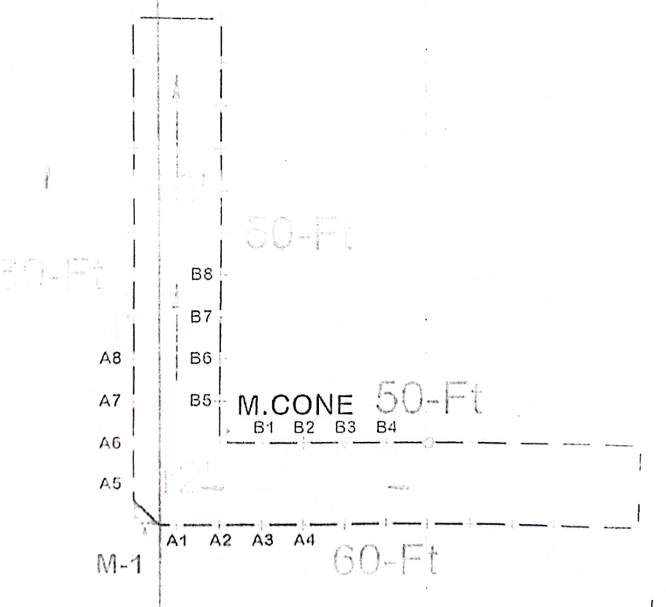

Bus Driver
Track Shape: L
Track Length: 200 × 200
Track Width: 18 × 18
Turn Width: 28 × 28
The candidate may adjust the vehicle forward or in reverse twice to prevent any collision with the cones.
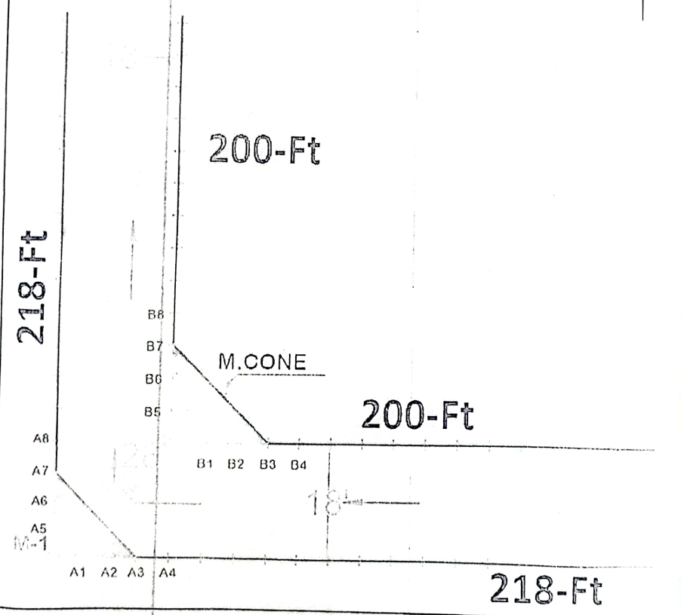

Mini Truck Driver
Track Shape: L
Track Length: 150 × 150
Track Width: 15 × 15
Turn Width: 21 × 21
The candidate may adjust the vehicle forward or in reverse twice to prevent any collision with the cones.
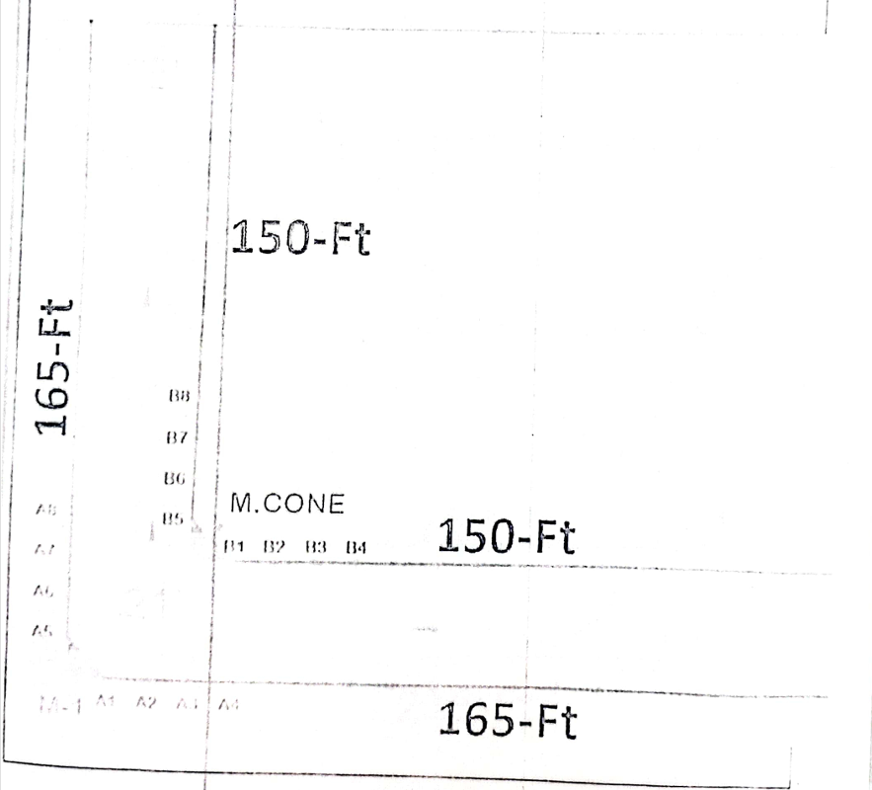

Truck Driver
Track Shape: L
Track Length: 200 × 200
Track Width: 16 × 16
Turn Width: 25 × 25
The candidate may adjust the vehicle forward or in reverse twice to prevent any collision with the cones.
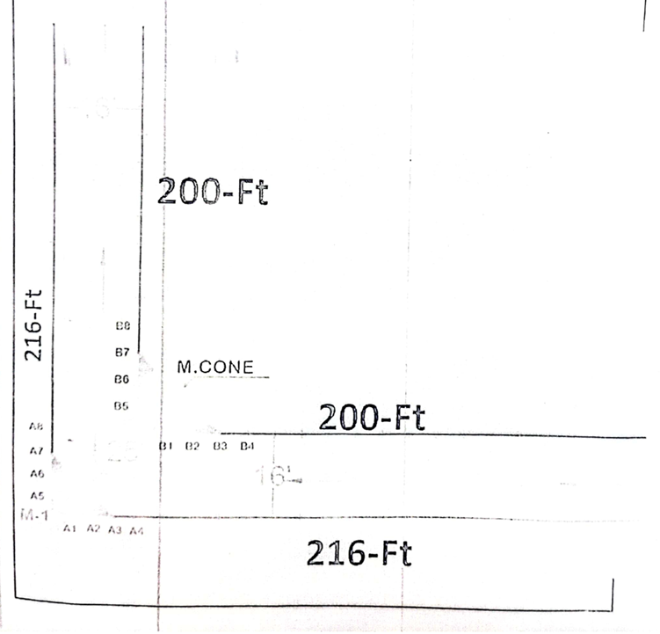

Motorcycle
Track Shape: Figure 8
Length: 50 × 50
Circle Width: 25 × 25

