Government of Pakistan

**National Vocational and Technical Training Commission**

**Prime Minister’s Youth Skill Development Program (PMYSD)**



**Course Contents / Lesson Plan**

**Course Title: Heavy Transport Vehicle (HTV) Driver**

**Duration:** 3 Months

Table of Contents

1. Introduction 5

2. Purpose of the Qualification: 5

3. Overall objectives of training program 5

4. Entry level of trainees 6

5. Minimum qualification for teachers 6

6. Duration of the course: 6

7. Scheme of Studies 7

8. Details of Modules 8

8.1: Understand Traffic Rules & Regulations of Pakistan and CoDs 8

8.1.1: Basic Introduction of road Transport 8

8.1.2: Learn the process of License to Drive 8

8.1.3: Code of Conduct on the Road Vehicles 8

8.2: Soft Skills, Driver fatigue and workplace health safety 10

8.2.1: Soft Skills 10

8.2.1: Apply general safety practices 10

8.2.2: PPE (Personal Protective Equipment) 10

8.2.3: Health and Safety (First Aids) 10

8.2.4: Apply road safety practices (Safe Driving Techniques) 11

8.2.5: Ensure personal protective equipment (PPE) 11

8.2.6: Maintain First aid Box 11

8.2.7: Maintain Fire Extinguisher 11

8.2.8: Implement safety measures 12

8.2.9: Prepare for emergencies 12

8.2.10: Respond to emergencies 12

8.2.11: Maintain Personal Hygiene 12

8.2.12: Dispose off-waste materials 12

8.3: Heavy Transport Vehicle (HTV) 13

8.3.1: Basics of HTVs Vehicles driving 13

8.3.2: Driving Techniques of HTVs Vehicles 13

8.3.3: Technical information of Vehicle (Parts and Control) HTVs Vehicles 14

8.3.4: Controls of HTVs Vehicles 14

8.3.5: Driving Abilities of HTVs Vehicles 16

8.4.6: Driving Practice of HTVs Vehicles 16

8.3.7: Parking Skills of HTVs Vehicles 20

8.3.8: Tips for Parallel Parking HTVs Vehicles 21

8.3.9: Health and Safety of HTVs Vehicles 21

8.4: 22 Wheeler driving skills 22

8.4.1: Introduction to 22-Wheelers 22

8.4.2: Driving Techniques and Maintenance 23

8.4.3: Advanced Driving and Compliance 23

8.4.4: Route and Logistics Management 24

8.5: GPS Navigation for HTV Driver Training 25

8.5.1: Benefits of GPS Navigation for LTV & HTV Drivers 25

8.5.2: Types of GPS Navigation Systems 25

8.5.3: Operating a GPS Navigation System Safely 25

8.5.4: Important Considerations 26

9. Multi Choice Questions. 26

10: Answer Key 46

**11.** **Basic Language Skills** 48

13.1: Basic Language Proficiency (Arabic) 48

13.2: Basic Language Proficiency (English) 65

13.3: Basic Language Proficiency German 80

13.4: Basic Language Proficiency Japanese 90

13.5: Basic Language Proficiency Korean 109

DO NOT: 174

DO BE PATIENT! 174

Defensive / Aggressive Driving 174

The Flashing of Headlights 175

Honking the Horn 175

Lane Protocol 175

Roundabout Protocol 175

Caution 177

Avoid driving behind: 178

Police Checks and Penalties 178

ACCIDENT GUIDELINES 180

DO NOT MOVE YOUR VEHICLE UNTIL THE POLICE TELL YOU TO 180

DRIVER LICENSE REQUIREMENTS: 182

PLEASE NOTE THAT INSURANCE COMPANIES WILL NOT COVER ANY DAMAGE TO THE VEHICLE DUE TO DRIVING OFF ROAD. 183

# Introduction

The Heavy Transport Vehicle (HTV) driver course is specialized training programs designed to equip individuals with the necessary skills and knowledge for professional driving in the transportation sector. The HTV driver modules prepare individuals to handle heavy transport vehicles, including buses, trucks, and trailers, with advanced driving skills, regulatory compliance, high-level safety measures, technical knowledge, and logistics management. This course is essential for ensuring the safety, efficiency, and reliability of transport services, enhancing the professional capabilities of drivers, and contributing to overall road safety and regulatory adherence in the transportation industry.

Therefore, industry expectations for skilled workforce are also dynamic which can only be managed through setting relevant curriculum in collaboration with the leading industries. Being familiar of this fact, National Vocational & Technical Training Commission (NAVTTC) developed curriculum for HTV driver under National Vocational Qualifications Framework (NVQF). These Modules have been developed by a Qualifications Development Committee (QDC).

# Purpose of the Qualification:

The purpose of this qualification is to set high professional standards for HTV drivers. The specific objectives of developing these qualifications are as under:

* Improve the professional competence of the trainees
* Provide opportunities for recognition of skills attained through non-formal or informal pathways
* Improve the quality and effectiveness of training and assessment for HTV drivers
* Enable the existing workforce to capacitate themselves in new technologies and methods

# Overall objectives of training program

The HTV qualification consists of 20 % theory and 80 % practical. and having the following Modules

1. Understand Traffic Rules & Regulations
2. Driver fatigue and workplace health safety
3. Heavy Transport Vehicle (HTV)
4. 22-Wheeler driving skills
5. Basic maintenance skills for LHTV

# Entry level of trainees

The entry for National Certificate, in HTV Driver is, a person having Matric Certificate.

# Minimum qualification for teachers

* BS/BS/ADP Technology with 2 years teaching experience having HTV driving experience
* Diploma with 5-year field experience with HTV driving

**Medium of instruction**

English, and Urdu.

# Duration of the course:

The proposed curriculum is composed of 6modules that will be covered in **300 Learning hours**. Duration of the course is proposed to be **3 months.**

The distribution of contact/Learning hours and credit hours are given below:

3 months= 10 Weeks (Technical) + 2 Weeks (Language Skills)

**Total Time of Technical Modules = 250 hours**

**Theory = 50 hours (20 %)**

**Practical = 200 hours (80 %)**

**Total Time of Soft Skill = 50 hours**

**Theory = 10 hours (20 %)**

**Practice = 40 hours (80 %)**

**Technical + Soft Skills = 250 + 50 hours**

**Grand Total = 300 hours. & 30 Credits**

|  |  |  |  |  |
| --- | --- | --- | --- | --- |
| **Pictorial Description** | **Categories of License/Permits** | **Minimum Maximum Age Required** | **Required Experience** | **Category of vehicle as per Weight Limit** |
| Car Black and White Clip Art Free PNG Image｜IllustoonBlack Motorcycle Vector Art, Icons, and Graphics for Free Download | Motorcycle, Motorcar/Jeep/Car or any other similar category license | 18 Year Minimum | Nil being fresh applicant | **Motorcycle/Motorcar**: Up to 125 Cc and more than 125 CC  **Car/Jeep**: Max mass not exceeding 3500 kg |
| Premium Vector | Hiroof van line art silhouette vehicles | LTV License  (Commercial Purpose) | (21-60) Years | 03-Year-old Valid car license | Above 3500 Kg |
| Van Black and White Clip Art Free PNG Image｜Illustoon | LTV/PSV License  (Public Service Vehicle)  Mazda Mini-Bus Rickshaw, Pick up van | (22-60) Years | 01-Year-old NHMP LTV license | Above 3500 kg with seating up to 22 |
|  | HTV-A/ CE license  includes articulated vehicles more than 14 wheelers  (Trailers, lorries etc)  \*\***Only NMHP is authorized licensing Authority in Pakistan** | (21-60) Years | 03 years old valid license other than bike or invalid carriage | More than 40,000 kg |
| Pakistani Truck Art Images – Browse 416 Stock Photos, Vectors, and Video |  Adobe Stock | HTV(Heavy Transport Vehicle) /HTV-B (trucks)  Includes rigid vehicles upto 14 wheelers | (24-60) Years | 03 Years old valid LTV license | Upto 40,000 Kg |
| Black Bus Stock Illustrations – 27,597 Black Bus Stock Illustrations,  Vectors & Clipart - Dreamstime | HTV/PSV license  (Public Service Vehicle)  (Metro Bus, Bus, Daewoo Bus) | (25-60) Years | 01-Year-old valid NHMP HTV license | Seating capacity more than 22 |

**Category of NHMP License As per Vehicle**

# Scheme of Studies

**(A). Technical Skills**

|  |  |  |  |  |  |  |  |  |  |
| --- | --- | --- | --- | --- | --- | --- | --- | --- | --- |
| **S. No** | **Name of Module** | **Category** | **Contact Hour** | | | **Credit** | **Periods per week** | | |
| **Th** | **Pr** | **Total** | **Th** | **Pr** | **Total** |
| 1 | Understand Traffic Rules & Regulations | Core | 5 | 18 | 23 | 2.3 | 0.5 | 1.8 | 2.3 |
| 2 | Driver fatigue and workplace health safety | Functional | 5 | 18 | 23 | 2.3 | 0.5 | 1.8 | 2.3 |
| 3 | Heavy Transport Vehicle (HTV) | Core | 15 | 66 | 81 | 8.1 | 1.5 | 6.6 | 8.1 |
| 4 | 22 Wheeler driving skills | Core | 15 | 66 | 81 | 8.1 | 1.5 | 6.6 | 8.1 |
| 5 | Basic maintenance skills for LTV and HTV | Core | 9 | 33 | 42 | 4.2 | 0.9 | 3.3 | 4.2 |
| **Total hours of Technical Modules** | | | **49** | **201** | **250** | **25** | **4.9** | **20.1** | **25.0** |

**(B). Language/Soft Skills**

|  |  |  |  |  |  |  |  |  |  |
| --- | --- | --- | --- | --- | --- | --- | --- | --- | --- |
| 1 | Language Skills Arabic | Generic | **Optional subjects:**  **Choose any one Language with 10 hours Theory and 40 hours for Practice** **with a Ratio of 20% theory and 80% Practice.** | | | | | | |
| 2 | Language Skills English | Generic |
| 3 | Language Skills German | Generic |
| 4 | Language Skills Japanese | Generic |
| 5 | Language Skills Korean | Generic |
| **Total hours of Soft Skills Modules** | | | **10** | **40** | **50** | **5** | **5** | **20** | **25.0** |

**Note: -** **Maximum possible Time of the 3 Months course**

**1 Period = 1 Hour,**

**5 Period in a day = 5 hours**

**5 days in a week = 25 hours**

**12 Week course. = 300 hours**

# 8. Details of Modules

## 8.1: Understand Traffic Rules & Regulations of Pakistan and CoDs

**Theory: 5 Hours Practical: 18 Hours Total: 23 Hours**

|  |  |  |
| --- | --- | --- |
| 8.1.1: Basic Introduction of road Transport | | |
| **Theory** | **Practical** | **Duration** |
| * Introduction and Importance of Road Transport * Define different regions of world (Asia, Gulf and Europe) * Knowledge of safety regulations and traffic laws in different regions of Pakistan & Countries of Destinations (CoDs) * Define Highway codes book. * Driver Competence & Fitness Test knowledge. | * Audio/Video Presentation * Group Discussion * Demos * Quizzes | Theory: 2hr.  Practical: 6 hrs.  Total: 8 hrs. |
| 8.1.2: Learn the process of License to Drive | | |
| **Theory** | **Practical** | **Duration** |
| * Knowledge about Road Transport Licensing process for different authorities. | * Audio/Video Presentation * Group Discussion * Quizzes * Observations | Theory: 2hr  Practical: 6hrs.  Total: 8hrs |
| 8.1.3: Code of Conduct on the Road Vehicles | | |
| **Theory** | **Practical** | **Duration** |
| * Define Use of Seat Belts * Avoid Distracted Driving knowledge * Obey Parking Regulations knowledge * Use of Indicators knowledge * How to respond to emergencies vehicles knowledge | * Pre departure Inspection of Vehicle.   + Check air pressure.   + Check Oil.   + Check break, indicators and head lights.   + Check water and wipers.   + Check battery.   + Check tires, lights, and fluid levels before any trip. * To perform forward driving. * Observer Traffic Singles and Road Sings. * Follow speed limits. * Follow Lane Discipline | Theory:2hr  Practical:6hrs.  Total:8hrs |

**Knowledge & Understanding: -**

**Reference Material (Traffic Rules of Country of Destination): -**

***Pakistan (NH&MP) (***[*https://dla.nhmp.gov.pk/GUIDE-FOR-PRACTICAL-DRIVING-TEST-P1-PII-Final.pdf*](https://dla.nhmp.gov.pk/GUIDE-FOR-PRACTICAL-DRIVING-TEST-P1-PII-Final.pdf)***)***

***Saudi Arabia*** (<https://www.rcrc.gov.sa/wp-content/uploads/2019/10/004618.pdf>)

***Qatar*** (<https://www.scribd.com/document/245603728/Qatar-Traffic-Manual>)

***UAE*** ([https://licensing.rta.ae/handbook/lmv/lmv_en.pdf)](https://edi-uae.com/public/uploads/downloads/20190724133013RTA_Handbook_-_Light_Motor_Vehicle_(LMV)_-_English.pdf))

***Bahrain*** (<https://services.bahrain.bh/wps/PA_GDTDhBoardServices/faces/javax.faces.resource/en/GDTLaw.pdf?rel=v1>)

***Canada*** (<https://www.atstraffic.ca/wp-content/uploads/2016/08/MoST_PM.pdf>)

***United Kingdom*** (<https://www.gov.uk/government/publications/traffic-signs-manual>)

***Australia*** (<https://pcc.gov.au/uniform/Australian-Road-Rules-19March2018.pdf>)

***United States of America*** (<https://2009-2017.state.gov/documents/organization/234570.pdf>)

***Vienna Convention On Road traffic Rules (1968)*** (<https://treaties.un.org/doc/Publication/MTDSG/Volume%20I/Chapter%20XI/XI-B-19.en.pdf>)

## 8.2: Soft Skills, Driver fatigue and workplace health safety

**Theory: 5 Hours Practical: 18 Hours Total: 23 Hours**

|  |  |  |
| --- | --- | --- |
| 8.2.1: Soft Skills | | |
| **Theory** | **Practical** | **Duration** |
| Soft Skills Manual developed by NAVTTC, accessed through the following link  (<https://navttc.gov.pk/AssetFiles/03Jan24_SoftSkills.pdf>) | | Theory: 10 hr.  Practical: 0hrs.  Total: 10 hrs. |
| 8.2.1: Apply general safety practices | | |
| **Theory** | **Practical** | **Duration** |
| * Stress & Fatigue Management knowledge * Define Load Management (HTV/LTV specific) * Define PPE (Personal Protective Equipment) * First Aids knowledge | * Work * Rest * Road Clear * Chain of responsibility * Work and rest options * Standard Hours * Alcohol, drugs and professional drivers | Theory: 0.5hr.  Practical: 2hrs.  Total: 2.5hrs. |
| 8.2.2: PPE (Personal Protective Equipment) | | |
| **Theory** | **Practical** | **Duration** |
| * Define High-visibility clothing * Define Safety footwear * Define Eye rinsing liquid * Define Warning vest * Define Eye protection (googles) | * Audio/Video Presentation * Group Discussion * Quizzes * Observations | Theory: 0.5hr  Practical:1hrs  Total: 1.5hr |
| 8.2.3: Health and Safety (First Aids) | | |
| **Theory** | **Practical** | **Duration** |
| * Define ABC (airway, breathing, and circulation) of First aids * Define Stopped Heart Beats * Define Bleeding, Chocking, Burns * Define Unconscientious * Define Broken Bone/Fracture * Define health safety measurement. | * Audio/Video Presentation * Group Discussion * Quizzes * Observations * What to do | Theory: 0.5hr  Practical:1hrs  Total:1.5hrs |
| 8.2.4: Apply road safety practices (Safe Driving Techniques) | | |
| **Theory** | **Practical** | **Duration** |
| * Defensive Driving knowledge * Speed Management knowledge * Define Maintaining Vehicle Condition * Define Avoiding Distractions * Define Intersection Safety * Define Proper Lane Usage * Define Weather Conditions * Fatigue Management knowledge * Pedestrian and Cyclist knowledge * Define Emergency Response Preparedness | * Demonstration * Audio/Video Presentation * Group Discussion * Demos * Quizzes | Theory: 0.5hr  Practical:3hrs  Total: 3.5hrs |
| 8.2.5: Ensure personal protective equipment (PPE) | | |
| **Theory** | **Practical** | **Duration** |
| * Personal Protective Equipment (PPE) Types and its uses | * Arrange PPEs as per requirement * Wear proper PPE as per nature of job. * Store PPE at appropriate place after use | Theory: 0.5 hr.  Practical: 1hrs.  Total: 1.5hrs. |
| 8.2.6: Maintain First aid Box | | |
| **Theory** | **Practical** | **Duration** |
| * First-Aid-Box and its uses. * Knowledge of first-aid-box items. | * Ensure availability of first aid box * Check first aid box for requisite emergency medicines * Check expiry date of medicines * Perform first aid treatment against electric shock. * Perform first aid treatment / bandages against minor injuries | Theory: 0.5hr  Practical:1hrs  Total: 1.5hrs |
| 8.2.7: Maintain Fire Extinguisher | | |
| **Theory** | **Practical** | **Duration** |
| * Fire Extinguisher its types and uses * Types of fire extinguishing materials. | * Check expiry of fire extinguisher * Operate fire extinguisher. * Replace fire extinguisher | Theory: 0.5hr  Practical:1hrs  Total: 1.5hrs |
| 8.2.8: Implement safety measures | | |
| **Theory** | **Practical** | **Duration** |
| * Hazard and its Types * Treatment of various hazards | 1. Take required health and safety training 2. Identify work place hazardous, Reasons and materials | Theory: 0.5hr  Practical:1hrs  Total: 1.5hrs |
| 8.2.9: Prepare for emergencies | | |
| **Theory** | **Practical** | **Duration** |
| * Know about the techniques for provision of first aid treatment. | 1. Take emergency response training 2. Ensure emergency response exercises. 3. Perform mock exercise for first aid of Cardio Respiratory Resuscitation (CPR**)** 4. Perform mock exercise for first aid treatment against electric shock/minor injury | Theory: 0hr  Practical:2hrs  Total: 2hrs |
| 8.2.10: Respond to emergencies | | |
| **Theory** | **Practical** | **Duration** |
| * Use of emergency equipment * Know about the emergency plan | 1. Follow emergency plan 2. Communicate instructions 3. Assess risk and determine course of action. 4. Operate emergency equipment and supplies | Theory: 0.5hr  Practical:1hrs.  Total: 1.5hrs |
| 8.2.11: Maintain Personal Hygiene | | |
| **Theory** | **Practical** | **Duration** |
| * Hygiene and its Types * Knowledge of personal hygiene | 1. Wash hands with soap frequently 2. Trim and clean nails 3. Maintain good hair hygiene 4. Take shower regularly. 5. Maintain body odour using deodorants/body spray | Theory: 0hr  Practical:2hrs  Total: 2hrs |
| 8.2.12: Dispose off-waste materials | | |
| **Theory** | **Practical** | **Duration** |
| * Types of waste materials * Knowledge and understanding of waste material handling. | 1. Separate waste into recyclable and nonrecyclable category 2. Check local regulations 3. Handle hazardous waste carefully 4. Adopt responsible waste management habits | Theory: 0.5hr  Practical:2hrs  Total: 2.5hrs |

## 8.3: Heavy Transport Vehicle (HTV)

**Theory: 15 Hours Practical: 66 Hours Total: 81 Hours**

|  |  |  |
| --- | --- | --- |
| 8.3.1: Basics of HTVs Vehicles driving | | |
| **Theory** | **Practical** | **Duration** |
| * Define HTV Vehicle * Define Types of HTV Vehicle * Knowledge about HTV Vehicle (buses, trucks, trailers, cranes, and any type of heavy transport) * Knowledge of Basic Requirement of HTV Vehicle License | * Audio/Video Presentation * Group Discussion * Quizzes * Observations | Theory: 1hr.  Practical: 3hrs.  Total: 4hrs. |
| 8.3.2: Driving Techniques of HTVs Vehicles | | |
| **Theory** | **Practical** | **Duration** |
| Knowledge about   * + Pre-Trip Inspection   + Vehicle Control   + Turning and Maneuvering   + Backing Up   + Managing Hills and Grades   + Safe Following Distance   + Interacting with Other Road Users   + Adverse Weather Conditions   + Cargo Securement   + Emergency Procedures | * Conduct a thorough inspection of the HTV before each trip, checking brakes, tires, lights, fluids, and cargo securement. * Practice smooth acceleration and braking to maintain control and stability, particularly when carrying heavy loads. * Use wider turns to accommodate the HTV's longer length and avoid cutting corners. * Minimize the need for backing up by planning routes and parking in positions that allow for forward movement. * Approach inclines at an appropriate speed and gear to prevent stalling or loss of traction. * Adjust following distance based on weather conditions, traffic flow, and road surface conditions. * Be patient and allow extra time for pedestrians, cyclists, and smaller vehicles to maneuver around the HTV. * Use windshield wipers, defrosters, and headlights as necessary to enhance visibility. * Ensure cargo is properly loaded and secured within weight limits to prevent shifting or loss during transit. * Carry emergency contact information and be prepared to provide assistance to others in need. | Theory: 1hr  Practical:3hrs.  Total: 4hrs |
| 8.3.3: Technical information of Vehicle (Parts and Control) HTVs Vehicles | | |
| **Theory** | **Practical** | **Duration** |
| Knowledge about   * + Engine   + Transmission   + Chassis   + Body   + Suspension System   + Braking System   + Steering System   + Electrical System   + Fuel System   + Cooling System   + Exhaust System   + Wheels and Tires | To ensure the optimal performance and safety of a HTV vehicle, it is essential to inspect various critical components thoroughly. The Engine, Transmission, Chassis, Body, Suspension System, Braking System, Steering System, Electrical System, Fuel System, Cooling System, Exhaust System, Wheels and Tires | Theory: 2hr  Practical:9 hrs.  Total: 11 hrs |
| 8.3.4: Controls of HTVs Vehicles | | |
| **Theory** | **Practical** | **Duration** |
| Knowledge about   * + Steering System   + Transmission   + Braking System   + Acceleration   + Instrument Cluster   + Lights and Signals   + Mirrors   + Auxiliary Controls   + Safety Equipment   + Specialized Controls (depending on vehicle) | * Demonstrate smooth and controlled steering while navigating through tight turns or narrow lanes. * Execute smooth gear changes, especially when starting from a stop or ascending/descending slopes. * Demonstrate effective braking control to bring the HTV to a complete stop from a moderate speed. * Accelerate the HTV smoothly and progressively to merge into highway traffic or overtake slower vehicles. * Monitor and interpret information displayed on the instrument cluster while driving. * Use vehicle lights and signals effectively to communicate intentions and comply with traffic regulations. * Maintain situational awareness by using mirrors to monitor surrounding traffic and potential blind spots. * Operate auxiliary controls such as windshield wipers, horn, and HVAC systems as needed for safe and comfortable driving conditions. * Ensure proper use and readiness of safety equipment such as seat belts and emergency tools. * Operate specialized controls specific to the HTV's purpose, such as hydraulic lifts or differential locks. | Theory: 2hr  Practical:9 hrs.  Total: 11 hrs |
| 8.3.5: Driving Abilities of HTVs Vehicles | | |
| **Theory** | **Practical** | **Duration** |
| * Define Vehicle Control and Maneuverability. * Spatial Awareness and Positioning Knowledge. * Safety and Risk Management knowledge. * Braking and Stopping Distance Management knowledge * Adaptability to Road Conditions knowledge. * Communication and Coordination skills knowledge. * Load Management and Cargo Security knowledge * Define Maintenance procedure * Regulatory Compliance knowledge * Define Emergency Response Preparedness procedures | * **Controlled U-turn:** Maneuver HTV in tight space, precise steering and throttle, avoiding encroachment. * **Navigate through cones:** Stay within boundaries, avoid contact. * **Identify hazards:** Spot pedestrian crossings, merging traffic, proactive risk mitigation. * **Emergency stop:** Halt HTV from speed, safe distance, maintain control. * **Drive in weather conditions:** Adapt to rain, snow, and gravel, ensure stability and comfort. * **Signal lane changes:** Clear communication, use signals effectively. * **Secure load:** Properly strap cargo, prevent shifting during maneuvers. * **Pre-trip inspection:** Check tires, fluids, lights, ensure roadworthiness. * **Hours-of-service compliance:** Follow regulations, schedule breaks, maintain records. * **Emergency response:** Safely Park, assess situation, and initiate protocols. | Theory: 3hr  Practical:15 hrs.  Total: 18 hrs |
| 8.4.6: Driving Practice of HTVs Vehicles | | |
| **Theory** | **Practical** | **Duration** |
| * Narrow Lane Navigation knowledge * Define Figure 8 Maneuver * Define Sandy Patch Handling * Zigzag Road Navigation knowledge * Causeway and Bridge Crossing understating * Define Sharp Turnings knowledge * Define Railway Crossing Protocol * Define Speed Breaker Approach * Define Parking of the Vehicle | * To navigate a narrow lane without encroaching on the sides.   + Approach the narrow lane slowly, assessing the width.   + Maintain a steady speed and position the vehicle carefully.   + Use mirrors effectively to monitor clearance on both sides.   + Complete the lane without touching any barriers or obstacles. * To drive a HTV for Figure 8 turn smoothly.   + Identify a clear area suitable for the maneuver.   + Approach the center point and initiate the turn.   + Use coordinated steering and throttle control to complete the Figure 8 pattern.   + Ensure the vehicle remains within the designated area throughout the maneuver. * To traverse a sandy patch without losing traction.   + Approach the sandy patch cautiously, maintaining a consistent speed.   + Keep a firm grip on the steering wheel to prevent oversteer.   + Use gentle throttle inputs to maintain momentum without spinning wheels.   + Exit the sandy area smoothly without getting stuck. * To navigate sharp turns on a zigzag road.   + Approach each turn at an appropriate speed, considering the curvature.   + Use proper lane positioning and adjust speed before entering each turn.   + Maintain smooth steering and avoid cutting corners.   + Complete the zigzag section while staying within lane boundaries. * To safely cross a causeway or bridge.   + Approach the causeway or bridge at a moderate speed.   + Adhere to weight restrictions and traffic signs.   + Maintain a steady pace while crossing to ensure stability.   + Check mirrors for any following traffic upon completing the crossing. * To negotiate a sharp turn safely.   + Approach the turn at a reduced speed appropriate for the curve.   + Use the correct gear and maintain proper lane positioning.   + Apply smooth and controlled steering inputs throughout the turn.   + Exit the turn while maintaining appropriate speed and lane discipline. * To approach and cross a railway crossing safely.   + Approach the railway crossing at a slow, controlled speed.   + Observe traffic signals and stop if required by signs or signals.   + Ensure all tracks are clear before proceeding across the crossing.   + Maintain awareness of potential train movements even after crossing. * To approach and cross a speed breaker smoothly.   + Identify the speed breaker well in advance and reduce speed accordingly.   + Approach the speed breaker at a controlled speed to minimize vehicle impact.   + Maintain a firm grip on the steering wheel to absorb the bump smoothly.   + Gradually accelerate after safely passing over the speed breaker. * To parallel park a HTV vehicle accurately.   + Find a suitable parking space large enough for the vehicle.   + Position the vehicle parallel to the parking spot, leaving enough clearance.   + Use mirrors and reverse camera (if available) to guide the vehicle into the space.   + Complete the parking maneuver while aligning the vehicle parallel to the curb. | Theory: 3 hr  Practical:12 hrs.  Total: 15 hrs |
| 8.3.7: Parking Skills of HTVs Vehicles | | |
| **Theory** | **Practical** | **Duration** |
| * Knowledge of Preparation   + I Shape   + L Shape   + Y Shape   + Snake Shape * HTV Vehicle Approach knowledge * Define Manoeuvring * Define HTV vehicle Alignment * Define HTV vehicle Final Adjustments * Define Securing the HTV vehicle | * Identify a suitable parallel parking space that is sufficiently long for the HTV. * Signal your intention to park and check mirrors to ensure the area is clear. * Begin reversing slowly, turning the steering wheel towards the curb. * Use mirrors and if available, a reverse camera to monitor the distance from the curb and adjacent vehicles. * Aim to position the HTV within the confines of the parking space, maintaining a safe distance from the curb. * Adjust the steering as necessary to align the HTV parallel to the curb. * Check all mirrors and surroundings to ensure the HTV is properly parked and does not obstruct traffic. * Once parked, engage the parking brake securely. * If applicable, deploy wheel chocks to prevent unintended movement. | Theory: 1 hr  Practical: 6hrs.  Total: 7hrs |
| 8.3.8: Tips for Parallel Parking HTVs Vehicles | | |
| **Theory** | **Practical** | **Duration** |
| Knowledge of   * + Take Your Time   + Use Mirrors Effectively   + Practice Makes Perfect   + Safety First | * Safely navigate the HTV through a narrow construction area without damaging the vehicle or surrounding obstacles. * Merge the HTV smoothly into traffic on the highway while effectively using mirrors to monitor surrounding vehicles. * Successfully reverse the HTV into a designated loading bay using precise maneuvering skills. * Safely cross the railway tracks while adhering to traffic signals and ensuring no trains are approaching | Theory: 1hr  Practical:6hrs.  Total: 7hrs |
| 8.3.9: Health and Safety of HTVs Vehicles | | |
| **Theory** | **Practical** | **Duration** |
| * Define Physical Health   + Regular Medical Check-ups   + Ergonomic Considerations   + Exercise and Stretching * Define Mental Well-being   + Stress Management   + Rest Breaks * Define Vehicle Safety   + Pre-Trip Inspections   + Load Securing * Define Environmental Considerations   + Air Quality   + Temperature Control * Define Hydration and Nutrition   + Hydration   + Healthy Eating * Define Personal Protective Equipment (PPE)   + Seatbelt   + Safety Shoes * Define Communication and Training   + Safety Training   + Communication | * Schedule annual medical check-ups with a healthcare provider. * Adjust the driver's seat and controls for comfort and support. * Incorporate stretching exercises before and after driving shifts. * Use relaxation techniques like deep breathing or mindfulness exercises. * Take regular breaks during long drives to rest and recharge. * Conduct thorough pre-trip inspections of the HTV. * Ensure proper securing of loads to prevent shifting during transit. * Maintain clean cabin air filters for good air quality inside the HTV. * Manage cabin temperature for comfort and alertness. * Drink water regularly throughout the day. * Pack nutritious snacks and meals for the journey. * Always wear a seatbelt while operating the HTV. * Wear appropriate footwear with good grip. * Attend regular safety training sessions provided by the company. * Maintain clear communication with dispatchers and colleagues. | Theory: 1hr  Practical:3hrs.  Total: 4hrs |

## 8.4: 22 Wheeler driving skills

**Theory: 15 Hours Practical: 66 Hours Total: 81 Hours**

|  |  |  |
| --- | --- | --- |
| 8.4.1: Introduction to 22-Wheelers | | |
| **Theory** | **Practical** | **Duration** |
| * Describe Components: chassis, engine, transmission, braking systems, axles. * Understand torque, load distribution, and powertrain basics. * Knowledge of personal safety: gear, posture, and fatigue management. * Understand vehicle safety: pre-trip inspection checklist. * Knowledge of heavy vehicle-specific rules and traffic signals. * Understand speed limits and overtaking laws. * Knowledge of basic tool kit for inspection and maintenance | * Demonstrate vehicle parts and their functions. * Perform pre-inspection: * Checking tires, brakes, lights, and fluids. * Identifying warning signs on the dashboard. * Practice handling of basic tools (spanners, jacks, etc.). | Theory: 4 hr  Practical:15 hrs.  Total: 19hrs |
| 8.4.2: Driving Techniques and Maintenance | | |
| **Theory** | **Practical** | **Duration** |
| * + Understand gear shifting techniques (manual and automated systems).   + Knowledge of steering control and braking systems (ABS, air brakes).   + Maneuvering large vehicles in tight spaces.   + Describe engine basics: checking oil, coolant, and filters.   + Understand common mechanical faults and emergency fixes.   + Importance of regular servicing. | Practice controlled environment driving   * Starting, stopping, and low-speed maneuvers. * Parking, reversing, and turning practice.   Hands-on maintenance exercises:   * Changing oil and filters. * Checking and inflating tires. * Troubleshooting simple electrical issues (fuse replacement). | Theory: 4hr  Practical:18hrs.  Total: 22 hrs |
| 8.4.3: Advanced Driving and Compliance | | |
| **Theory** | **Practical** | **Duration** |
| * Knowledge of driving techniques on highways, slopes, and uneven terrain. * Understand fuel-efficient driving techniques. * Explain management of heavy loads in challenging conditions. * Recognize engine problems through sound and performance. * Knowledge of basic diagnostics using onboard vehicle systems. * Knowledge of managing breakdowns on the road. | * Practice driving in real-world scenarios (highways and city roads). * Practice emergency maneuvers:   Sudden braking and swerving.  Simulated tire bursts or brake failures.   * Perform troubleshooting exercises under supervision. | Theory: 4 hr  Practical:18hrs.  Total: 22 hrs |
| 8.4.4: Route and Logistics Management | | |
| **Theory** | **Practical** | **Duration** |
| * Knowledge of basic route planning and GPS usage. * Understand cargo weight limits and axle load distribution. * Knowledge of communication with logistics teams and managers. * Understand Environmental and Legal Compliance   Regulations on emissions and noise levels.  Vehicle documentation: permits, licenses, and records. | * Practice GPS route for selected destinations * Perform a mock delivery route in real world. * Perform Handling cargo loading and unloading independently. * Perform real-world troubleshooting and inspection exercises. | Theory: 3 hr  Practical:15hrs.  Total: 18 hrs |

## 8.5: GPS Navigation for HTV Driver Training

**Theory: 9 Hours Practical: 33 Hours Total: 42 Hours**

|  |  |  |
| --- | --- | --- |
| 8.5.1: Benefits of GPS Navigation for LTV & HTV Drivers | | |
| **Theory** | **Practical** | **Duration** |
| * Improved route planning and efficiency * Reduced driver workload and fatigue * Enhanced situational awareness, especially on unfamiliar routes * Real-time traffic updates and alternative route suggestions * Location tracking for fleet management purposes | * Explore stations showcasing live traffic updates, safety alerts, lane guidance for LTV & HTV drivers. * In class demonstration of limited visibility driving vs. GPS guided navigation. | Theory: 4 hr  Practical:15 hrs.  Total: 19hrs |
| 8.5.2: Types of GPS Navigation Systems | | |
| **Theory** | **Practical** | **Duration** |
| * + In-dash navigation systems integrated into the vehicle's dashboard   + Portable navigation devices with standalone displays   + Smartphone navigation apps | * In-class demonstration of different GPS navigation systems. | Theory: 5hr  Practical:18hrs.  Total: 23 hrs |
| 8.5.3: Operating a GPS Navigation System Safely | | |
| **Theory** | **Practical** | **Duration** |
| * + Pre-trip planning: Entering destination information, checking route details, and identifying potential hazards.   + While driving: Following voice prompts or on-screen instructions cautiously, avoiding distractions, and maintaining focus on the road.   + Limitations awareness: Recognizing that GPS systems can provide inaccurate information or outdated routes. Dependence on GPS should not replace a driver's knowledge of traffic signs, road conditions, and safe driving practices. | * Hands-on practice using a simulator or a non-driving environment to plan routes and navigate using a GPS system specific to LTVs and HTVs. * Analyze situations where GPS may provide inaccurate information and emphasize the importance of driver judgment. | Theory: 5hr  Practical:18hrs.  Total: 23 hrs |
| 8.5.4: Important Considerations | | |
| **Theory** | **Practical** | **Duration** |
| * + Map Updates: Ensure the GPS system has the latest maps to avoid outdated directions.   + Point of Interest (POI) Selection: Choose POIs suitable for large vehicles, considering factors like road width, height restrictions, and parking availability.   + Driver Responsibilities: GPS is a tool, not a substitute for safe driving practices. Always prioritize road signs, traffic regulations, and real-time road conditions over GPS instructions.   + Distraction Prevention: Minimize interaction with the GPS system while driving. Utilize features like voice prompts and pre-programmed destinations. | * Reconstruct a hypothetical LTV/HTV accident and discuss safety improvements. | Theory: 5hr  Practical:18hrs.  Total: 23 hrs |

# Multi Choice Questions.

**Module 1: Understand Traffic Rules & Regulations**

1. What is the legal age for the drivers to obtain a non-professional driving license in Pakistan?
2. 16 years
3. 18 years
4. 20 years
5. 22 years
6. Which side of the road should you drive in Pakistan?
7. Left side
8. Right side
9. Center
10. Any side
11. What does a red traffic light indicate?
12. Stop
13. Go
14. Slow down
15. Prepare to go
16. What does a flashing yellow light mean?
17. Stop
18. Go
19. Slow down and proceed with caution
20. Don’t move
21. When approaching a pedestrian crossing ie. Zebra crossing, drivers should:
22. Speed up
23. Stop if there are pedestrians
24. Ignore pedestrians
25. Honk to alert pedestrians
26. What is the maximum speed limit in urban areas unless otherwise displayed?
27. 40 km/h
28. 50 km/h
29. 80 km/h
30. 65 km/h
31. Overtaking is prohibited:
32. On sharp curves
33. At pedestrian crossings
34. At intersections
35. All of the above
36. What does a solid white line on the road to signify?
37. You can change lanes
38. You cannot change lanes or over take
39. Parking is allowed
40. It is a pedestrian lane
41. In case of an accident, the driver must:
42. Drive away quickly
43. Stop and provide assistance
44. Call the police
45. Continue driving if the damage is minor
46. What is the penalty for driving without a valid license in Pakistan?
47. Fine only
48. Imprisonment
49. Fine and/or imprisonment
50. No penalty
51. Using a mobile phone while driving is:
52. Permitted
53. Permitted with a hands-free device
54. Prohibited
55. Permitted only for texting
56. The use of seat belts is:
57. Optional
58. Mandatory for the driver only
59. Mandatory for both driver and front-seat passenger
60. Mandatory for all passengers
61. Which document is essential to carry while driving in Pakistan?
62. Passport
63. Vehicle registration book and Driving License
64. Credit card
65. Birth certificate
66. What is the purpose of a speed bump?
67. To increase vehicle speed
68. To slow down VEHICLE
69. To separate lanes
70. To park vehicles
71. If a traffic signal is out of order, you should:
72. Ignore it and proceed
73. Drive as if it is green
74. Follow the signals of the traffic warden
75. Stop and wait until it is fixed
76. A broken white line on the road means:
77. No parking
78. Passing is allowed if done safely/can overtake
79. No passing
80. One-way street
81. What is the maximum speed limit FOR LTV on motorways in Pakistan?
82. 100 km/h
83. 110 km/h
84. 120 km/h
85. 130 km/h
86. When should you use your car horn?
87. To greet friends
88. To alert other drivers of your presence
89. To express frustration
90. In silent zones
91. Why are dippers used?
92. For overtaking
93. To stop your vehicle
94. To show your presence
95. none
96. When are you allowed to overtake another vehicle on the road?
97. On curves
98. At intersections
99. On a straight road.
100. On bridges
101. What should a driver do if they miss an exit on the motorway?
102. Reverse to the exit
103. Make a U-turn
104. Continue to the next exit
105. Stop and wait for assistance
106. What is the purpose of a zebra crossing?
107. Parking area
108. Pedestrian crossing
109. Vehicle stopping area
110. Bicycle crossing
111. What should a driver do when approaching a roundabout?
112. Speed up
113. Stop
114. Give way to traffic coming from right side
115. Enter without checking
116. What is minimum age limit for HTV driving license?
117. 21
118. 18
119. 24
120. 22
121. Issuance of driving license system is followed by:
122. Ordinance 1965
123. Ordinance 1966
124. Ordinance 1968
125. Ordinance 1970

**Module 2: Apply General & Road Safety**

1. **What is the primary purpose of road warning signs?**

A) To inform drivers of nearby restaurants

B) To guide drivers to the nearest gas station

C) To warn drivers of potential hazards ahead

D) To provide advertisements

1. **What does triangular sign indicate?**

A) Prohibited actions

B) Mandatory actions

C) Warning of potential hazards

D) Information

1. **Which color is commonly used for warning signs on the road?**

A) Blue

B) Green

C) Yellow

D) Red

1. **What does a yellow diamond-shaped sign with a black exclamation mark indicate?**

A) No parking

B) Yield

C) General caution

D) Pedestrian crossing

1. **What does this sign mean?**

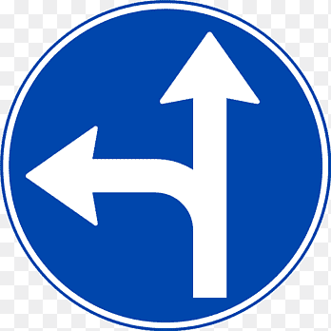A) U-turn ahead

B) Go straight or Left

C) Truck stop ahead

D) Road narrows ahead

1. **What does this sign mean?**

A) U-turn ahead

B) Give Way

C) Roundabout

D) Honk continuously

1. **What does a flashing red traffic light signify?**

A) Slow down

B) Stop, then proceed when safe

C) Caution, proceed with care

D) Pedestrian crossing

1. **What should a driver do when they see a sign indicating "Slippery When Wet"?**

A) Speed up to avoid skidding

B) Maintain a constant speed

C) Reduce speed and drive with caution

D) Stop immediately

1. **Which sign indicates a school zone?**

A) A triangular sign with children crossing

B) A diamond sign with a pedestrian symbol

C) A circular sign with a bicycle symbol

D) A square sign with a bus symbol

1. **What is the purpose of a speed limit sign?**

A) To inform drivers of the maximum safe speed for the specific area

B) To suggest a speed to drive at

C) To indicate a minimum speed requirement

D) To warn of upcoming speed traps

1. **What does this sign mean?**

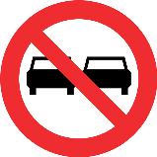A) No entry

B) Overtaking in not allowed

C) Left turn permitted

D) Left lane ends

1. **Which safety feature is most effective in preventing fatalities in vehicle collisions?**

A) Head rest

B) Seat belts

C) Anti-lock braking system (ABS)

D) Traction control

1. **How many types of traffic sign boards are?**

A) 2

B) 5

C) 3

D) 4

1. **How often should heavy vehicle drivers conduct a pre-trip inspection?**

A) Once a week

B) Every trip

C) Once a month

D) Before heading out on route.

1. **Traffic signs in blue, green or black color indicate?**

A) Mandatory

B) Information

C) Warning

D) Prohibited

1. **Which sign indicates danger ahead?**

|  |  |  |  |
| --- | --- | --- | --- |
| **A** | **B** | **C** | **D** |
| Other danger | Motorway | Temporary right lane closed | Crossroads |

1. **What should you do if you see a sign warning of animals crossing the road?**

A) Speed up to pass the area quickly

B) Drive with caution and be prepared to stop

C) Ignore the sign

D) Sound your horn continuously

1. **Which sign indicates ROAD NARROWS ON RIGHT?**

|  |  |  |  |
| --- | --- | --- | --- |
| **A** | **B** | **C** | **D** |
| Road narrows on right | Uneven road | Road hump | Roadworks |

1. **Which document is essential for legally driving a heavy vehicle?**

A) Personal ID card

B) Vehicle registration

C) Heavy Vehicle License (HTV license)

D) Vehicle insurance policy

1. **What does a double solid yellow line on the road signify?**

A) Passing is allowed in both directions

B) No passing in either direction

C) Passing allowed on the left only

D) Passing allowed on the right only

1. **How should you after witnessing a sign indicating a narrow bridge ahead?**

A) Speed up to cross quickly

B) Slow down and be prepared to stop if necessary

C) Drive in the middle of the bridge

D) Change lanes immediately

1. **Is the extreme left lane used only for overtaking?**

A) Wrong

B) Right

C) No idea

D) None

1. **Which type of road sign is usually triangular in shape?**

A) Regulatory signs

B) Warning signs

C) Informational signs

D) Directional signs

1. **What should a driver do if they encounter a flashing yellow traffic light?**

A) Stop completely

B) Proceed with caution

C) Speed up

D) Ignore the light

1. **What is the purpose of reflective tape on heavy vehicles?**

A) To enhance visibility during the day

B) To reduce fuel consumption

C) To improve nighttime visibility

D) To indicate vehicle weight

1. **What is the safest way to approach a sharp curve?**
2. Accelerate into the curve
3. Brake hard in the middle of the curve
4. Slow down before entering the curve
5. Maintain the same speed throughout

**Module 3: Heavy Transport Vehicle (HTV)**

1. **What is the primary consideration when planning a route for a heavy transport vehicle (HTV)?**

A) Scenic views

B) Availability of fuel stations

C) Weight restrictions on roads and bridges

D) Availability of rest areas

1. **What is the correct procedure for making a wide right turn in an HTV?**

A) Swing into the left lane before turning right

B) Turn from the center lane

C) Swing wide into the intersection before completing the turn

D) Turn sharply from the right lane

1. **Which of the following is a critical step in a pre-trip inspection for an HTV?**

A) Checking the cleanliness of the cabin

B) Ensuring all paperwork is in order

C) (Power) Petrol, Oil, Water, Electricity and Rubber)

D) Refueling the vehicle

1. **How often should HTV drivers check their mirrors?**

A) Every 30 seconds

B) Every 5-8 seconds

C) Once an hour

D) Only when changing lanes

1. **What is the primary purpose of a hand brake in vehicle?**

A) To enhance acceleration

B) to control rear wheel

C) To improve fuel efficiency

D) To stabilize the vehicle

1. **What should an HTV driver do if they experience brake failure?**

A) Speed up to regain control

B) Shift to a step-by-step lower gear

C) Turn off the engine

D) Honk continuously to alert other drivers

1. **What is the main advantage of using a tachograph in HTVs?**

A) To track vehicle speed

B) To monitor driver hours and compliance

C) To enhance navigation

D) To improve fuel efficiency

1. **Which factor is crucial for maintaining stability in an HTV?**

A) High speed

B) Balanced cargo loading

C) Frequent lane changes

D) Sudden braking

1. **What is a key factor in ensuring the stability of a heavy vehicle during turns?**

A) High speed

B) Low speed and wide turns

C) Abrupt steering

D) Frequent lane changes

1. **What is the recommended following distance for HTVs under normal conditions?**

A) 1 second

B) 2 seconds

C) 3 seconds

D) 4 seconds or more

1. **What should an HTV driver do when approaching a steep downgrade?**

A) Shift to a higher gear

B) Shift to a lower gear before descending

C) Maintain current speed and gear

D) Turn off the engine

1. **What is the primary function of hydraulic brakes in HTVs?**

A) To increase speed

B) To provide efficient braking power

C) To reduce fuel consumption

D) To stabilize the vehicle

1. **Why is it important to check tire pressure regularly in HTVs?**

A) To improve acceleration

B) To prevent tire blowouts and ensure safety

C) To reduce vehicle weight

D) To enhance visibility

1. **Which technique helps in managing fatigue for HTV drivers?**

A) Consuming energy drinks frequently

B) Following regular sleep schedules and taking breaks

C) Listening to loud music

D) Driving continuously without stopping

1. **What should a driver do if their HTV starts to hydroplane?**

A) Brake hard

B) Accelerate

C) Steer straight and gently ease off the accelerator

D) Turn the steering wheel sharply

1. **What is the consequence of neglecting maintenance on a heavy vehicle?**

A) Increased fuel efficiency

B) Reduced risk of breakdowns

C) Higher risk of mechanical failure and accidents

D) Improved vehicle performance

1. **What is the most effective way to handle a blowout in an HTV?**

A) Brake immediately

B) Accelerate quickly

C) Maintain a firm grip on the steering wheel and gradually slow down

D) Turn off the engine

1. **Which type of transmission is commonly found in HTVs?**

A) Manual transmission

B) Automatic transmission

C) Continuously Variable Transmission (CVT)

D) Dual-clutch transmission

1. **Why is it important to use proper securing techniques for cargo in HTVs?**

A) To enhance vehicle speed

B) To prevent cargo shifting and ensure stability

C) To reduce fuel consumption

D) To improve visibility

1. **Which of the following is a key step in load management?**

A) Overloading the vehicle

B) Distributing weight evenly

C) Ignoring weight limits

D) Loading all cargo at the rear

1. **What is the purpose of a sleeper berth in HTVs?**

A) To store cargo

B) To provide a resting area for drivers

C) To enhance fuel efficiency

D) To stabilize the vehicle

1. **How can HTV drivers reduce fuel consumption?**

A) Accelerate quickly and maintain high speeds

B) Maintain a steady speed and avoid rapid acceleration

C) Use air conditioning continuously

D) Frequently change gears

1. **What should be done if an HTV starts to skid on ice?**

A) Brake hard

B) Accelerate

C) Steer gently in the direction of the skid

D) Turn off the engine

1. **Which type of cargo requires special handling and securing techniques?**

A) Perishable goods

B) Heavy machinery

C) Hazardous materials

D) All of the above

1. **What is the function of a load-sensing valve in HTVs?**

A) To increase speed

B) To adjust braking force based on vehicle load

C) To improve fuel efficiency

D) To reduce vehicle height

1. **What is the recommended tire tread depth for HTVs?**

A) 1/32 inch

B) 2/32 inch

C) 4/32 inch

D) 6/32 inch

1. **What is the primary purpose of reflective tape on HTVs?**

A) To enhance daytime visibility

B) To improve nighttime visibility

C) To indicate vehicle weight

D) To reduce fuel consumption

1. **Which technique is used to safely navigate through curves in an HTV?**

A) Speed up before entering the curve

B) Brake while in the curve

C) Slow down before entering the curve and accelerate gradually while exiting

D) Maintain a constant speed

**Module 4: 22 Wheeler driving skills**

Q1: What is the main purpose of the trailer in a 22-wheeler?

A. To steer the vehicle

B. To carry the load

C. To house the engine

D. To hold fuel

Answer: B. To carry the load

Q2: What connects the cab to the trailer in a 22-wheeler?

A. Axle

B. Coupler (fifth wheel)

C. Brake line

D. Clutch

Answer: B. Coupler (fifth wheel)

Q3: Which part of the 22-wheeler is responsible for stopping the vehicle?

A. Steering

B. Axles

C. Braking system

D. Transmission

Answer: C. Braking system

Q4: What does a red traffic light mean?

A. Slow down

B. Stop

C. Drive faster

D. Overtake

Answer: B. Stop

Q5: What should you check before starting a trip?

A. Only the fuel tank

B. Lights, brakes, tires, and fluids

C. Number of passengers

D. Route distance

Answer: B. Lights, brakes, tires, and fluids

Q6: What is the main reason to wear a seatbelt?

A. To avoid a traffic fine

B. For driver comfort

C. For safety during accidents

D. To drive faster

Answer: C. For safety during accidents

Q7: When should you use low gears in a 22-wheeler?

A. On steep inclines or descents

B. While overtaking

C. When driving on highways

D. During heavy traffic

Answer: A. On steep inclines or descents

Q8: What should you do before reversing a 22-wheeler?

A. Blow the horn and proceed immediately

B. Check mirrors and surrounding area

C. Accelerate quickly

D. Signal other drivers to stay back

Answer: B. Check mirrors and surrounding area

Q9: Why is it important to maintain a safe distance from other vehicles?

A. To drive faster

B. To reduce fuel consumption

C. To have enough space to stop safely

D. To overtake easily

Answer: C. To have enough space to stop safely

Q10: What does it mean if the oil pressure warning light is on?

A. The fuel tank is empty

B. The oil level is low or oil is not circulating properly

C. The tires need air

D. The brakes are not working

Answer: B. The oil level is low or oil is not circulating properly

Q11: How often should you check tire pressure?

A. Only before a long trip

B. Every morning before driving

C. Once a month

D. Only if a tire looks flat

Answer: B. Every morning before driving

Q12: If your brakes fail while driving, what should you do first?

A. Shift to a lower gear and use the parking brake gradually

B. Speed up to reach a repair shop quickly

C. Jump out of the vehicle

D. Keep driving and hope they recover

Answer: A. Shift to a lower gear and use the parking brake gradually

Q13: Why is it important to secure cargo properly?

A. To avoid theft

B. To prevent the cargo from shifting and causing imbalance

C. To reduce loading time

D. To impress clients

Answer: B. To prevent the cargo from shifting and causing imbalance

Q14: What is the maximum axle load allowed for a 22-wheeler?

A. It depends on the regulations of the country

B. 20 tons

C. 50 tons

D. There is no limit

Answer: A. It depends on the regulations of the country

Q15: What document is necessary to carry when transporting goods?

A. Driver’s license only

B. Vehicle registration, permits, and cargo documentation

C. Passport

D. Personal identification card

Answer: B. Vehicle registration, permits, and cargo documentation

**Module 5: Practice LTV and HTV basic maintenance skills**

1. **What is the primary purpose of regular vehicle maintenance?**

A) To increase vehicle speed

B) To ensure safety and reliability

C) To improve vehicle aesthetics

D) To reduce insurance costs

1. **How often should engine oil be checked in LTVs and HTVs?**

A) Once a year

B) Every 5,000 miles

C) Weekly

D) Monthly

1. **Which fluid is essential for the proper functioning of an HTV's braking system?**

A) Engine oil

B) Brake fluid

C) Transmission fluid

D) Power steering fluid

1. **What is the first step in performing a pre-trip inspection?**

A) Checking tire pressure

B) Starting the engine

C) Inspecting lights and signals

D) Checking the fuel level

1. **What should you check regarding the lights on both LTVs and HTVs?**

A) Brightness and alignment

B) Color and style

C) Size and shape

D) Manufacturer

1. **What tool is commonly used to check tire pressure?**

A) Torque wrench

B) Tire gauge

C) Pressure washer

D) Thermometer

1. **Which document should always be kept up-to-date for vehicle maintenance?**

A) Driver's license

B) Vehicle registration

C) Maintenance logbook

D) Insurance policy

1. **What should be done if the check engine light comes on?**

A) Ignore it and continue driving

B) Check for any obvious issues and consult a mechanic

C) Disconnect the battery

D) Turn off all electronic devices

1. **How often should the coolant level be checked in an HTV?**

A) Every day

B) Weekly

C) Monthly

D) Only during scheduled maintenance

1. **Which component is crucial for starting the vehicle?**

A) Alternator

B) Battery

C) Radiator

D) Catalytic converter

1. **What is the purpose of the serpentine belt in a vehicle?**

A) To enhance acceleration

B) To drive multiple peripheral devices in the engine

C) To reduce engine noise

D) To filter the engine oil

1. **When should the transmission fluid be checked?**

A) Every 1,000 miles

B) During each oil change

C) When the vehicle is new

D) Only when there is a problem

1. **What is the main sign of worn brake pads?**

A) High-pitched squealing noise

B) Smooth braking

C) Increased fuel consumption

D) Improved acceleration

1. **Why is it important to maintain proper alignment in LTVs and HTVs?**

A) To increase vehicle speed

B) To ensure even tire wear and proper handling

C) To reduce vehicle weight

D) To enhance visibility

1. **How often should windshield wipers be replaced?**

A) Every month

B) Every 6 to 12 months

C) Every 2 years

D) Only when they are broken

1. **What is the function of the alternator in a vehicle?**

A) To start the engine

B) To charge the battery and power the electrical system

C) To cool the engine

D) To filter the fuel

1. **How can you check for a potential coolant leak?**

A) Look for wet spots under the vehicle

B) Check tire pressure

C) Listen for unusual engine noises

D) Check fuel level

1. **What is the purpose of a vehicle's suspension system?**

A) To increase speed

B) To absorb and dampen shocks for a smoother ride

C) To reduce fuel consumption

D) To enhance engine performance

1. **Which fluid should be checked to ensure smooth steering operation?**

A) Brake fluid

B) Engine oil

C) Transmission fluid

D) Power steering fluid

1. **How often should the spark plugs be replaced in an LTV?**

A) Every 3,000 miles

B) Every 12,000 miles

C) Every 30,000 to 50,000 miles

D) Every 100,000 miles

1. **What is a common sign of a failing alternator?**

A) Engine overheating

B) Dimming headlights

C) High-pitched squealing noise

D) Smooth braking

1. **Why is it important to regularly change the engine oil and oil filter?**

A) To increase speed

B) To ensure engine lubrication and long life

C) To enhance vehicle aesthetics

D) To reduce vehicle weight

1. **What is the function of the fuel filter in a vehicle?**

A) To increase fuel efficiency

B) To remove impurities from the fuel before it reaches the engine

C) To cool the fuel

D) To increase vehicle speed

1. **What should you do if you notice unusual vibrations while driving?**

A) Ignore them

B) Check for proper tire balance and alignment

C) Increase speed

D) Turn off the engine

1. **Why is it important to maintain the correct coolant level?**

A) To increase speed

B) To prevent engine overheating

C) To reduce fuel consumption

D) To enhance visibility

# 10: Answer Key

|  |  |  |  |  |  |  |  |  |  |
| --- | --- | --- | --- | --- | --- | --- | --- | --- | --- |
| **Module 1** | | | | | | | | | |
|  |  |  |  |  |  |  |  |  |  |
| **B** | **A** | **A** | **C** | **B** | **D** | **D** | **B** | **B** | **A** |
|  |  |  |  |  |  |  |  |  |  |
| **C** | **C** | **B** | **B** | **C** | **B** | **C** | **B** | **A** | **C** |
|  |  |  |  |  |  |  |  |  |  |
| **C** | **B** | **C** | **D** | **A** |  |  |  |  |  |

|  |  |  |  |  |  |  |  |  |  |
| --- | --- | --- | --- | --- | --- | --- | --- | --- | --- |
| **Module 2** | | | | | | | | | |
|  |  |  |  |  |  |  |  |  |  |
| **C** | **C** | **C** | **C** | **B** | **B** | **B** | **C** | **A** | **A** |
|  |  |  |  |  |  |  |  |  |  |
| **B** | **B** | **C** | **B** | **B** | **A** | **B** | **A** | **C** | **B** |
|  |  |  |  |  |  |  |  |  |  |
| **B** | **A** | **B** | **B** | **C** | **C** |  |  |  |  |

|  |  |  |  |  |  |  |  |  |  |
| --- | --- | --- | --- | --- | --- | --- | --- | --- | --- |
| **Module 3** | | | | | | | | | |
|  |  |  |  |  |  |  |  |  |  |
| **C** | **C** | **C** | **B** | **B** | **B** | **B** | **B** | **B** | **D** |
|  |  |  |  |  |  |  |  |  |  |
| **B** | **B** | **B** | **B** | **C** | **C** | **C** | **A** | **B** | **B** |
|  |  |  |  |  | **26.** | **27.** | **28.** |  |  |
| **B** | **B** | **C** | **D** | **B** | **C** | **B** | **C** |  |  |

|  |  |  |  |  |  |  |  |  |  |
| --- | --- | --- | --- | --- | --- | --- | --- | --- | --- |
| **Module 4** | | | | | | | | | |
|  |  |  |  |  |  |  |  |  |  |
|  |  |  |  |  |  |  |  |  |  |
|  |  |  |  |  |  |  |  |  |  |
|  |  |  |  |  |  |  |  |  |  |
|  |  |  |  |  |  |  |  |  |  |
|  |  |  |  |  |  |  |  |  |  |

|  |  |  |  |  |  |  |  |  |  |
| --- | --- | --- | --- | --- | --- | --- | --- | --- | --- |
| **Module 5** | | | | | | | | | |
|  |  |  |  |  |  |  |  |  |  |
| **B** | **C** | **B** | **C** | **A** | **B** | **C** | **B** | **B** | **B** |
|  |  |  |  |  |  |  |  |  |  |
| **B** | **B** | **A** | **B** | **B** | **B** | **A** | **B** | **D** | **C** |
|  |  |  |  |  |  |  |  |  |  |
| **B** | **B** | **B** | **B** | **B** |  |  |  |  |  |

1. **Basic Language Skills**

## 13.1: Basic Language Proficiency (Arabic)

**Theory: 10 Hours Practical: 40 Hours Total: 50 Hours**

|  |  |  |
| --- | --- | --- |
| **التحية والتعارف (Introduction & Greetings)** | | |
| **Theory** | **Practical** | **Duration** |
| * **شرح الكلمات الجديدة بالأردية** * **تدريب الحوار بين الطالبين** * **تدريب الطلاب على استخدام الكلمات** * **تدريب على الاستماع** * **مشاهدة فيديو للحوار** | **التعارف بين الشخصين**  **قاسِمٌ: السلامُ عليْكم!**  **عَلِيٌّ: وَعَلَيْكُمُ السَّلامُ ورَحْمَةُ اللهِ وبَرَكَاتُهُ!.**  **قاسِمٌ: كَيْفَ حَالُكَ؟**  **عَلِيٌّ: بِخَيْرٍ وَالْحَمْدُ لِلهِ.**  **قاسِمٌ: أَنَا اِسْمِيْ قَاسِمٌ، وَأَنْتَ مَا اسْمُكَ؟**  **عَلِيٌّ: اسْمِيْ عَلِيٌ. مِنْ أَيْنَ أَنْتَ يَا قَاسِمُ؟.**  **قاسِمٌ: أَنَا مِنْ تُرْكِيَا، وَأَنْتَ مَا جِنْسِيَّتُكَ؟**  **عَلِيٌّ: أَنَا سُعُوْدِيٌ.**  **قاسِمٌ: تَشَرَّفْنَا.**  **عَلِيٌّ: تَشَرَّفْنَا بِكَ.**  **قاسِمٌ: إِلَى الِّلقَاء.**  **عَلِيٌّ: مَعَ السَّلَامَةِ.**   * **أَجِبْ لِمَا يَأْتِيْ:**   **1. السَّلَامُ عليكُمْ ..................**  **2. مَااسْمُكَ؟ ..................**  **3. كَيْفَ حَالُكَ؟ ..................**  **4. مِنْ أَيْنَ أَنْتَ؟ ..................**  **5.مَا جِنْسِيَّتُكَ؟ ..................**  **6. هَلْ أَنْتَ بَاكسْتانِيٌّ؟ ..................**  **7. هَلْ هُوَ مِنْ سُورِيَّا؟ ..................**  **8. مَعَ السَّلاَمَة ..................**   * **تَبَادَلِ السُّؤَالَ والجَوَابَ مَعْ زَمِيْلِك، كَمَا فِي الْمِثَالِ:**   **المثال, مِنْ أَيْنَ أَنْتَ؟ , أَنْتَ – بَاكِسْتَان, أَنَا مِنْ بَاكِسْتَان**  **1, ________ , أَنْتِ - العرَاق________,**  **2, ________, هُوَ - سُوْرِيَا_________,**  **3, ________ , هِيَ - مِصْر________,**  **4, ________ , أَنْتِ - باكِسْتَان______,**   * **املإِ الفَرَاغَ في الجُمَل الآتِيَةِ مِمَّا يَاْتِيْ:**   **سُودَانيَّة، كَيْفَ، مِنْ، أَيْنَ، لِــ، مُدَرِّسٌ، سَهْلًا، إلى، خَيْر، سعيدة.**  **1. أَهْلًا وَ .........**  **2. الحَمْدُ ....... اللهِ.**  **3. سمِيْر........**  **4. فُرْصَةٌ...........**  **5. فاطمة...............**  **6. أنَا ....... مِصْر.**  **7. بــــــــــ ..........**  **8. ...... حالُكَ؟**  **9. مِنْ ....... أَيْنَ أَنْتِ؟**  **10. ...... اللِّقاء** | Theory:90 min  Practical:270min.  Total: 6hr. |
| **السفر (Travelling)** | | |
| **Theory** | **Practical** | **Duration** |
| * **شرح الكلمات الجديدة بالأردية** * **تدريب الحوار بين الطالبين** * **تدريب الطلاب على استخدام الكلمات** * **تدريب على الاستماع** * **مشاهدة فيديو للحوار** | **الحوار في المطار عند المغادرة**  **حَمَد: السَّلَامُ عَلَيْكُمْ!**  **الْمَوَظَّفُ: وَعَلَيْكُمُ السَّلَامُ وَرَحْمَةُ اللهِ وبَرَكِاتُهُ!**  **الْمَوَظَّفُ: تَذْكِرَةَ الطَّائِرَةِ وَجَوَازَ السَّفَرِ مِنْ فَضْلِكَ.**  **حَمَد: تَفَضَّلْ.**  **الْمَوَظَّفُ: كَمْ حَقِيْبَةً مَعَكَ ؟**  **حَمَد: مَعِيْ حَقِيْبَةٌ وَاحِدَةٌ.**  **الْمَوَظَّفُ: أَعْطِنِيْ جوَازَ السَّفَرِ، لَوْ سَمَحْتَ.**  **حَمَد: بِكُلِّ سُرُوْرٍ، تَفَضَّلْ.**  **الْمَوَظَّفُ: حَسَنٌ. رِحْلَةٌ سَعِيْدَةٌ.**  **حَمَد: شُكْرًا.**  **اقْرَأِ الْجَمَلَ الْآتِيَةَ، ولَاحِظْ مَا تَحْتَهُ خَطٌّ:**  **1. لَوْ سَمَحْتَ، أَعْطِنِيْ الْقَلَمَ. تَفَضَّلْ.**  **2. مِنْ فَضْلِكَ، أُرِيْدُ فِنْجَانَ قَهْوَةٍ.**  **3. أَعْطِنِيْ جَوَازَ السَّفَرِ، لَوْ سَمَحْتَ. بِكُلِّ سُرُوْرٍ.**  **4. شُكْرًا عَلَى الْمُسَاعَدَةِ.**  **5. عَفْوًا، أَيْنَ الْمَطَارُ؟**  **6. أَرَاكَ غَدًا، إِنْ شَاءَ اللهُ.**  **7. إِلَى اللِّقَاءِ.**  **8. مَعَ السَّلَامَةِ.**  **اكتُبِ التَّعْبِيْرَ الْمُنَاسِبَ فِي الفَرَاغ:**  **لَوْ سَمَحْتَ، إِلَى اللِّقَاء، مَعَ السَّلَامَةِ، تَفَضَّلْ، عَفْوًا.**  **1. ................... ، أُرِيْدُ بَعْضَ السُّكَّرِ**  **2. أَعْطِنِيْ الْقَلَمَ مِنْ فَضْلِكَ. ....................**  **3. أَنَا مُسَافِرٌ. .....................**  **4. ................ ، هَلْ أَسْتَطِيْعُ أَنْ أَجْلِسَ هُنَا، نَعَمْ تَفَضَّلْ.**  **5. .................. ، أَرَاكَ الْأُسْبُوعَ الْقَادِمَ**   * **الحوار في المطار عند الوصول**   **هَذَا هُوَ مَطَارُ الخُرْطُوْمِ، هَذِهِ هِيَ طِائِرَةُ الْكُوِيْتِ، يُوْسُفُ يَدْخُلُ صَالَةَ الْوُصُوْلِ، يُوْسُفُ الْآنَ أَمَامَ مَكْتَبِ الْجَوَازَات.**  **يُوْسَفُ: السَّلَامُ عَلَيْكُمْ!**  **مُوَظَّفُ الْجَوَازَاتِ: وَعَلَيْكُمُ السَّلَامُ وَرَحْمَةُ اللهِ وبَرَكِاتُهُ!**  **مُوَظَّفُ الْجَوَازَاتِ: بِطَاقَةَ الْوُصُوْلِ مِنْ فَضْلِك!**  **يُوْسَفُ: هَذِهِ هِيَ.**  **مُوَظَّفُ الْجَوَازَاتِ: جَوَازُ السَّفَرِ مِنْ فَضْلِكَ!**  **يُوْسَفُ: هَذَا هُوَ.**  **.مُوَظَّفُ الْجَوَازَاتِ: مَا سَبَبُ الزِّيَارَةِ ؟ .**  **يُوْسَفُ: العمل في الشركة أنا سائقٌ.**  **مُوَظَّفُ الْجَوَازَاتِ: مَا العُنْوَانُ فٍي الْخُرْطُوْمِ ؟**  **يُوْسَفُ: مَعْهَدُ اللُّغَةِ الْعَرَبِيَّةِ.**  **مُوَظَّفُ الْجَوَازَاتِ: هَذَا هُوَ الْجَوَازُ.**  **يُوْسَفُ: شُكْرًا.**  **مُوَظَّفُ الْجَوَازَاتِ: مَعَ السَّلَامَةِ.**  **الحوار في المطار عندما فقد المسافر حقيبته**  المشافر: معذرة، رحلتي وصلت من باكستان، أبحث عن حقيبتي. لم أجد على الحزام الناقل هل يمكنك مساعدتي؟  وكيل الأمتعة: اسمح لي أن أتحقق من الحالة نيابةً عنك. يرجى وصف الأمتعة الخاصة بك؟  المشافر: إنها حقيبة سوداء.  وكيل الأمتعة: هل يمكنني الحصول على رقم بطاقة الأمتعة الخاصة بك؟ / دعني أبحث عن تفاصيل رحلتك. يبدو أن حقيبتك لا تزال في مرحلة النقل ويجب أن تصل في الرحلة التالية.  المسافر (بعد أن وجد الحقيبة): " ها هي! شكرًا لك على مساعدتك.  وكيل الأمتعة: مرحبًا بك. طاب يومك! | Theory:90 min  Practical:270min.  Total: 6hr. |
| **السكن (Residence)** | | |
| **Theory** | **Practical** | **Duration** |
| * **شرح الكلمات الجديدة بالأردية** * **تدريب الحوار بين الطالبين** * **تدريب الطلاب على استخدام الكلمات** * **حفظ الأرقام (1- 100)** * **تدريب على الاستماع** * **مشاهدة فيديو للحوار** | **الحوار عن عنوان البيت**  **أَحْمَدُ: السَّلَامُ عَلَيْكُمْ!**  **حَسَّانُ: وَعَلَيْكُمُ السَّلَامُ وَرَحْمَةُ اللهِ وَبَرَكَاتُهُ!**  **أَحْمَدُ: أَيْنَ تَسْكُنُ ؟**  **حَسَّانُ: أَسْكُنُ فِيْ حَيِّ الْمَطَارِ. وَأَيْنَ تَسْكُنُ أَنْتَ ؟**  **أَحْمَدُ: أَسْكُنُ فِيْ حَيِّ الْجَامِعَةِ.**  **حَسَّانُ: هَلْ تَسْكُنُ فِيْ بَيْتٍ ؟**  **أَحْمَدُ: نَعَمْ أَسْكُنُ فِيْ بَيْتٍ.**  **أَحْمَدُ: هَلْ تَسْكُنُ فِيْ بَيْتٍ ؟**  **حَسَّانُ: لَا، أَسْكُنُ فِيْ شَقَّةٍ.**  **أَحْمَدُ: مَا رَقْمُ شَقَّتِكَ ؟**  **حَسَّانُ: 5. مَا رَقْمُ بَيْتِكَ ؟**  **أَحْمَدُ: 9.**  **أَيَّامَ الْأُسْبُوْعِ:**  **الْأَحَدُ – الْإِثْنَيْن – الثُّلَاثَاء – الأَرْبِعَاءُ - الْخَمِيْسُ – الْجُمُعَةُ - السَّبْتُ**  **الحوار عند اِسْتِئْجَارٌ الشقة**  **المُسْتَأْجِرُ: السَّلَامُ عَلَيْكُمْ!**  **الْمُؤَجِّرُ: وَعَلَيْكُمُ السَّلَامُ وَرَحْمَةُ اللهِ وَبَرَكَاتُهُ!**  **المُسْتَأْجِرُ: أُرِيْدُ شَقَّةً، مِنْ فَضْلِكَ.**  **الْمُؤَجِّرُ: لَدَيْنَا شَقَّةٌ جَمِيْلَةٌ.**  **المُسْتَأْجِرُ: كَمْ غُرْفَةً فِي الشَّقَّةِ؟**  **الْمُؤَجِّرُ: فِي الشَقَّةِ خَمْسُ غُرَفٍ.**  **المُسْتَأْجِرُ: فِيْ أَيِّ دَوْرٍ الشَّقَّةُ ؟**  **الْمُؤَجِّرُ: الشَّقَّةُ فِي الدَّوْرِ الْخَامِسِ ؟**  **المُسْتَأْجِرُ: أُرِيْدُ مُشَاهَدَةَ الشَّقَّةِ.**  **الْمُؤَجِّرُ: تَفَضَّلْ.**  **الْمُؤَجِّرُ: هَذِهِ هِيَ الشَّقَّةُ.**  **المُسْتَأْجِرُ: هَذِهِ شَقَّةٌ جَمِيْلَةٌ.**  الحوار في غرفة الاستقبال لحجز الغرفة  عمر: وعليكم السلام ورحمة الله وبركاته  موظف الاستقبال: السلام عليكم ورحمة الله وبركاته  الشخص: أريد سكنا من فضلك أخبرني عن الخدمات المرافقة به  موظف الاستقبال: لدينا قاعة طعام وغرفة مشتركة مع التلفزيون والحمام وخدمة الواي فائي المجانية في جميع أنحاء المنزل.  الشخص: تبدو جيدة! أريد أن أعرف عن غرفة النوم ؟  موظف الاستقبال: لدينا غرف نوم مريحة، وحمامات مشتركة في كل طابق، ومطبخ حيث يمكن للمرء طبخ الطعام.  الشخص: هل هناك أي قواعد محددة يجب أن أعرفها؟  موظف الاستقبال: نعم، يجب على الضيوف العودة بحلول الساعة 11 مساءً لأسباب أمنية. إذا كنت تريد الوصول خارج هذه الساعات، فما عليك سوى إخبارنا بذلك مسبقًا.  الشخص: حسنًا، من الجيد أن نعرف ذلك. أريد الآن حجز غرفة.  موظف الاستقبال: مرحباً بك! إذا كان هناك أي شيء آخر تحتاجه، فلا تتردد في السؤال.  الشخص: شكرا مرة أخرى، أتمنى لك يوما سعيدا!  موظف الاستقبال: وأنت أيضاً! | Theory:60 min  Practical:270min.  Total: 5.5hr. |
| **التسوق (Shopping)** | | |
| **Theory** | **Practical** | **Duration** |
| * **شرح الكلمات الجديدة بالأردية** * **تدريب الحوار بين الطالبين** * **تدريب الطلاب على استخدام الكلمات** * **تدريب على الاستماع** * **مشاهدة فيديو للحوار** | **الحوار في دكان الملابس**  **البائعُ: مَرْحَبًا، أَيُّ خِدْمَةٍ؟**  **المُشْتَرِي: أُرِيْدُ قَمِيْصًا/سروال/ الأحذية، لَوْ سَمَحْتَ.**  **البائعُ: تَفَضَّلْ هُنَا، هَذَا قِسْمُ الْقَمْصَانِ/سراويل/ أحذية. هَذَا قَمِيْصٌ/سروال أَبْيَضُ، وَهَذَا أَصْفَرُ، وَهَذَا أَزْرَقُ، وهَذَا أَحْمَرُ، وهَذَا أَسْوَدُ.**  **المُشْتَرِي: بِكَمْ الْقَمِيْصُ/السروال؟ .**  **البائعُ: القَمِيْصُ/ السروال بِعِشْرِيْنَ/ بثلاثين دِيْنَارًا.**  **البائِعُ: أَيُّ قَمِيْصٍ/سروال تُرِيْدُ؟.**  **المُشْتَرِي: أُرِيْدُ القَمِيْصَ/ الْأَزْرَقَ.**  **البائعُ: هَذَا هُوَ القَمِيْص/ السروال الأَزْرَقَ.**  **البائعُ: لَدَيْنَا أَثْوَابٌ جَمِيْلَةٌ.**  **المُشْتَرِي: بِكَمْ الثَّوْبَ؟**  **البائعُ: الثَّوْبُ بِثَلَاثِيْنَ دِيْنَارًا.**  **المُشْتَرِي: أُرِيْدُ الثَّوْبَ الْأَبْيَضَ. وهل تقدمون خصما على هذه الأثواب ؟**  **البائعُ: نعم، لدينا خصم %30 (ثلاثين بالمئة)**  **المُشْتَرِي: حسنا ! من فضلك أخبرني المبلغ المطلوب**  **البائعُ: الْمَطْلُوبُ خَمْسُونَ دِيْنَارًا.**  **المُشْتَرِي: تَفَضَّل، هَذِهِ خَمْسُونَ دِيْنَارًا.**  **تعبيرات التسوق**  **تِجَارةٌ إلَكْتِرُوْنِيَّة (الیکٹرانک ٹریڈ)، بيع وشراء عَبْرَ الْإِنْتَر نَتْ + الشبكة، أو الشَّبْكَة الْعَنْكَبُوْتِيَّة، تخْفِيْضَات الْمَوْسِم أو تَخْفِيْضَات مَوْسِميَة (في نهاية الشِّتَاء، وفي نهاية الصيف)، التسوُّق عَبْرَ الْإِنْتَرْنَتْ أو عَبْرَ الشَّابِكَة (آن لائن شاپنگ)، الشَّخْصُ الَّذِيْ يُحِبُّ التَّسَوُّقَ كَثِيْرًا = تقول لهُ: هُوَ يَعْشَقُ التَّسَوُّقَ.**  **التسوق مع الأسرة**  **أحمد: السلامُ عليْكم يَا أُمِّيْ! إلَى أَيْنَ أَنْتِ ذَاهِبةٌ؟**  **الأُمُّ: وَعَلَيْكُمُ السَّلامُ ورَحْمَةُ اللهِ وبَرَكَاتُهُ، أَنَا ذَاهِبَةٌ إِلى السُّوقِ يَا وَلَدِيْ.**  **فاطمة: هَلْ يُمْكِنُ لِيْ أَنْ أَتَسَوَّقَ مَعَكِ يَا أُمِّيْ؟**  **الأُمُّ: عَلَى الرَّحْبِ والسَّعَةِ، تَفَضَّلِيْ.**  **الأمُّ وابنَتُهَا تَصِلَانِ إلى السُّوقِ**  **البَائِعُ: أَيُّ خِدْمَةٍ؟، كَيْفَ يُمْكِنُنِيْ أَنْ أُسَاعِدَكِ سَيِّدَتِيْ؟**  **الأُمُّ: لَوْ سَمَحْتَ! هَلْ يُوجَدُ لَدَيْكُمْ تَخْفِيْضَاتٌ؟**  **البائِعُ: نَعَمْ سَيِّدَتِيْ، لَدَيْنَا تَخْفِيْضَاتٌ تَصِلُ إلى ثلاثين في المِئَةِ (30 %).**  **الأمُّ: لَوْ سَمَحْتَ! أُرِيْدُ حِذّاءً لِبِنْتِيْ.**  **البائِعُ: كَمْ مَقَاسُ رِجْلِ ابْنَتِكِ سَيِّدَتِيْ؟**  **الأمُّ: ثلاثٌ وثلاثونَ (33).**  **يأتِيْ البائِعُ بالحِذاء الأسْوَدِ.**  **فاطمة: لا أُرِيْدُ هذا الحِذَاءَ، أُرِيْدُ حذاءً بُنِّيًّا .**  **الأمُّ: لَوْ سَمَحْتَ! هَلْ لَدَيْكَ حِذَاءٌ بُنِيٌّ؟**  **البائِعُ: سَأَنْظُرُ في المَخْزَنِ.**  **بَعْدَ دقَائِق.**  **البائعُ: هذا آخِرُ حذَاءٍ، وهو على مَقَاسِ رِجْلِ ابْنَتِكِ؟**  **البائِعُ: تفضَّلِيْ يا ابنتي! قَيْسِيْ الحِذَاءَ.**  **فاطمة: نَعَمْ، الحِذّاء جَيِّدٌ.**  **الأُمُّ: لَوْ سَمَحْتَ! كَمْ سِعْرُ الْحِذَاء؟**  **البائِعُ: قبل التَّخْفِيضِ: سِعْرُهُ مِئَةُ لَيْرَةً (100).**  **بَعْدَ التَّخْفِيْضِ: سِعْرُهُ سَبْعُوْنَ لَيْرَةً (70) فقط.**  **الأمُّ: تَفَضَّلْ يَا أَخِيْ! هذه سَبْعُونَ لَيْرَةً.**  **البائِعُ: مُبَارَك يَا ابْنَتِيْ**  **فاطمة: شُكْرًا لَكَ يَا عَمٌّ**  **أسئِلَة عامَّة حَوْلَ التَّسَوُّقِ:**  **1. هل تُحِبُّوْنَ التَّسَوُّقَ؟**  **2. أيَّ شيْئٍ في التَّسَوُّق تُحِبُّونَه كثيرًا؟**  **3. كَمْ مَرَّةً تَتَسَوَّقُ فِي الشَّهْر ؟**  **4. أَيْنَ تُحِبُّ التَّسَوُّقَ ؟**  **5. كَمْ مَسَافَةً لِلسُّوقِ الْمَرْكَزِيْ مِن بَيْتِكُمْ؟**  **6. هلْ هُناكَ تَخْفِيْضَاتٌ مَوْسَمِيَّةٌ في السُّوقِ الْمَرْكَزِيْ؟**  **بيع لوازم البيت**  **البائعُ: تَفَضَّلْ، أَيُّ خِدْمَةٍ؟**  **المَرْأَةُ: أُرِيْدُ سَمَكًا، وَلَحْمًا، ودَجَاجًا.**  **البائعُ: تَفَضَّلِيْ السَّمَكَ، والَّلحْمَ، والدَّجَاجَ. وَمَاذَا تُرِيْدِيْنَ أَيْضًا؟**  **المَرْأَةُ: أُرِيْدُ خِيَارًا، وبَصَلًا، وطَمَاطِمَ.**  **البائعُ: تَفَضَّلِيْ الخِيَارَ، والبَصَلَ، والطَّمَاطِمَ. وَمَاذَا تُرِيْدِيْنَ أَيْضًا؟**  **المَرْأَةُ: أُرِيْدُ سُكَّرًا، وَشَايًا، وَ بُنًّا.**  **البائعُ: تَفَضَّلِيْ السُكَّرَ، وَالشَّايَ، والْبُنَّ. وَمَاذَا تُرِيْدِيْنَ أَيْضًا؟**  **المَرْأَةُ: نَعَمْ، طَبَقُ بَيْضٍ، وَعُلْبَةُ مِلْحٍ.**  **البائعُ: هّذَا طَبَقُ البَيْضٍ، وَهَذِهِ عُلْبَةُ الْمِلْحِ.**  **البائعُ: المَطْلُوبُ ثَمَانُوْنَ دِيْنَارًا.**  **المَرْأَةُ: تَفَضَّلْ، هَذِهِ ثَمَانُوْنَ دِيْنَارًا.** | Theory:60 min  Practical:270min.  Total: 5.5hr. |
| **عند الطبيب (To the Doctor)** | | |
| **Theory** | **Practical** | **Duration** |
| * **شرح الكلمات الجديدة بالأردية** * **تدريب الحوار بين الطالبين** * **تدريب الطلاب على استخدام الكلمات** * **تدريب على الاستماع** * **مشاهدة فيديو للحوار** | **الحوار عن الإجازة بسبب المرض**  **الْمُديرُ: السلام عليكم ورحمة الله وبركاته**  **العَامِلُ: وعليكم السلام ورحمة الله وبركاته**  **الْمُديرُ: لماذا تَغيَّبْتَ عَن الدِّرَاسةِ.**  **العَامِلُ: أُصِبْتُ بزكامٍ شديدٍ.**  **الْمُديرُ: بِم شعرتَ؟**  **العَامِلُ: شعرتُ بصداعٍ شديدٍ في البارحةِ، وارتفعتْ درجة حرَارِتي.**  **الْمُديرُ: هَل قَابلتَ الطبيبَ؟**  **العَامِلُ: نعم، ذهبتُ إلى المستَشْفَى بالإسعافِ وقابلتُ الطبيبَ.**  **الْمُديرُ: هَل فَحَصَك الطبيبُ؟ وماذا قال لكَ؟**  **العَامِلُ: نعم، فحصَنِي الطبيبُ، وفحص صدري وقلبي ووضع مقياس الحرارة في فمي، وقاس درجة الحرارة وضغط الدَّمِ، وكتَبَ الطبيبُ وصفَةَ العلاجِ ونصحني بتناولِ الدَّواء والحِمْيَةِ.**  **الْمُديرُ: أين التقرير الطِّبيُّ؟**  **العَامِلُ : هذا هو التقرير الطبي.**  **الْمُديرُ: بم تشعر الآن؟**  **العَامِلُ: الحمد لله، أشعر بالراحة الآن وتحسَّنَتْ حالتي.**  **الْمُديرُ: قواك الله**  **العَامِلُ: شكراً لكم.**  **الحوار مع الطبيب في العيادة أو المستشفى**  **الطبيب: بم تشعر الآن؟**  **محمد: عندي ألم شديد في بطني.**  **الطبيب: هل عندك صُداع.**  **محمد: لا**  **الطبيب: هل لديك قيء؟**  **محمد: لا.**  **الطبيب: هل عندك إسْهَالٌ؟**  **محمد: نَعَم، قليل**  **الطبيب: أرجو أن تضع مقياس الحرارة في فمِكَ.**  **محمد: يضعه في فمه.**  **الطبيب: اكشف صدرك من فضلك؟ (يشكف صدره)**  **محمد: شكرًا ، يفحص الطبيبُ الصدر والظهر بالسماعة.**  **الطبيب: صدرك سليم - الحمد لله.**  **محمد: ماذا عندي؟**  **الطبيب: عندك حُمى خفيفة، وصفة العلاج: أقراص، شراب، وحقن.**  **محمد: كم يوما أتناول الدواء ؟**  **الطبيب: على الأقل ثلاثة أيام**  **محمد: إن شاء الله- سأزوركم بعد ثلاثة أيام**  **الطبيب: شفاك الله**  **الآلام يشعر بها المريض في أعضا الجسد المختلفة**  **أكمل كما في النموذج**  **(رأسي) عندي ألم شديد في رأسي. أشعر بألم شيديد في رأسي وأنا مصاب بألم شديد في رأسي**   * **ظهري .................................** * **سِنِّي .................................** * **كتفي اليمنى .................................** * **كتفي اليسرى ................................** * **رجلي اليمنى .................................** * **ضرسي .................................** * **بطني .................................** * **عيني اليمنى ................................** * **عيني اليسرى ...............................** * **رقبتي ...............................** * **يدي ...............................** * **ركبتي ...............................** * **ساقي ................................**   **الحوار الثاني مع الطبيب**  **الطبيب: بماذا تشعر؟**  **المريض: أشعر بألم شديد في رقبتي وظهري**  **الطبيب: متى بدأ الألم.**  **مريض: منذ أسبوع**  **الطبيب: متى شعرتَ بالألم الشديد؟**  **مريض: اليوم في الصباح**  **الطبيب: هل تناولت الدواء؟**  **المريض: نعم، تناولتُ قرصًا ليخفف الألم فقط.**  **الطبيب: حسنًا، تفضل، ارقد على السرير. اكشف صدرك وظهرك.**  **المريض: هل عرفتَ السبب؟**  **الطبيب: لا سأعرف بعد أن أفحص جسمك من فضلك.**  **المريض: الألم هنا يادكتور**  **الطبيب: تنفس بعمقٍ**  **المريض: وأحسُّ هنا أيضًا**  **الطبيب: اطمئن: ظهرك سليم، بعض الآلام في رقبتك.**  **المريض: هل الحرارة مرتفعة يا دكتور.**  **الطبيب: نعم، هناك ارتفاع قليل في الحرارة، ولكن لا بأس، اطمئن.**  **المريض: شكرًا**  **الطبيب: تناول هذا الدواء بانتظام. تناول قرصًا ثلاث مرات قبل الطعام، وخذحقنة كل مساء. وتناول ملعقة صغيرة من هذا الشراب بعد أكل الطعام.**  **المريض: هل أتناول كل ألوان الطعام. ماذا أتبع من الحِمْيَةِ؟**  **الطبيب: أطعمة خفيفة وفواكه ومشروبات، وحليباً دافئًا وامتنع عن اللحوم والأملاح.**  **المريض: كم يومًا يستمر العلاج؟**  **الطبيب: أربعة أيام، زُرني بعد ذلك.**  **المريض: إن شاء الله.**  **الطبيب: مع السلامة. أتمنى لك الشفاء العاجل.**  **المريض: شكرًا يادكتور.** | Theory:60 min  Practical:270min.  Total: 5.5hr. |
| **الجوُّ (The Weather)** | | |
| **Theory** | **Practical** | **Duration** |
| * **شرح الكلمات الجديدة بالأردية** * **تدريب الحوار بين الطالبين** * **تدريب الطلاب على استخدام الكلمات** * **تدريب على الاستماع**   **مشاهدة فيديو للحوار** | **الحوار عن الفصول الأربعة**  **أحمد: السَّلام عليكم ورحمة الله وبركاته.**  **حسن: وعَليكم السلام ورحمة الله وبركاته.**  **أحمد: كيف الجو في الخارجِ؟**  **حسن: الجو حارٌ في الخارجِ، هذا فصلُ الصيفِ.**  **أحمد: كم كان الحر شديدًا في هذه السنة؟**  **حسن: لقد بلغَتْ درجةُ الحرارةِ فوقَ خمسين درجةً أوأكثر من ذلك.**  **أحمد: ليتَ الصيفَ ينتهى بسرعةٍ.**  **حسن: ولكن الحرارة مفيدةٌ للزَّرعِ والثِّمارِ والفَواكِه.**  **أحمد: هذا صحيحٌ، ففي الصيفِ تنْضج الثّمارُ ويَكْثرُ الزرعُ.**  **حسن: لو لا الصيفُ لما وجدْنا الطعامَ.**  **أحمد: لاشكَّ فِي ذلك، إن في اختلافِ الفصُولِ رحمةٌ.**  **حسن: طبعًا، ففي فصْل الشتاءِ بردٌ وفي الخريفِ مَطَرٌ، وفي الصيف حرٌ وفي الربيعِ معتدلٌ. وفي كل فصلٍ فاكهةٌ لذيذةٌ.**  **أحمد: حقَّاً، مَا أجْمَلَ هذه الفصُولَ!**  **حسن: مَا أروع حِكَم اللهِ فيها!**  **الحوار عن فصل الربيع وجماله**  **عصام: ما أجمل الطقس هذه الأيام؟**  **ياسر: هذا فصلُ الربيعِ يا صديقي. الجو معتدل هذه الأيام، ليس حارًا ولا باردًا.**  **عصام: الجو لطيف، والزهور متفتحة في كل مكان، وكل شيء أخضر حولنا.**  **ياسر: مَا أجمل ألوان هذه الزهور، وما أطيب رائحتها؟**  **عصام: طبعًا، فصل الربيع فصلُ الجمالِ والخُضرَةِ.**  **ياسر: فصل الربيع الفصل الذي يحبُّه الجميع.**  **عصام: لماذا تفضل هذا الفصل؟**  **ياسر: لأن فيه جو لطيف، وطقس رائعٌ. وفيه تهبط الطيور على أغصان الأشجار. وتغرد أحْلَى الألحان. تزهر الأشجار وتورق، وتلتبسُ الأرض لباساً أخضر.**  **عصام: تخضب الأرض وتخضر الحدائق.**  **ياسر: سبحان الذي صنع كل هذا الجمالِ.**  **عصام: هيا يا صديقي، نستمتع بجمال هذا الجو الرائع، والمناظر السحرية.**  **الحوار عن فصل الخريف والأمطار**  **سالم: مَا أكثر الأمطار هذه السنة؟**  **غانم: هذا فصلُ الخريفِ، تَسقُطُ فيه أمطارٌ غَزيْرَةٌ ويَعْقُبها حَبسٌ شديدٌ.**  **سالم: الجو حارٌ جدًا، ودرجةُ الرطوبةِ عاليةٌ.**  **غانم: ارتَفعتْ الحدَّةُ واشتدَّتْ درجةُ الحرارةِ.**  **سالم: ما اشتدَّ الحرُّ في هذا الفصلِ.**  **غانم: تسقُطُ أوراقُ الأشجارِ وتذْبُلُ.**  **سالم: ماذا تَلبَسُ في هذه الأيام؟**  **غانم: أَلْبسُ الملابس الخَفِيْفَةَ وهي مصْنُوعَةُ من القُطْنِ.**  **سالم: ماذا تُفَضِّل من المشرُوبَاتِ؟**  **غانم: أُفضُّل المشروباتِ الباردةَ مثل عَصْيرَ اللَّيْمُونِ والأناناس والرُّمان والخُوْخِ.**  **سالم: ماذا تَستَخْدمُ عند نزولِ المطرِ؟**  **غانم: أَسْتَخدِمُ المظَّلةَ عند نزولِ المطرِ.**  **سالم: هل تُحبُّ هذا الفَصْلَ؟**  **غانم: لَا، أُحبُّ هذا الفصْلَ لأَّن فيه حَبْسٌ شديدٌ، والجوُّ مرطوبٌ فيه كذَلك.**  **سالم: لكنَّنِي أُفضِّلُ هذا الفَصْلَ لأَّن الأمطار تجعل السماءَ صافيةً.**  **غانم: حقًّا، ما أجمل هذا الفصل!** | Theory:60 min  Practical:270min.  Total: 5.5hr. |
| **العمل (The Work/Job)** | | |
| **Theory** | **Practical** | **Duration** |
| **شرح الكلمات الجديدة بالأردية**  **تدريب الحوار بين الطالبين**  **تدريب الطلاب على استخدام الكلمات**  **تدريب على الاستماع**  **مشاهدة فيديو للحوار** | **الحوار عن المهن المختلفة**  **خالد: السَّلامُ عليكُم ورحمَة اللهِ وبَرَكاتُه أيُّها الزُّمَلاء الكِرام**  **الجميع: وَعليكُم السَّلامُ ورحمَة اللهِ وبَركاتُهُ الأَخ الكريم**  **خالد: اسمِي خَالدٌ أَنَا مُهندِسٌ في الشَّركة الحُكُومِية.**  **عمر: اسمِي عُمَر وأَنَا طَبيبٌ في المستشفَى الكَبير.**  **بدر: اسمِي بَدر أَنَا مُدَرِّسٌ في المدرسَةِ الحُكُومِية.**  **قاسم: اسمِي قَاسمٌ وأَنا طَيّارٌ في شركة الطَّيران.**  **فهد: وأنَا فَهدٌ أَعملُ في المكتبِ الحُكُومي كمؤظفٍ.**  **خالد: أهلًا وسهلًا، كمْ ساعةً تَعملُ أنتَ يا عُمر؟**  **عمر: أَنا أعملُ في المستشفى ثمانٍ سَاعاتٍ تقريبًا**  **خالد: يا بدر مَاذا تُدَرِّسُ في المدرسةِ الحُكومية؟**  **بدر: أنَا أُدَرِّسُ مَادةَ العُلُومِ.**  **خالد: يَا قَاسم في أيِّ شَركةٍ تَعملُ؟**  **قاسم: أَنَا أَعملُ في شَركة الخُطوطِ الجَوِّيةِ السُّعودِية.**  **خالد: يا فهدٌ مَتى تَذهَبُ إلى مَكتَبِكَ صَباحًا ؟**  **فهد: أَنَا أَخْرُجُ مِن السَّاعة السَّابِعة والنِّصفِ**  **خالد: شُكرًا أيُّها الزُّملاء. مع السَّلامةِ**  أكمل الجملة بالكلمة المناسبة:  الشَخصُ الذِي يَبنِي المَباني فَهُوَ .............  الشَّخص الذِي يَصنَعُ الأشياء مِن الحَدِيدِ فهو .........  الشَّخص الذِي يَصنَعُ الأشياء مِن الخَشَبِ فهو .......  الشَّخص الذي يُصلِحُ الأنابيب فهو .............  الشخص الذي يَقُصُّ شَعْرَ الإنسانِ فَهُو ............  الشَّخص الذِي يَبيعُ لَحمَ الحَيواناتِ فَهُو ............  الشَّخص الذي يُصلِحُ الأشياء الكَهْرُبائِية فَهُو .....  الشَّخص الذِي يَقُودُ السَّيارةَ أو الحَافِلةَ فَهُو .........  الشخص الذي يطبخ الطعام فَهُو ...............  الشخص الذي يعمل في المزرعة فَهُو ............  **حوار بين المشرف والعامل حول الراتب**  **العامل: صباح الخير، أستاذ خالد.**  **المشرف خالد: صباح النور، حسن. كيف حالك اليوم؟**  **العامل حسن: بخير، شكراً. أردت التحدث معك بشأن راتبي، إذا كان لديك بعض الوقت.**  **المشرف: بالطبع، تفضل بالجلوس. ما الأمر؟**  **العامل: لقد لاحظت أن راتبي لم يتغير منذ فترة طويلة، وأشعر بأنني أعمل بجد وأقدم أفضل ما لدي. هل هناك إمكانية لزيادة الراتب أو تقديم مكافآت؟**  **المشرف: أفهم شعورك يا حسن. دعني أشرح لك الأمر. نحن في الوقت الحالي نواجه بعض التحديات المالية في المصنع، ولكن دعني أرى ماذا يمكننا أن نفعل. هل لديك أمثلة على ما قدمته من إنجازات أو تحسينات في عملك؟**  **العامل: نعم، لقد قمت بتحسين كفاءة الإنتاج في خط التجميع بنسبة 20% من خلال اقتراح بعض التعديلات. كما أنني ساعدت في تدريب العمال الجدد وأشرفت على تنفيذ بعض الإجراءات الجديدة التي قللت من نسبة الأخطاء.**  **المشرف: هذا رائع يا حسن. بالتأكيد، هذه إنجازات تستحق التقدير. هل أرسلت هذه الإنجازات إلى قسم الموارد البشرية؟**  **العامل: نعم، قمت بإرسال تقرير مفصل عن هذه الإنجازات الشهر الماضي.**  **المشرف: جيد. سأتابع مع قسم الموارد البشرية بشأن تقريرك وسأناقش إمكانية زيادة راتبك بناءً على مساهماتك. أيضًا، هل هناك أي تفاصيل أخرى تود مناقشتها؟**  **العامل: نعم، كنت أتساءل إذا كان هناك نظام مكافآت للموظفين الذين يحققون أداءً متميزًا؟**  **المشرف: في الواقع، نحن نفكر في وضع نظام مكافآت جديد لتحفيز الموظفين على الأداء المتميز. سأتأكد من أن مساهماتك وطلباتك تؤخذ بعين الاعتبار عند وضع هذا النظام.**  **العامل: شكراً لك، أستاذ خالد. هذا يعني لي الكثير. هل هناك أي إجراءات إضافية يجب علي اتباعها؟**  **المشرف: في الوقت الحالي، تابع عملك الجيد وكن صبوراً. سأقوم بتحديثك بأي تطورات. وإذا كانت هناك أي معلومات جديدة من قسم الموارد البشرية، سأخبرك فوراً.**  **العامل: شكراً جزيلاً لك على تفهمك ودعمك. أتطلع إلى سماع الأخبار الجيدة قريباً.**  **المشرف: لا شكر على واجب، حسن. نحن نقدّر جهودك ونسعى دائماً لدعم موظفينا. أتمنى لك يوماً موفقاً في العمل.**  **العامل: شكراً لك، أستاذ خالد. يومك سعيد.** | Theory:60 min  Practical:260min.  Total: 5.33hr |
| **ورشة السيارات/ الحادث على الشارع (Car Workshop/ Car Accident on the Road)** | | |
| **Theory** | **Practical** | **Duration** |
| * **شرح الكلمات الجديدة بالأردية** * **تدريب الحوار بين الطالبين** * **تدريب الطلاب على استخدام الكلمات** * **تدريب على الاستماع** * **مشاهدة فيديو للحوار** | **الحوار في ورشة السيارات**  **العميل: مرحباً، صباح الخير.**  **الفني: صباح الخير، أهلاً وسهلاً. كيف يمكنني مساعدتك اليوم؟**  **العميل: لدي مشكلة في سيارتي. بدأت تصدر صوتاً غريباً عند التشغيل وأشعر بأنها لا تعمل بشكل جيد.**  **الفني: أفهم. هل يمكنك توضيح نوع الصوت ومتى يحدث بالضبط؟**  **العميل: نعم، الصوت يشبه الصرير، ويظهر عند بدء التشغيل، وأحياناً أثناء القيادة.**  **الفني: حسناً، هل لاحظت أي مشاكل أخرى مثل اهتزازات أو نقص في الأداء؟**  **العميل: نعم، هناك اهتزازات خفيفة عندما أقوم بالتسارع.**  **الفني: شكراً على التوضيح. سأقوم بفحص السيارة الآن. يرجى الانتظار لبضع دقائق.**  **(بعد فترة من الفحص)**  **الفني: يبدو أن المشكلة تتعلق بحزام المحرك. إنه مهترئ ويحتاج إلى استبدال. بالإضافة إلى ذلك، هناك بعض الأجزاء في نظام الإشعال تحتاج إلى فحص شامل.**  **العميل: كم سيستغرق إصلاح هذه المشكلة؟**  **الفني: استبدال الحزام لن يستغرق وقتاً طويلاً، حوالي ساعة. ولكن الفحص الشامل لنظام الإشعال قد يستغرق بضع ساعات إضافية للتأكد من عدم وجود مشاكل أخرى.**  **العميل: حسناً، وما التكلفة المتوقعة لهذه الإصلاحات؟**  **الفني: تكلفة استبدال الحزام ستكون حوالي 100 دولار، والفحص الشامل لنظام الإشعال قد يكلف حوالي 150 دولاراً إضافية، بناءً على النتائج والإصلاحات المطلوبة.**  **العميل: يبدو معقولاً. من فضلك، قم بالإصلاحات اللازمة.**  **الفني: بالطبع، سنبدأ العمل على الفور. يمكنك الانتظار في غرفة الانتظار أو ترك السيارة والعودة لاحقاً.**  **العميل: سأنتظر هنا، شكراً لك.**  **الفني: لا شكر على واجب. سنخبرك عندما تكون السيارة جاهزة.** | Theory:60 min  Practical:260min.  Total: 5.33hr |
| **الطعام والشراب (Food & Drinks)** | | |
| **Theory** | **Practical** | **Duration** |
| * **شرح الكلمات الجديدة بالأردية** * **تدريب الحوار بين الطالبين** * **تدريب الطلاب على استخدام الكلمات** * **تدريب على الاستماع** * **مشاهدة فيديو للحوار** | **الحوار في المطعم**  **عمر: السَّلامُ عَليكُمْ وَرَحْمَةُ اللهِ وبَرَكَاتُه**  **فهد: وَعَليكُم السَّلام وَرَحمةُ اللهِ وبرَكَاتُه**  **عمر: أَشْعُرُ بِالجُوعِ هَيَّا نَذهَبْ إلى الَمطْعَمِ**  **فهد: أَنَا كَذَلِكَ أَشْعُرُ بِالجُوعِ.**  **عمر: إلى أيِّ مَطْعَمٍ نَأكُلُ الطَّعَامَ؟**  **فهد: المَطْعَمُ عَلى شَارعِ القُدّسِ جَيِّدٌ**  **عمر: حَسَنًا، هَيَّا نَذْهَبْ إليه.**  **(في المعطم)**  **نَادِلُ الَمطْعَمِ: أَهْلًا وَسَهلًا – أَيّ خِدمةٍ ؟**  **عمر: هَاتِ قَائِمةَ الطَّعامِ**  **نادلُ المَطْعَمِ: تَفَضَّلْ ، هَذِهَ قَائِمَةُ الطَّعَامِ**  **عمر: يَا فَهدُ مَاذا تُفَضِّلُ مِنَ الطَّعَامِ؟**  **فهد: أُفَضِّلُ السَّمَكَ وَبَعضُ الأَرزِ**  **عمر: وَأنَا أُفَضِّلُ الدَّجَّاجَ المَشْوِي**  **عمر: وَمَاذَا تُفَضِّلُ مِنَ الشَّرابِ**  **فهد: أُفَضِّلُ المَاءَ فَقَطْ**  **عمر: أَحْضِرْ الدَّجَاجَ المَشْوِي والسَّمَكَ وَبَعضَ الأَرُزَ.**  **نادِلُ المَطْعَمِ: حَاضِرٌ**  **(عمر وفهد يأكلان الطعام)**  **عمر: هَاتِ فَأْتُورةَ الطَّعَامِ**  **نادلُ المَطْعَمِ: هَذِهِ هِيَ فَأتُورَةُ الطَّعَامِ**  **عمر: المَطْلُوبُ خَمْسِينَ رِيالًا، تَفَضَّلْ.**  **نادلُ المَطْعَمِ: شُكْرًا.**  **الحوار عن الوجبات اليومية**  **زَينب: السَّلامُ عَليكُم وَرَحمَة اللهِ وبَركَاتُهُ**  **مَريَم: وَعليكُمُ السَّلام وَرحْمَةُ اللهِ وَبَركَاتُهُ**  **زينب: كَيفَ حَالُكِ يَا زينبُ؟ أَرَاكِ نَحِيفَةً فِي هَذِهِ الأيام**  **مَريم: الْحَمدُ لِلهِ أَنَا بِخَيرٍ وَلَستُ مَريضةً بِلْ أُريد أَن أَنقُصَ وَزنِي.**  **زينب: وَماذا تَفْعَلِينَ لِأجلِ ذَلكَ؟**  **مريم: آكلُ طَعامًا قَليلًا**  **زينب: كَمْ وَجَبَةً تَأكُلِينَ في اليوم؟**  **مَريم: آكلُ وَجَبَتَينِ: الفَطُورُ وَالعَشاء**  **زينب: وَمَاذا تَأكُلِينَ في الفُطُور؟**  **مريم: آكُلُ السَّلَطَةَ وَالفَاكِهةَ وَأَشْرَبُ العَصِيرَ.**  **زينب: وَماذَا تَأكلينَ في العَشاء؟**  **مريم: آكُلُ الخَضْرَوَاتِ والأَرزَ وَأَشْرَبُ الَماءَ**  **زينب: وَلِكِنْ آكُلُ ثَلاثَ وَجَبَاتٍ فِي اليَومِ وَأُحِبُّ الطعامَ الكَثيرَ**  **مريم: ومَاذا تَأكُلِينَ في الفَطُورِ؟**  **زينب: آكُلُ الخُبزَ والبَيضَ والزُبدةَ وآكلُ في الغَدَاء: اللَّحمَ والدَّجَاجَ والخُبزَ وآكُلُ في العَشاء: السَّمكَ والأَرزَ والفَاكِهةَ وأَشْرَبُ المَاءِ**  **مريم: هَذا كَثيرٌ جِدًا يا زينب أَصْبَحْتِ سَمِينةٌ جِدًا.**  **زينب: وأنتِ تأكلينَ قَليلًا جِدًا وأَصْبَحتِ نَحِيفةً جِدًا.**  **مريم: مَع السَّلامةِ**  **زينب: مَعَ السَّلامَةِ** | Theory:60 min  Practical:260min.  Total: 5.33hr |

## 13.2: Basic Language Proficiency (English)

**Theory: 10 hours Practical: 40 hours Total: 50 hours**

|  |  |  |
| --- | --- | --- |
| **Basic Introduction & Greetings** | | |
| **Theory** | **Practical** | **Duration** |
| Listening and speaking   * Demo by teacher/ pair of students- * Video presentation to connect with actual scenario * Role play {Pair/ group activity) | Kamal: Assalam-o-Alaikum!  Samir: Waalaikum Assalam!  Kamal: How are you?  Samir: I’m good Alhamdulillah and what about you?  Kamal: I’m fine too!  Kamal: I am Kamal Ibrahim and what’s your name?  Samir: I am Samir Muhammad/ My name is Samir Muhammad.  Kamal: Who is she?  Samir: She is Laila Ahmed.  Kamal: Welcome, how are you, Laila?  Laila: Fine, Alhamdulillah, and how are you?  Kamal: Fine, Alhamdulillah. What is your nationality, Laila?  Laila: I am Lebanese/ I am from Lebanon.  Samir: I am from Egypt, Laila is from Lebanon, and where are you from, Kamal?  Kamal: I am Sudanese/ I am from Sudan.  Samir: I am an engineer, Laila is a teacher, and you, Kamal, what do you do?  Kamal: I am a doctor at the university.  Samir: What do you like to do in your spare time? / What are your interests? / What is your hobby?  Kamal: I love gardening and enjoy morning walk. / I love reading books and watching movies. / I socialize/ hangout with my friends/ family / I love cooking/ baking/ dress designing  Samir: Good to meet you. / Nice meeting you  Kamal: Same here. See you again.  Samir: Yes sure! / Why not! Have a good day.  Kamal: Good day to you too. Bye! | Theory:40min  Practical:200mi  Total:4hrs |
| **Conversation about weather- Hot and humid** | | |
| **Theory** | **Practical** | **Duration** |
| Listening and speaking   * Demo by teacher/ pair of students- * Video presentation to connect with actual scenario * Role play {Pair/ group activity) | Salem: It is very hot and humidity.  Ghanem: Yes, it is. The intensity will increase with rise in temperature.  Salem: The heat is unbearable.  Salem: What do you wear these days?  Ghanem: I wear light cotton clothes.  Salem: What do you prefer to drink?  Ghanem: I prefer cold drinks such as lemonade, pineapple, pomegranate and peach juice.  Salem: Do you have an umbrella/ rain coat?  Ghanem: Yes, I have it. / Take it  Salem: Do you like rainy weather?  Ghanem: No, I don’t like it because it causes humidity.  Salem: But I like it because rain brings fresh air.  Ghanem: Indeed! | Theory: 20min  Practical:100min  Total:2hr |
| **Conversation about weather-Spring season** | | |
| **Theory** | **Practical** | **Duration** |
| Listening and speaking   * Demo by teacher/ pair of students- * Video presentation to connect with actual scenario * Role play {Pair/ group activity) | Issam: These days, the weather is awesome.  Yasser: This is spring, my friend. The weather is mild these days, neither hot nor cold.  Issam: Subhan Allah! I can see the beautiful flowers surrounded by greenery everywhere/ Of course, spring is the season of beauty and greenery.  Yasser: Spring is the season that everyone loves.  Issam: Why do you like to do these days?  Yasser: I prefer hanging out with friends/ family/ enjoy the beautiful weather/ natural beauty.  Issam: Come on, my friend, let us enjoy the beauty of this wonderful atmosphere and the magical scenery | Theory: 20min  Practical:100min  Total:2hr |
| **Conversation about weather-Summer season** | | |
| **Theory** | **Practical** | **Duration** |
| Listening and speaking   * Demo by teacher/ pair of students- * Video presentation to connect with actual scenario * Role play {Pair/ group activity) | Ahmed: Assalam-o-Alaikum  Hassan: Waalaikum Assalam!  Ahmed: How is the weather outside?  Hassan: It's hot outside, it's summer.  Ahmed: How intense was the heat this year?  Hassan: The temperature has reached above fifty degrees or more.  Ahmed: I wish summer would end quickly.  Hassan: But heat is beneficial for crops, fruits, and fruits.  Ahmed: This is true. In the summer, the fruits ripen and the planting increases.  Hassan: If it were not for summer, we would not have food.  Ahmed: There is no doubt about that. There is a mercy in the difference in seasons.  Ahmed: True. | Theory: 20min  Practical:100min  Total:2hr |
| **Dialogues of a person at airport while check-in / check-out** | | |
| **Theory** | **Practical** | **Duration** |
| Listening and speaking   * Demo by teacher/ pair of students- * Video presentation to connect with actual scenario * Role play {Pair/ group activity) | **Check-In**  Hamad: Assalam-o-Alaikum!  Employee: Waalaikum Assalam! Plane ticket and passport, please.  Hamad: take this.  Employee: How many bags do you have?  Hamad: I have one bag.  Employee: Give me the passport, please.  Hamad: Have a look.  The employee: Hassan. Happy trip.  Hamad: Thank you.  **Check-out.**  Youssef: Good morning!  Passport Officer: Good morning!  Passport Officer: Arrival card, please!  Youssef: Here it is.  Passport Officer: Passport, please!  Youssef: Take this.  Passport Officer: What is the reason for the visit?  Youssef: Studying/ visiting/ for job/ on business trip.  Passport Officer: What is the address in _______________?  Youssef: Arabic Language Institute/ place name  Passport employee: This is the passport.  Youssef: Thank you. | Theory: 20min  Practical:100min  Total:2hr |
| **Dialogues of a person at airport at boarding gate and onboard** | | |
| **Theory** | **Practical** | **Duration** |
| Listening and speaking   * Demo by teacher/ pair of students- * Video presentation to connect with actual scenario * Role play {Pair/ group activity) | **Checking In- Boarding Gate**  Passenger: Excuse me, is this the gate for flight AA123 to Chicago?  Attendant: Yes, it is. Boarding will start in about 15 minutes.  **Onboard a Plane**  Flight Attendant: Welcome aboard. May I see your boarding pass?  Passenger: Here you go. Where can I store my bag? Please guide me to find my seat!  Flight Attendant: Of course. Your seat is in row 12, aisle on your right."  Arrival at Destination:  Passenger (to Customs Officer): Good afternoon. I'm here for a short visit.  Officer: Welcome. How long will you be staying?  Passenger: Just a week. Here's my passport. | Theory: 20min  Practical:100min  Total:2hr |
| **Dialogues to use while looking for the luggage at the airport** | | |
| **Theory** | **Practical** | **Duration** |
| Listening and speaking   * Demo by teacher/ pair of students- * Video presentation to connect with actual scenario * Role play {Pair/ group activity) | **At Baggage Claim**  Passenger: Excuse me, my flight just arrived from Pakistan, I'm looking for my bag. It hasn't come out on the carousel (conveyer belt)? / I'm having trouble finding my bag. Can you help me track it down?  Baggage Agent: Let me check the status for you. Please describe your luggage?  Passenger: It's a black suitcase with a red ribbon tied around the handle.  Airport Staff: Can I have your baggage tag number? / Let me look up your flight details. It seems your bag is still in transit and should arrive on the next flight.  **Receiving Baggage**  Passenger (after locating bag): Great, there it is! Thank you for your help. Baggage Handler: You're welcome. Have a nice day! Baggage Handler: You're welcome. Have a nice day! | Theory:30min  Practical:90min  Total: 2hr |
| **Residence- Dialogues with hostel owner for booking a room**. | | |
| **Theory** | **Practical** | **Duration** |
| Listening and speaking   * Demo by teacher/ pair of students- * Video presentation to connect with actual scenario * Role play {Pair/ group activity) | **At the reception**  Hostel Owner: Good evening! How can I help you?  Person: I'm interested in staying at your hostel. Please tell me about the facilities you offer?  Hostel Owner: We have a dining hall that serves meals, a common room with TV, a laundry room available for use and free Wi-Fi throughout the hostel.  Person: Looks good! May I know about the rest area?  Hostel Owner: We have comfortable bedrooms with bunk beds, shared bathrooms on each floor, and a kitchen where one can cook meal.  Person: Are there any specific rules I should know about?  Hostel Owner: Yes, guests need to be back by 11 PM for security reasons. If you need to arrive outside these hours, just let us know in advance.  Person: Alright, that's good to know. I'll now want to book a room. Kindly share the monthly rent.  Hostel Owner: You're welcome! It is only_____ Dirham/Riyale.  Person: Thanks again, have a good day!  Receptionist: You too! | Theory: 20min  Practical:100min  Total:2hr |
| **Dialogue with a person while hiring a residence** | | |
| **Theory** | **Practical** | **Duration** |
| Listening and speaking   * Demo by teacher/ pair of students- * Video presentation to connect with actual scenario * Role play {Pair/ group activity) | Renter: Assalam-o-Alaikum!  Owner: Waalaikum Assalam!  Renter: I want an apartment, please.  Owner: We have a beautiful apartment.  Renter: How many rooms are in the apartment?  Owner: The apartment has five rooms.  Renter: What floor is the apartment on?  Owner: The apartment is on the fifth floor?  Renter: I want to view the apartment.  Owner: This is the apartment.  Renter: This is a beautiful apartment. What is the monthly rent?  Owner: It is only_____ Dirham/Riyale. | Theory: 20min  Practical:100min  Total:2hr |
| **Dialogue with a person asking him about his residence** | | |
| **Theory** | **Practical** | **Duration** |
| Listening and speaking   * Demo by teacher/ pair of students * Video presentation to connect with actual scenario * Role play {Pair/ group activity) | Ahmed: Assalam-o-Alaikum!  Hassan: Waalaikum Assalam!  Ahmed: Where do you live?  Hassan: I live in the airport neighborhood. Where do you live?  Ahmed: I live in the University neighborhood.  Hassan: Do you live in a house?  Ahmed: Yes, I live in a house.  Ahmed: Do you live in a house?  Hassan: No, I live in an apartment.  Ahmed: What is your apartment number?  Hassan: 5. What is your house number?  Ahmed: 9. | Theory: 20min  Practical:100min  Total:2hr |
| **Shopping- Buying things for residence** | | |
| **Theory** | **Practical** | **Duration** |
| Listening and speaking   * Demo by teacher/ pair of students- * Video presentation to connect with actual scenario * Role play {Pair/ group activity) | Buyer: Assalam-o-Alaikum!  Seller: Waalaikum Assalam!  Seller: What do you want to buy?  Buyer: I want some furniture for the bedroom?  Seller: We have a good collection. You can select that suits you. What do you want for the living room?  Buyer: I want a sofa and a rug.  Seller: What do you want for the kitchen?  Buyer: I want an oven and a refrigerator.  Seller: What do you want for the bathroom?  Buyer: I want a heater and a mirror.  Buyer: I want to see the furniture.  Seller: Please. | Theory: 20min  Practical:100min  Total:2hr |
| **Shopping- Buying dresses** | | |
| **Theory** | **Practical** | **Duration** |
| Listening and speaking   * Demo by teacher/ pair of students * Video presentation to connect with actual scenario * Role play {Pair/ group activity) | Seller: What do you want to buy sir?  Buyer: I would like a shirt/ pair of trousers/ shoes please.  Seller: Come here, this is the T-shirts/ trousers/ shoes section. This is white shirt/ trousers, this is yellow, this is blue, this is red, and this is black/ these are different styles and colour of shoes  Buyer: How much is this shirt/ pair of trousers/ shoes?  Seller: The shirt/ pair of trousers/ shoes costs twenty dinars.  Seller: Which shirt/ pair of trousers/ shoes do you want?  Buyer: I want the blue shirt / pair of trousers/ shoes.  Seller: This is the blue shirt / pair of trousers/ shoes.  Seller: We have beautiful dresses/ shirt / pair of trousers/ shoes.  Buyer: How much is this dress/ shirt / pair of trousers/ shoes.?  Seller: The dress is worth thirty dinars.  Buyer: I want the white dress. Do you offer any discounts?  Seller: Yes, ma’am, we offer discounts of up to thirty percent (30%). Please share the final bill.  Buyer: Fifty dinars. | Theory: 30min  Practical:90min  Total:2hr |
| **Shopping- Buying grocery** | | |
| **Theory** | **Practical** | **Duration** |
| Listening and speaking   * Demo by teacher/ pair of students * Video presentation to connect with actual scenario * Role play {Pair/ group activity) | Seller: How may I help you sir?  Buyer: I want fish, meat, and chicken.  Seller: Enjoy the fish, meat, and chicken. What else do you want?  Buyer: I want cucumbers, onions, and tomatoes/ potatoes/ ginger/ garlic/ green chilies.  Seller: Here are the things. What else do you want?  Buyer: I want sugar, tea, and coffee.  Seller: Bring sugar, tea, and coffee. What else do you want?  Buyer: A tray of eggs, and a box of salt, pack of milk/bottle of milk  Seller: Here is the dozen of eggs/ tray of eggs, and this is the box of salt.  Buyer: What is the total cost?  Seller: It is eighty dinars. | Theory: 30min  Practical:90min  Total:2hr |
| **Conversation between manager and the employee about being absent due to illness** | | |
| **Theory** | **Practical** | **Duration** |
| Listening and speaking   * Demo by teacher/ pair of students * Video presentation to connect with actual scenario * Role play {Pair/ group activity) | Manager: Assalam-o-Alaikum  Employee: Waalaikum Assalam  Manager: Why were you absent yesterday?  Employee: I had a severe cold and cough/ high fever/ headache/ stomach ache/ stomach upset /dizziness.  Manager: Have you seen the doctor?  Employee: Yes, I did.  Manager: What did he tell you?  Employee: He told me that I’ll be fine soon and he wrote a prescription for the treatment and advised me to take medicine and to eat healthy diet.  Manager: Have you brought the medical report?  Employee: Here it is.  Manager: You can apply for medical leave. | Theory: 30min  Practical:90min  Total:2hr |
| **Conversation between the Doctor and the patient about illness** | | |
| **Theory** | **Practical** | **Duration** |
| Listening and speaking   * Demo by teacher/ pair of students * Video presentation to connect with actual scenario * Role play {Pair/ group activity) | Doctor: What do you feel/ What is the problem?  Muhammad: I have severe pain in my stomach.  Doctor: Do you have a headache?  Muhammad: No/ yes  Doctor: Do you feel nausea/ vomiting?  Muhammad: No/ yes.  Doctor: Do you have diarrhea?  Muhammad: Yes, a little  Doctor: Please put the thermometer in your mouth.  Muhammad: What is the illness?  Doctor: You have a mild fever.  Muhammad: For how many days do I have to take the medicine?  Doctor: At least three days  Muhammad: I will visit you in three days  Doctor: May God heal you | Theory: 30min  Practical:90min  Total:2hr |
| **Conversation between the Doctor and the patient about illness** | | |
| **Theory** | **Practical** | **Duration** |
| Listening and speaking   * Demo by teacher/ pair of students * Video presentation to connect with actual scenario * Role play {Pair/ group activity) | Doctor: How do you feel?  Patient: I feel severe pain in my neck and back.  Doctor: When did the pain start?  Patient: Since last week/ yesterday/ today/ in the morning/ last night  Doctor: Have you taken the medicine?  Patient: Yes, I took a pill just to relieve the pain. Do you know the reason?  Doctor: No, I will know after I examination.  Patient: I feel pain here.  Doctor: Breathe deeply  Patient: And I feel it here too. Doctor, is the temperature high?  Doctor: Yes, there is slight increase in temperature, but that's okay, rest assured.  Patient: Thank you  Doctor: Take this medicine regularly. Take one tablet three times before food, and take an injection every evening. Drink a teaspoon of this drink after eating food.  Patient: What diet should I follow?  Doctor: Light foods, fruits, drinks, warm milk, and abstain from meat and salt.  Patient: How many days does the treatment last?  Doctor: Four days, visit me after that.  Patient: God willing.  Doctor: Goodbye. Get well soon.  Patient: Thank you, Doctor. | Theory:40min  Practical:200min  Total:4hrs |
| **Conversation in a Car Workshop** | | |
| **Theory** | **Practical** | **Duration** |
| Listening and speaking   * Demo by teacher/ pair of students * Video presentation to connect with actual scenario * Role play {Pair/ group activity) | Customer: Good morning.  Mechanic: Good morning! How can I help you?  Customer: I’ve been having some trouble with my car/ It's making a strange noise when I start it/ It doesn’t seem to be running smoothly.  Mechanic: Can you describe the noise? / When does it happen?  Customer: It is a strange sound/ It happens when I start the car/ while I’m driving.  Mechanic: Have you noticed any other issues, like vibrations or a loss of power?  Customer: It is slight vibrations when I accelerate.  Mechanic: Thanks for the details. I'll take a look at your car now. Please have a seat in waiting area.  Customer: How long will the repairs take?  Mechanic: This might take a couple of hours/ sometime/ It depends on what we find.  Customer: What are your service charges?  Mechanic: It will cost ______ Riyale  Customer: Please inform when it is done.  Mechanic: Sure! We’ll let you know. | Theory: 30min  Practical:90min  Total:2hr |
| **Dialogue between Supervisor and Worker in a Factory about specific issues** | | | |
| **Theory** | **Practical** | **Duration** | |
| Listening and speaking   * Demo by teacher/ pair of students * Video presentation to connect with actual scenario * Role play {Pair/ group activity) | Worker: Good morning, supervisor. I'd like to discuss a few important matters with you today.  Supervisor: Good morning! Sure, what's on your mind?  Worker: I have revied our workplace policies, but I have a few questions to understand them. Kindly explain some points?  Supervisor: Let's go through them together. Which policies specifically are you unsure about?  Worker: Another issue I've been experiencing language barriers with some team members. It's causing delays in our projects. Do you have any suggestions on how we can improve communication/ my performance skills?  Supervisor: Thanks for sharing this issue. We will work out to explore solutions, such as language training or assigning a translator.  Worker: I noticed a deduction in my salary this month, and I don’t know the reason. Could you help me understand the reasons behind it?  Supervisor: Let me check that for you. It is likely related to our performance standards. I'll review them and provide you with a clear explanation.  Worker: I was expecting my probation period to conclude soon, but I've been informed about a possible extension. Could you explain what factors contributed to this decision?  Supervisor: Certainly. Let's sit down and discuss your performance during this period and any areas where improvement is needed. This will help us understand the cause of this extension.  Worker: Thank you for addressing the concerns, supervisor. I appreciate your guidance in resolving these issues.  Supervisor: You're welcome. It's important to keep communication open and find solutions together. Let's ensure we address these matters effectively for a better work environment | Theory:40min  Practical:80min  Total:2hrs | |
| **Dialogue between Supervisor and Worker in a Factory about routine performance** | | | |
| **Theory** | **Practical** | **Duration** | |
| Listening and speaking   * Demo by teacher/ pair of students * Video presentation to connect with actual scenario * Role play {Pair/ group activity) | Worker: Good morning.  Supervisor: Good morning. How can I help you today?  Worker: I wanted to discuss something about my job. Do you have a few minutes?  Supervisor: Of course. Have a seat. What’s on your mind?  Worker: Well, I've been feeling a bit odd with my current workload/ It seems like I've been assigned more tasks recently/ I'm finding it hard to keep up.  Supervisor: I understand. We have been experiencing an increase in orders, and that's put a lot of pressure on everyone/ Can you specify the tasks that are causing you the difficulty?  Worker: Sure. The main issue is the additional quality checks that were added to my responsibilities. It’s taking a lot of time, and I’m struggling to finish my regular tasks on time.  Supervisor: I see. Quality checks are important, but we don’t want them to interfere with your primary duties. Let me see if we can reassign some of these tasks or provide additional help.  Worker: That would be great. Also, I was wondering if there’s any chance of getting some training on the new machinery. I feel that I’m not fully confident in using it efficiently.  Supervisor: Absolutely. Training is crucial for both safety and efficiency. I’ll arrange a training session for you and any other workers who might need it. Is there anything else you’d like to discuss?  Worker: Actually, yes. I’ve been with the company for over three years now, and I haven’t had a review or a raise. I wanted to know if we could discuss that as well.  Supervisor: I appreciate your dedication and hard work, John. Let’s schedule a performance review for next week. We can discuss your progress, set goals, and talk about potential raises at that time.  Worker: Thank you. I really appreciate it.  Supervisor: No problem. We value your contributions to the team, and we want to ensure you have the support you need. Anything else?  Worker: That’s all for now. Thanks for listening and for your support.  Supervisor: My pleasure. Have a great day, and keep up the good work.  Worker: Thanks. You too. | Theory:40min  Practical:80min  Total:2hrs | |
| **Conversation of a driver making an emergency call after an accident** | | | |
| **Theory** | **Practical** | **Duration** | |
| Listening and speaking   * Demo by teacher/ pair of students * Video presentation to connect with actual scenario * Role play {Pair/ group activity) | Driver: I need emergency services, there's been an accident at [location].  Emergency helper: Stay calm, sir/ma'am. / What's the nature of the accident? Are there injuries?  Driver: Yes, it's bad. My car is wrecked, and there's another vehicle involved. I think someone might be hurt.  Emergency helper: Alright, help is on the way. / Can you confirm if everyone is conscious? / Are you injured?  Driver: I'm okay, just shaken. The other driver seems to be unconscious. We need an ambulance quickly!  Emergency helper: Understood. Police and paramedics are enroute. / Please try to keep yourself and others safe until they arrive. / Can you tell me if there's any leaking fuel or hazards?  Driver: I'll check... No, I don't see anything leaking. / But the road is blocked, and it's dark here.  Emergency helper: Thank you for checking. Officers will be there shortly to assist with traffic control. / Stay with me on the line until help arrives. You're doing great.  Driver: Okay, thank you. I'll stay here.  Emergency helper: Help is almost there. Keep your hazard lights on and try to remain calm.  Driver: I will. Hurry, please.  Emergency helper: "They're almost there. Thank you for your patience. Help will be with you very soon. | Theory:40min  Practical:200min  Total:4hrs | |
| **Conversation about eating** | | | |
| **Theory** | **Practical** | **Duration** | |
| Listening and speaking   * Demo by teacher/ pair of students * Video presentation to connect with actual scenario * Role play {Pair/ group activity) | **At a restaurant**  Omar: Assalam-o-Alaikum  Fahd: Waalaikum Assalam  Omar: I feel hungry. Let’s go to the restaurant.  Fahd: I feel hungry too.  Omar: Where do we eat?  Fahd: The restaurant on Al-Quds Street is good  Omar: Okay, let's go to it.  (in restaurant)  Restaurant waiter: Welcome sir  Omar: Bring me the menu  Restaurant waiter: Here is the menu.  Omar: Fahd, what do you want to eat?  Fahd: I prefer fish and some rice  Omar: I prefer grilled chicken  Omar: would you like cold drink or water?  Fahd: Just water please.  Omar: (Giving order) Bring the grilled chicken, fish, and some rice.  Restaurant waiter: present  (Omar and Fahd eat food)  Omar: Bring me the food bill  Restaurant waiter: This is the food bill.  Omar: Keep the change please.  Restaurant waiter: Thank you.  **At home**  Khaled: May God’s peace, mercy, and blessings be upon you.  Omar: May God’s peace, mercy, and blessings be upon you.  Khaled: I am very hungry  Omar: The food is ready on the table  Khaled: What is this? Fish, meat, chicken, rice, salad, fruit, that's too much.  Omar: Don't eat - Don't eat - Wait.  Khaled: Why? I am hungry  Omar: We eat with the guests  Khaled: The guests? who?  Omar: Some of my family members  Khaled: Where are the guests?  Omar: In the living room  Khaled: Really | Theory:40min  Practical:200min  Total:4hrs | |

## 13.3: Basic Language Proficiency German

**MODULES**

|  |  |  |  |  |  |
| --- | --- | --- | --- | --- | --- |
| **Scheduled Weeks** | **Module Title** | **Days** | **Hours** | **Learning Units** | **Home Assignment** |
| **Week 1** | **Introduction to German Basics** | Day 1 | Hour 1 | Course Introduction | * **Task 1** |
| Hour 2 | Intro to Alphabet |
| Hour 3 | Alphabet Practice |
| Hour 4 | Alphabet practice |
| Day 2 | Hour 1 | Learning of key sounds |
| Hour 2 | Learning of key sounds |
| Hour 3 | Practice of key sounds |
| Hour 4 | Practice of key sounds |
| Day 3 | Hour 1 | Learning of Vocabulary (Daily life) |
| Hour 2 | Practice of Vocabulary |
| Hour 3 | Practice of key sounds |
| Hour 4 | Practice of key sounds |
| Day 4 | Hour 1 | Learning of Subject pronouns |
| Hour 2 | Practice of Subject Pronouns |
| Hour 3 | Learning of vocabulary (Emotions and Expressions) |
| Hour 4 | Practice of Vocabulary |
| Day 5 | Hour 1 | Learning of Counting (1-12) |
| Hour 2 | Practice of counting |
| Hour 3 | Learning of vocabulary (fruit, vegetables, colors) |
| Hour 4 | practice of Vocabulary |
| **Week 2** | **Learning Fundamentals of German** | Day 1 | Hour 1 | Learning of counting (13-100) | * **Task 2**   *Details may be seen at Annexure-I* |
| Hour 2 | Practice of counting |
| Hour 3 | Learning of vocabulary (professions ,weather condition) |
| Hour 4 | Practice of Vocabulary |
| Day 2 | Hour 1 | Learning of counting (100-1000) |
| Hour 2 | Practice Of counting |
| Hour 3 | Learning of week days |
| Hour 4 | Practice of week days |
| Day 3 | Hour 1 | Revision of counting |
| Hour 2 | Revision of counting |
| Hour 3 | Learning of vocabulary (Food ,Restaurant , Hotel ) |
| Hour 4 | Practice of vocabulary |
| Day 4 | Hour 1 | Learning of month names |
| Hour 2 | Practice of month names |
| Hour 3 | Self-introduction |
| Hour 4 | Self-introduction |
| Day 5 | Hour 1 | Greetings |
| Hour 2 | Greetings |
| Hour 3 | Revision of counting and weekdays |
| Hour 4 | Revision of month names |
| **Week 3** | **Sentence making with helping verbs** | Day 1 | Hour 1 | Learning of helping verbs (is, am ,are) | * **Task 3**   *Details may be seen at Annexure-I* |
| Hour 2 | Practice by sentence making |
| Hour 3 | Practice by sentence making |
| Hour 4 | Learning and practice of vocabulary (Transport, Accommodation, Animals) |
| Day 2 | Hour 1 | Learning of helping verbs(was, were) |
| Hour 2 | Practice by Sentence making |
| Hour 3 | Practice by sentence making |
| Hour 4 | Learning and practice of vocabulary( Flowers, Music, grocery ) |
| Day 3 | Hour 1 | Learning of helping verbs (has, have ) |
| Hour 2 | Sentence making practice |
| Hour 3 | Sentence making practice |
| Hour 4 | Learning and practice of vocabulary (Sports, Gender Articles) |
| Day 4 | Hour 1 | Learning of helping verbs(had) |
| Hour 2 | Sentence making practice |
| Hour 3 | Sentence making practice |
| Hour 4 | Learning and practice of vocabulary (action verbs, Travelling) |
| Day 5 | Hour 1 | Revision of helping verbs |
| Hour 2 | Revision of helping verbs |
| Hour 3 | Revision of helping verbs |
| Hour 4 | Learning and practice of vocabulary (Day time , Technology) |
| **Week 4** | **Tenses Learning /verb conjugations** | Day 1 | Hour 1 | Learning of present Tense | * **Task 4**   *Details may be seen at Annexure-I* |
| Hour 2 | Sentence making practice |
| Hour 3 | Learning and practice of verbs |
| Hour 4 | Learning and practice of vocabulary (Events, places, Countries ) |
| Day 2 | Hour 1 | Learning of present tense |
| Hour 2 | Practice by Sentence making |
| Hour 3 | Learning and practice of verbs |
| Hour 4 | Revision of vocabulary |
| Day 3 | Hour 1 | Learning of present tense |
| Hour 2 | Practice of present tense |
| Hour 3 | Learning and practice of verbs |
| Hour 4 | Learning and practice of vocabulary (Directions, Education ) |
| Day 4 | Hour 1 | Learning of Present Tense |
| Hour 2 | Sentence making practice |
| Hour 3 | Learning and practice of verbs |
| Hour 4 | Learning and practice of vocabulary (kitchen, drinks) |
| Day 5 | Hour 1 | Revision of present tense |
| Hour 2 | Revision of present Tense |
| Hour 3 | Reading practice |
| Hour 4 | Speaking practice (W Family Questions ) |
| **Week 5** | **Grammar Learning and other module practice** | Day 1 | Hour 1 | Basic preposition learning | * **Task 5**   *Details may be seen at Annexure-I* |
| Hour 2 | Practice of preposition |
| Hour 3 | Speaking practice (W Family Question) |
| Hour 4 | Reading practice |
| Day 2 | Hour 1 | Learning of vocabulary (Relatives, Spices) |
| Hour 2 | Practice of vocabulary |
| Hour 3 | Listening practice (Conversation in Hotel) |
| Hour 4 | Speaking practice (Question , Answer) |
| Day 3 | Hour 1 | Learning of clock time |
| Hour 2 | Practice of clock time |
| Hour 3 | Speaking practice (Dialogue Discussion) |
| Hour 4 | Listening practice (Conversation in Bank) |
| Day 4 | Hour 1 | Learning of plural form |
| Hour 2 | Practice of pluralform |
| Hour 3 | Liening practice (Conversation with Friends) |
| Hour 4 | Revision of vocabulary |
| Day 5 | Hour 1 | Learning of Bills and currency |
| Hour 2 | Revision of prepositions |
| Hour 3 | Speaking practice (W Family Questions) |
| Hour 4 | Listening practice (Conversation in Hospital) |
| **Week 6** | **Basic Grammar Learning and other module practice** | Day 1 | Hour 1 | Learning of vocabulary (hobby, furniture ) | * **Task 6**   *Details may be seen at Annexure-I* |
| Hour 2 | Practice of vocabulary |
| Hour 3 | Reading practice |
| Hour 4 | Listening practice (Conversation with Friends) |
| Day 2 | Hour 1 | Revision of Vocabulary |
| Hour 2 |
| Hour 3 |
| Hour 4 |
| Day 3 | Hour 1 | Revision of helping verbs |
| Hour 2 |
| Hour 3 |
| Hour 4 |
| Day 4 | Hour 1 | Learning of gender articles |
| Hour 2 | Practice of gender articles |
| Hour 3 | Learning of vocabulary (adjectives) |
| Hour 4 | Practice vocabulary |
| Day 5 | Hour 1 | Learning of opposite words |
| Hour 2 | Practice of opposite words |
| Hour 3 | Reading practice |
| Hour 4 | Listening practice (conversation about shopping) |
| **Week 7** | **Season Learning and Grammar (Model Verbs)** | Day 1 | Hour 1 | Learning of Season | * **Task 7**   *Details may be seen at Annexure-I* |
| Hour 2 | Practice of Season |
| Hour 3 | Speaking Practice (Question, Answer) |
| Hour 4 | Reading Practice |
| Day 2 | Hour 1 | Learning of model verb (want) |
| Hour 2 | Practice by sentence making |
| Hour 3 | Listening Practice (conversation about Birthday party) |
| Hour 4 | Speaking Practice(dialogue about shopping) |
| Day 3 | Hour 1 | Revision of model verb |
| Hour 2 | Vocabulary Practice (weather) |
| Hour 3 | Reading Practice |
| Hour 4 | Listening Practice (conversation in school) |
| Day 4 | Hour 1 | Learning of model verb (Should) |
| Hour 2 | Sentence making practice with model verb |
| Hour 3 | Reading practice |
| Hour 4 | Speaking practice (Question, Answer) |
| Day 5 | Hour 1 | Practice of model verb (should ) |
| Hour 2 | Reading practice |
| Hour 3 | Speaking Practice (Discussion about party) |
| Hour 4 | Vocabulary Revision |
| **Week 8** | **Grammar (Model Verbs) and other Modules practice** | Day 1 | Hour 1 | Learning of model verb (must) | * **Task 8**   *Details may be seen at Annexure-I* |
| Hour 2 | Sentence making practice with model verb |
| Hour 3 | Reading Practice |
| Hour 4 | Speaking Practice (Question, Answer) |
| Day 2 | Hour 1 | Diseases |
| Hour 2 | Learning of model verb (Can) |
| Hour 3 | Sentence making practice with model verb |
| Hour 4 | Listening Practice (conversation about language class) |
| Day 3 | Hour 1 | Learning of model verb (would) |
| Hour 2 | Sentence making practice of model verb |
| Hour 3 | Speaking practice (dialogue discussion) |
| Hour 4 | Body parts Learning |
| Day 4 | Hour 1 | Learning of model verb (may) |
| Hour 2 | Sentence making practice of model verb |
| Hour 3 | Speaking practice (Question , Answer) |
| Hour 4 | Clothes |
| Day 5 | Hour 1 | Revision of Model Verbs |
| Hour 2 |
| Hour 3 |
| Hour 4 |
| **Week 9** | **Letter/E-Mail/SMS writing and other modules practice** | Day 1 | Hour 1 | Formal letter writing | * **Task 9**   *Details may be seen at Annexure-I* |
| Hour 2 | Formal letter writing |
| Hour 3 | Vocabulary practice |
| Hour 4 | Speaking practice |
| Day 2 | Hour 1 | Practice letter writing |
| Hour 2 | Practice letter writing |
| Hour 3 | Vocabulary practice |
| Hour 4 | Speaking practice |
| Day 3 | Hour 1 | Formal E mail writing learning |
| Hour 2 | Formal E mail writing practice |
| Hour 3 | Reading practice |
| Hour 4 | Listening practice |
| Day 4 | Hour 1 | Formal letter writing practice |
| Hour 2 | Formal E mail writing practice |
| Hour 3 | Vocabulary practice |
| Hour 4 | Listening practice |
| Day 5 | Hour 1 | Latter Practice  Email Practice |
| Hour 2 | Reading practice |
| Hour 3 | Vocabulary practice |
| Hour 4 | Speaking practice |
| **Week 10** | **Letter/E-Mail/SMS writing and other modules practice** | Day 1 | Hour 1 | In Formal letter writing | * **Task 10**   *Details may be seen at Annexure-I* |
| Hour 2 | In Formal letter writing |
| Hour 3 | Vocabulary Practice |
| Hour 4 | Speaking Practice |
| Day 2 | Hour 1 | In Formal letter Practice |
| Hour 2 | In Formal letter Practice |
| Hour 3 | Speaking Practice |
| Hour 4 | Listening Practice |
| Day 3 | Hour 1 | Formal E mail writing learning |
| Hour 2 | Formal E mail writing learning |
| Hour 3 | Country Names |
| Hour 4 | Speaking Practice |
| Day 4 | Hour 1 | In Formal SMS l writing learning |
| Hour 2 | In Formal SMS l writing Practice |
| Hour 3 | Reading Practice |
| Hour 4 | Speaking Practice |
| Day 5 | Hour 1 | Revision of all Formal In Formal Latters, E-Mail and SMS |
| Hour 2 |
| Hour 3 |
| Hour 4 |
| **Week 11** | **Letters / E-Mails /SMS , other modules practice** | Day 1 | Hour 1 | Formal Letter and Emails Practice | * **Task 11**   *Details may be seen at Annexure-I* |
| Hour 2 |
| Hour 3 |
| Hour 4 |
| Day 2 | Hour 1 | Informal Letters, E-Mails and SMS Practice |
| Hour 2 |
| Hour 3 |
| Hour 4 |
| Day 3 | Hour 1 | Listening Practice |
| Hour 2 | Reading practice |
| Hour 3 | Speaking practice |
| Hour 4 | Writing practice |
| Day 4 | Hour 1 | Revision of model verbs |
| Hour 2 |
| Hour 3 |
| Hour 4 |
| Day 5 | Hour 1 | Revision of present Tense |
| Hour 2 |
| Hour 3 |
| Hour 4 |
| **Week 12** | **Test Activity** | Day 1 | Hour 1 | Listening Test | * **Task 12**   *Details may be seen at Annexure-I*  **Final Project** |
| Hour 2 | Reading Test |
| Hour 3 | Vocabulary Test |
| Hour 4 | Alphabet Test |
| Day 2 | Hour 1 | Preposition, clock time Test |
| Hour 2 | Model verb Test |
| Hour 3 | Season, months, weekdays Test |
| Hour 4 | Speaking Test |
| Day 3 | Hour 1 | Possessive Article, counting Test |
| Hour 2 | Present Tense Test |
| Hour 3 | Vocabulary Test |
| Hour 4 | Letter writing Test |
| Day 4 | Hour 1 | Helping Verb Test |
| Hour 2 | Listening Test |
| Hour 3 | Letter writing Test |
| Hour 4 | Speaking Test |
| Day 5 | Hour 1 | Gender Article Test |
| Hour 2 | Self -introduction Test |
| Hour 3 | Reading Test |
| Hour 4 | Vocabulary Test |

**Tasks for Certificate in German Language A1**

| **Task No.** | **Task** | **Description** | **Week** |
| --- | --- | --- | --- |
|  | **Intro to German** | Write Alphabet with sounds and speak, write key sounds and pronounce words, write pronouns subject | **Week 1** |
|  | **Fundamentals of German** | Write and prepare month names, counting from 1 to 1000, weekdays, vocabulary, greetings | **Week 2** |
|  | **Helping Verbs** | Write sentences (positive, negative, interrogative ) using all helping verbs | **Week 3** |
|  | **Present Tense** | Write sentences (positive, negative, interrogative ) of present tense | **Week 4** |
|  | **Clock Time, vocabulary and Question making** | Write clock time and vocabulary. write w family questions | **Week 5** |
|  | **Basic Grammar Learning task** | Write and prepare vocabulary words and Gender articles .write Questions , Answers | **Week 6** |
|  | **Season and Grammar (Model verb)** | Write and prepare seasons and make sentences (positive, negative and interrogative) using Model verb | **Week 7** |
|  | **Grammar (Model verb)** | Make sentences (positive, negative and interrogative) using Model verb. Write a dialogue on shopping | **Week 8** |
|  | **Letter writing** | Write an informal letter and an E-Mail | **Week 9** |
|  | **Letter writing** | Write an Informal letter and E-Mail | **Week10** |
|  | **SMS writing** | Write an Informal SMS | **Week11** |
|  | **Test Activity** | Prepare Tests according to schedule | **Week12** |

## 13.4: Basic Language Proficiency Japanese

**MODULES**

|  |  |  |  |  |  |
| --- | --- | --- | --- | --- | --- |
| **Schedu led**  **Weeks** | **Module Title** | **Days** | **Hours** | **Learning Units** | **Home Assignment** |
| **Week 1** | **Introduction to Japanese Language** | **Day 1** | **Hour 1** | Basic Introduction of Japanese Language | * **Task 1**   *Details may be seen at Annexure-I* |
| **Hour 2** | Hiragana Sounds’ Introduction |
| **Hour 3** | Hiragana Writing  (Goju On 1-5 Rows) |
| **Hour 4** | Hiragana Writing  (Goju On 6-10 Rows) |
| **Day 2** | **Hour 1** | Hiragana Writing  (Daku On/ Han Daku On) |
| **Hour 2** | Hiragana Writing You On/  (Daku On/ Han Daku On)  Soku On |
| **Hour 3** | Numbers  (1-100) |
| **Hour 4** | Numbers  (101-10000) |
| **Day 3** | **Hour 1** | Time  Days of Month Days of Week |
| **Hour 2** | Months (Jan-Dec)  Months (Other than Calendar)  Years |
| **Hour 3** | Greetings |
|  |  |  | **Hour 4** | Self-Introduction |  |

|  |  |  |  |  |  |
| --- | --- | --- | --- | --- | --- |
|  |  | **Day 4** | **Hour 1** | Katakana  Goju On |  |
| **Hour 2** | Katakana  Daku On / Han Daku On |
| **Hour 3** | Katakana  You On / Soku On |
| **Hour 4** | Repetition of All  Kanas |
| **Day 5** | **Hour 1** | My Family |
| **Hour 2** | Opponent’s Family |
| **Hour 3** | Body Parts |
| **Hour 4** | Diseases |
| **Week 2** | **Basic Vocabulary Learning, Verbs Types and uses of verbs** | **Day 1** | **Hour 1** | Colors and Tastes | * **Task 2**   *Details may be seen at Annexure-I* |
| **Hour 2** | Seasons and Weathers |
| **Hour 3** | Cloths |
| **Hour 4** | Counters-1  Things/Persons/Order/Thin and Flat Things |
| **Day 2** | **Hour 1** | Counters-2  Machines, Vehicles/Age/Books etc./Clothes |

|  |  |  |  |  |  |
| --- | --- | --- | --- | --- | --- |
|  |  |  | **Hour 2** | Counters-3  Frequency/Small Things/Shoes, Socks/Houses |  |
| **Hour 3** | Counters-4  Floors of Building/Thin & Long Things/Drinks & so on in Cups and Glasses/ Small Animals Fish Cat etc. |
| **Hour 4** | Actions |
| **Day 3** | **Hour 1** | Occupations |
| **Hour 2** | Important Vocabulary |
| **Hour 3** | Verbs Making-1 |
| **Hour 4** | Verbs Making-2 |
| **Day 4** | **Hour 1** | Verbs Making-3 |
| **Hour 2** | Verbs Making-4 |
| **Hour 3** | Verbs Making-5 |
| **Hour 4** | Uses of Verbs |
| **Day 5** | **Hour 1** | Kanji Lesson-1  (1-10) |
| **Hour 2** | Kanji Lesson-2  (11-20) |
| **Hour 3** | Kanji Lesson-3  (21-30) |
|  |  |  | **Hour 4** | Kanji Lesson-4  (31-40) |  |

|  |  |  |  |  |  |
| --- | --- | --- | --- | --- | --- |
| **Week 3** | **N5 Kanji and Minna No Nihongo** | **Day 1** | **Hour 1** | Kanji Lesson-5  (41-50) | * **Task 3**   *Details may be seen at Annexure-I* |
| **Hour 2** | Kanji Lesson-6  (51-60) |
| **Hour 3** | Kanji Lesson-7  (61-70) |
| **Hour 4** | Kanji Lesson-8  (71-80) |
| **Day 2** | **Hour 1** | Kanji Lesson-9  (81-90) |
| **Hour 2** | Kanji Lesson-10  (91-100) |
| **Hour 3** | Revisions |
| **Hour 4** | Revisions |
| **Day 3** | **Hour 1** | Lesson-1 Introductions  Sentence Pattern |
| **Hour 2** | Lesson-1  Introductions Example Sentence |
| **Hour 3** | Lesson-1 Introductions  Conversation |

|  |  |  |  |  |  |
| --- | --- | --- | --- | --- | --- |
|  |  |  | **Hour 4** | Lesson-1 Listening |  |
| **Day 4** | **Hour 1** | Lesson-2  This/That/That Over There Sentence Pattern |
| **Hour 2** | Lesson-2  This/That/That Over There Example Sentence |
| **Hour 3** | Lesson-2  This/That/That Over There Conversation |
| **Hour 4** | Lesson-2  Listening |
| **Day 5** | **Hour 1** | Lesson-3  This Place/That Place/That Place Over There  Sentence Pattern |
| **Hour 2** | Lesson-3  This Place/That Place/That Place Over There  Example Sentence |
| **Hour 3** | Lesson-3  This Place/That Place/That Place Over There  Conversation |
| **Hour 4** | Lesson-3  Listening |
| **Week 4** | **Minna No Nihongo Lessons** | **Day 1** | **Hour 1** | Lesson-4 Time  Sentence Pattern | * **Task 4**   *Details may be seen at* |

|  |  |  |  |  |  |
| --- | --- | --- | --- | --- | --- |
|  |  |  | **Hour 2** | Lesson-4 Time  Example Sentence | *Annexure-I* |
| **Hour 3** | Lesson-4 Time  Conversation |
| **Hour 4** | Lesson-4  Listening |
| **Day 2** | **Hour 1** | Lesson-5  Present and Past Sentence Pattern |
| **Hour 2** | Lesson-5 Present and Past  Example Sentence |
| **Hour 3** | Lesson-5 Present and Past  Conversation |
| **Hour 4** | Lesson-5  Listening |
| **Day 3** | **Hour 1** | Lesson-6 Verbs  Sentence Pattern |
| **Hour 2** | Lesson-6 Verbs  Example Sentence |
| **Hour 3** | Lesson-6 Verbs  Conversation |
| **Hour 4** | Lesson-6  Listening |

|  |  |  |  |  |  |
| --- | --- | --- | --- | --- | --- |
|  |  |  |  | Conversation |  |
| **Day 4** | **Hour 1** | Lesson-7  Uses of Sources Sentence Pattern |
| **Hour 2** | Lesson-7  Uses of Sources Example Sentence |
| **Hour 3** | Lesson-7  Uses of Sources Conversation |
| **Hour 4** | Lesson-7  Listening |
| **Day 5** | **Hour 1** | Lesson-8  Usage of Adjectives Sentence Pattern |
| **Hour 2** | Lesson-8  Usage of Adjectives Example Sentence |
| **Hour 3** | Lesson-8  Usage of Adjectives Conversation |
| **Hour 4** | Lesson-8  Listening |
| **Week 5** | **Minna No Nihongo Lessons** | **Day 1** | **Hour 1** | Lesson-9  Likings and Abilities Sentence Pattern | * **Task 5**   *Details may be seen at Annexure-I* |
| **Hour 2** | Lesson-9  Likings and Abilities Example Sentence |

|  |  |  |  |  |  |
| --- | --- | --- | --- | --- | --- |
|  |  |  | **Hour 3** | Lesson-9 Counters  Conversation |  |
| **Hour 4** | Lesson-9  Listening |
| **Day 2** | **Hour 1** | Lesson-10  Places Marking Sentence Pattern |
| **Hour 2** | Lesson-10 Places Marking  Example Sentence |
| **Hour 3** | Lesson-10  Places Marking Conversation |
| **Hour 4** | Lesson-10  Listening |
| **Day 3** | **Hour 1** | Lesson-11  Counters Sentence Pattern |
| **Hour 2** | Lesson-11 Counters  Example Sentence |
| **Hour 3** | Lesson-11  Counters Conversation |
| **Hour 4** | Lesson-11  Listening |
| **Day 4** | **Hour 1** | Lesson-12  Weather and Comparison Sentence Pattern |

|  |  |  |  |  |  |
| --- | --- | --- | --- | --- | --- |
|  |  |  | **Hour 2** | Lesson-12  Weather and Comparison Example Sentence |  |
| **Hour 3** | Lesson-12  Weather and Comparison Conversation |
| **Hour 4** | Lesson-12  Listening |
| **Day 5** | **Hour 1** | Lesson-13  Want for Verbs and Nouns Sentence Pattern |
| **Hour 2** | Lesson-13  Want for Verbs and Nouns Example Sentence |
| **Hour 3** | Lesson-13  Want for Verbs and Nouns Conversation |
| **Hour 4** | Lesson-13  Listening |
| **Week 6** | **Minna No Nihongo Lessons** | **Day 1** | **Hour 1** | Lesson-14 Instructions  Sentence Pattern | * **Task 6**   *Details may be seen at Annexure-I* |
| **Hour 2** | Lesson-14  Permissions Example Sentence |
| **Hour 3** | Lesson-14 Instructions  Conversation |
| **Hour 4** | Lesson-14  Listening |

|  |  |  |  |  |  |
| --- | --- | --- | --- | --- | --- |
|  |  | **Day 2** | **Hour 1** | Lesson-15 Permissions  Sentence Pattern |  |
| **Hour 2** | Lesson-15 Permissions  Example Sentence |
| **Hour 3** | Lesson-15 Permissions  Conversation |
| **Hour 4** | Lesson-15  Listening |
| **Day 3** | **Hour 1** | Lesson-16  Multiple Tasks Sentence Pattern |
| **Hour 2** | Lesson-16 Multiple Tasks  Example Sentence |
| **Hour 3** | Lesson-16  Multiple Tasks Conversation |
| **Hour 4** | Lesson-16  Listening |
| **Day 4** | **Hour 1** | Lesson-17  Restrictions Sentence Pattern |
| **Hour 2** | Lesson-17 Restrictions  Example Sentence |
| **Hour 3** | Lesson-17  Restrictions |

|  |  |  |  |  |  |
| --- | --- | --- | --- | --- | --- |
|  |  |  |  | Conversation |  |
| **Hour 4** | Lesson-17  Listening |
| **Day 5** | **Hour 1** | Lesson-18  Hobbies and Abilities Sentence Pattern |
| **Hour 2** | Lesson-18  Hobbies and Abilities Example Sentence |
| **Hour 3** | Lesson-18  Hobbies and Abilities Conversation |
| **Hour 4** | Lesson-18  Listening |
| **Week 7** | **Minna No Nihongo Lessons** | **Day 1** | **Hour 1** | Lesson-19 Experience  Sentence Pattern | * **Task 7**   *Details may be seen at Annexure-I* |
| **Hour 2** | Lesson-19  Experience Example Sentence |
| **Hour 3** | Lesson-19  Experience Conversation |
| **Hour 4** | Lessons-19  Listening |
| **Day 2** | **Hour 1** | Lesson-20  Interrogative Sentence Sentence Pattern |

|  |  |  |  |  |  |
| --- | --- | --- | --- | --- | --- |
|  |  |  | **Hour 2** | Lesson-20 Interrogative Sentence  Example Sentence |  |
| **Hour 3** | Lesson-20 Interrogative Sentence  Conversation |
| **Hour 4** | Lessons-20  Listening |
| **Day 3** | **Hour 1** | Lesson-21  Opinion Sentence Pattern |
| **Hour 2** | Lesson-21 Opinion  Example Sentence |
| **Hour 3** | Lesson-21 Opinion  Conversation |
| **Hour 4** | Lessons-21  Listening |
| **Day 4** | **Hour 1** | Lesson-22 Who is Acting  Sentence Pattern |
| **Hour 2** | Lesson-22 Who is Acting  Example Sentence |
| **Hour 3** | Lesson-22 Who is Acting  Conversation |
| **Hour 4** | Lessons-22  Listening |

|  |  |  |  |  |  |
| --- | --- | --- | --- | --- | --- |
|  |  | **Day 5** | **Hour 1** | Lesson-23  If You Do This… Sentence Pattern |  |
| **Hour 2** | Lesson-23  If You Do This… Example Sentence |
| **Hour 3** | Lesson-23  If You Do This… Conversation |
| **Hour 4** | Lessons-23  Listening |
| **Week 8** | **Minna No Nihongo Lessons, N4 Kanji** | **Day 1** | **Hour 1** | Lesson-24 Who Did?  Sentence Pattern | * **Task 8**   *Details may be seen at Annexure-I* |
| **Hour 2** | Lesson-24 Who Did?  Example Sentence |
| **Hour 3** | Lesson-24  Who Did? Conversation |
| **Hour 4** | Lessons-24  Listening |
| **Day 2** | **Hour 1** | Lesson-25 If, Condition  Sentence Pattern |
| **Hour 2** | Lesson-25 If, Condition  Example Sentence |
| **Hour 3** | Lesson-25  If, Condition |

|  |  |  |  |  |  |
| --- | --- | --- | --- | --- | --- |
|  |  |  |  | Conversation |  |
| **Hour 4** | Lessons-25  Listening |
| **Day 3** | **Hour 1** | All Revision |
| **Hour 2** | All Revision |
| **Hour 3** | Test |
| **Hour 4** | Test |
| **Day 4** | **Hour 1** | Kanji  101-110 |
| **Hour 2** | Kanji  111-120 |
| **Hour 3** | Kanji  121-130 |
| **Hour 4** | Kanji  131-140 |
| **Day 5** | **Hour 1** | Kanji  141-150 |
| **Hour 2** | Kanji  151-160 |
| **Hour 3** | Kanji  161-170 |
| **Hour 4** | Kanji  171-180 |
| **Week 9** | **Minna No Nihongo Lessons, N4** | **Day 1** | **Hour 1** | Kanji  181-190 | * **Task 9**   *Details may* |

|  |  |  |  |  |  |
| --- | --- | --- | --- | --- | --- |
|  | **Kanji** |  | **Hour 2** | Kanji  191-200 | *be seen at Annexure-I* |
| **Hour 3** | Kanji  201-210 |
| **Hour 4** | Kanji  211-220 |
| **Day 2** | **Hour 1** | Kanji  221-230 |
| **Hour 2** | Kanji  231-240 |
| **Hour 3** | Kanji  241-250 |
| **Hour 4** | Kanji  251-260 |
| **Day 3** | **Hour 1** | Lesson-26 Who Did?  Sentence Pattern |
| **Hour 2** | Lesson-26 Who Did?  Example Sentence |
| **Hour 3** | Lesson-26 Who Did?  Conversation |
| **Hour 4** | Lessons-26  Listening |
| **Day 4** | **Hour 1** | Lesson-27 Ability to do  Sentence Pattern |
| **Hour 2** | Lesson-27 |

|  |  |  |  |  |  |
| --- | --- | --- | --- | --- | --- |
|  |  |  |  | Ability to do  Example Sentence |  |
| **Hour 3** | Lesson-27 Ability to do  Conversation |
| **Hour 4** | Lessons-27  Listening |
| **Day 5** | **Hour 1** | Lesson-28 Simultaneously working  Sentence Pattern |
| **Hour 2** | Lesson-28 Simultaneously working  Example Sentence |
| **Hour 3** | Lesson-28  Simultaneously working Conversation |
| **Hour 4** | Lessons-28  Listening |
| **Week 10** | **Minna No Nihongo Lessons** | **Day 1** | **Hour 1** | Lesson-29  Status and Position Sentence Pattern | * **Task 10**   *Details may be seen at Annexure-I* |
| **Hour 2** | Lesson-29  Status and Position Example Sentence |
| **Hour 3** | Lesson-29  Status and Position Conversation |
| **Hour 4** | Lessons-29  Listening |

|  |  |  |  |  |  |
| --- | --- | --- | --- | --- | --- |
|  |  | **Day 2** | **Hour 1** | Lesson-30  Locations and Directions Sentence Pattern |  |
| **Hour 2** | Lesson-30  Locations and Directions Example Sentence |
| **Hour 3** | Lesson-30  Locations and Directions Conversation |
| **Hour 4** | Lessons-30  Listening |
| **Day 3** | **Hour 1** | Lesson-31 Fields of Study  Sentence Pattern |
| **Hour 2** | Lesson-31 Fields of Study  Example Sentence |
| **Hour 3** | Lesson-31  Fields of Study Conversation |
| **Hour 4** | Lessons-31  Listening |
| **Day 4** | **Hour 1** | Lesson-32  Weather and Seasons Sentence Pattern |
| **Hour 2** | Lesson-32  Weather and Seasons Example Sentence |
| **Hour 3** | Lesson-32  Weather and Seasons |

|  |  |  |  |  |  |
| --- | --- | --- | --- | --- | --- |
|  |  |  |  | Conversation |  |
| **Hour 4** | Lessons-32  Listening |
| **Day 5** | **Hour 1** | Lesson-33  Signs and Precautions Sentence Pattern |
| **Hour 2** | Lesson-33  Signs and Precautions Example Sentence |
| **Hour 3** | Lesson-33  Signs and Precautions Conversation |
| **Hour 4** | Lessons-33  Listening |
| **Week 11** | **Minna No Nihongo Lessons** | **Day 1** | **Hour 1** | Lesson-34  Cooking Sentence Pattern | * **Task 11** *Details may be seen at Annexure-I* |
| **Hour 2** | Lesson-34 Cooking  Example Sentence |
| **Hour 3** | Lesson-34  Cooking Conversation |
| **Hour 4** | Lessons-34  Listening |
| **Day 2** | **Hour 1** | Lesson-35 Proverbs  Sentence Pattern |

|  |  |  |  |  |  |
| --- | --- | --- | --- | --- | --- |
|  |  |  | **Hour 2** | Lesson-35 Proverbs  Example Sentence |  |
| **Hour 3** | Lesson-35 Proverbs  Conversation |
| **Hour 4** | Lessons-35  Listening |
| **Day 3** | **Hour 1** | Lesson-36  Health and Care Sentence Pattern |
| **Hour 2** | Lesson-36 Health and Care  Example Sentence |
| **Hour 3** | Lesson-36 Health and Care  Conversation |
| **Hour 4** | Lessons-36  Listening |
| **Day 4** | **Hour 1** | Lesson-37 Incidents  Sentence Pattern |
| **Hour 2** | Lesson-37 Incidents  Example Sentence |
| **Hour 3** | Lesson-37 Incidents  Conversation |
| **Hour 4** | Lessons-37  Listening |

|  |  |  |  |  |  |
| --- | --- | --- | --- | --- | --- |
|  |  | **Day 5** | **Hour 1** | Lesson-38 Annual Events  Sentence Pattern |  |
| **Hour 2** | Lesson-38 Annual Events  Example Sentence |
| **Hour 3** | Lesson-38 Annual Events  Conversation |
| **Hour 4** | Lessons-38  Listening |
| **Week 12** | **Minna No Nihongo Lessons, Final Exam** | **Day 1** | **Hour 1** | Lesson-39  Feelings Sentence Pattern | * **Task 12**   *Details may be seen at Annexure-I*  **Final Project** |
| **Hour 2** | Lesson-39 Feelings  Example Sentence |
| **Hour 3** | Lesson-39  Feelings Conversation |
| **Hour 4** | Lesson-39  Listening |
| **Day 2** | **Hour 1** | Lesson-40  Measurements, Shapes and Patterns  Sentence Pattern |
| **Hour 2** | Lesson-40  Measurements, Shapes and Patterns  Example Sentence |

|  |  |  |  |  |  |
| --- | --- | --- | --- | --- | --- |
|  |  |  | **Hour 3** | Lesson-40  Measurements, Shapes and Patterns  Conversation |  |
| **Hour 4** | Lesson-40  Listening |
| **Day 3** | **Hour 1** | Kanji  261-270 |
| **Hour 2** | Kanji  271-280 |
| **Hour 3** | Kanji  281-290 |
| **Hour 4** | Kanji  291-300 |
| **Day 4** | **Hour 1** | Kanji  301-310 |
| **Hour 2** | Kanji  311-320 |
| **Hour 3** | Kanji  321-330 |
| **Hour 4** | Kanji  331-340 |
| **Day 5** | **Hour 1** | Revision |
| **Hour 2** | Revision |
| **Hour 3** | Test |
| **Hour 4** | Test |

**Tasks for Certificate in (N4 Japanese Language Course)**

|  |  |  |  |
| --- | --- | --- | --- |
| **Task No.** | **Task** | **Description** | **Week** |
| **1.** | **Hiragana & Katakana** | Hiragana, Katakana, Family and Body Parts | **Week 1** |
| **2.** | **Vocabulary** | Colors, Counters, Vocabulary, Verbs | **Week 2** |
| **3.** | **Kanji** | Kanji and Lessons 1 to 3 | **Week 3** |
| **4.** | **Lessons** | Lessons 3 to 8 | **Week 4** |
| **5.** | **Lessons** | Lessons 9 to 13 | **Week 5** |
| **6.** | **Lessons** | Lessons 14 to 18 | **Week 6** |
| **7.** | **Lessons** | Lessons 19 to 23 | **Week 7** |
| **8.** | **Lessons** | Lessons 24 to 25 Revision, Test and Kanji | **Week 8** |
| **9.** | **Kanji N4 Level** | Complete Kanji and Lesson 26 to 28 | **Week 9** |
| **10.** | **Lessons** | Lessons 29 to 33 | **Week10** |
| **11.** | **Lessons** | Lessons 34 to 38 | **Week11** |
| **12.** | **Lessons** | Lessons 39 to 40, Kanji 261 to 340, Final Test | **Week12** |
| **13.** | **Final Project** | Combining all the topics covered in the course to build a complete N4 Japanese language course that can perform tasks autonomously. | **Week12** |

## 13.5: Basic Language Proficiency Korean

**MODULES**

|  |  |  |  |  |  |
| --- | --- | --- | --- | --- | --- |
| **Sched uled Weeks** | **Module Title** | **Days** | **Hours** | **Learning Units** | **Home**  **Assignment** |
| **Week 1** | **Introduction of basic Korean alphabet** | **Day 1** | **Hour 1** | Course Introduction and Expectations | * **Task 1**   *Details may be seen at Annexure-I* |
| **Hour 2** | Intro to basic Korean vowels |
| **Hour 3** | How to speak vowels |
| **Hour 4** | Vowels practice |
| **Day 2** | **Hour 1** | Reading & writing of vowels |
| **Hour 2** | Check pronunciation of vowels |
| **Hour 3** | Basic consonants |
| **Hour 4** | Pronunciation of basic consonants |
| **Day 3** | **Hour 1** | Sounds of basic consonants |
| **Hour 2** | How to write of consonants |
| **Hour 3** | Learning of consonants & their different sounds by different side used |
| **Hour 4** | Check how writing students Basic vowels & consonants |
| **Day 4** | **Hour 1** | Composing of vowels & consonants to make words  With standing vowels |

|  |  |  |  |  |  |
| --- | --- | --- | --- | --- | --- |
|  |  |  | **Hour 2** | One by one every student have to compose words with standing vowels by making tables & check |  |
| **Hour 3** | Compose words with laying vowels & consonants |
| **Hour 4** | Check every student tables made with standing vowels |
| **Day 5** | **Hour 1** | Listen every student vowels sounds & write |
| **Hour 2** | Test by check sounds & written of tables |
| **Hour 3** | Check writing style of every student |
| **Hour 4** | Check every student speaking style |
| **Week 2** | **Basic words composing in Korean way Speaking reading & writing** | **Day 1** | **Hour 1** | Learning of double vowels Speaking of double vowels | * **Task 2**   *Details may be seen at Annexure-I* |
| **Hour 2** | Practice of double vowels By writing |
| **Hour 3** | Practice of sounds |
| **Hour 4** | Listening of double vowels |

|  |  |  |  |  |  |  |  |
| --- | --- | --- | --- | --- | --- | --- | --- |
|  |  | **Day 2** | | **Hour 1** | Basic counters (1) sino Korean ) learning to improve their reading & speaking ability until 10 numbers | |  |
| **Hour 2** | Check their reading writing ability | |
|  | |  | **Hour 3** | Learning 20 to 100 numbers by writing & reading |  | |
| **Hour 4** | Check speaking ability |
| **Day 3** | **Hour 1** | Check by test on white board writing of sino Korean numbers 1 to 100 and more on |
|  | **Hour 2** | Learning of pure Korean counters .1 to 10 numbers |
|  | **Hour 3** | Speaking of pure Korean numbers |
|  | **Hour 4** | 10 to 100 numbers practice of speaking & reading |
| **Day 4** | **Hour 1** | Test by speaking & written on white board from every student one by one |
|  | **Hour 2** | Days of week learning |
|  |  | Writing & speaking |
|  | **Hour 3** | Practice from one by one every student |
|  | **Hour 4** | Months of Year . |

|  |  |  |  |  |  |
| --- | --- | --- | --- | --- | --- |
|  |  | **Day 5** | **Hour 1** | Introduction OF General vocabulary. reading & writing in simple words |  |
| **Hour 2** | Single pair & double pair words reading writing speaking |
| **Hour 3** | Check writing & reading 3 pairs & 4 pairs words |
| **Hour 4** | Practice |

|  |  |  |  |  |  |
| --- | --- | --- | --- | --- | --- |
| **Week 3** | **Learning & test**  **Sino Korean & Pure Korean Days of week Months of year. Vegetable**  **, parts of body Colors.** | **Day 1** | **Hour 1** | Date & time in Sino Korean  Pure Korean | * **Task 3**   *Details may be seen at Annexure-I* |
| **Hour 2** | Compose Reading & writing |
| **Hour 3** | Practice |
| **Hour 4** | Check their writing & reading |
| **Day 2** | **Hour 1** | Months of Year |
| **Hour 2** | Days of weeks |
| **Hour 3** | Reading practice |
| **Hour 4** | Writing practice |
| **Day 3** | **Hour 1** | Vegetables name reading Learning |
| **Hour 2** | Name of colors reading & writing |
| **Hour 3** | Parts of body Reading & learning |
| **Hour 4** | Practice |
| **Day 4** | **Hour 1** | Test of all students by written |

|  |  |  |  |  |  |
| --- | --- | --- | --- | --- | --- |
|  |  |  | **Hour 2** | Family name |  |
| **Hour 3** | Practice |
| **Hour 4** | Give Homework & check |
| **Day 5** | **Hour 1** | Check home work by written on note books |
| **Hour 2** | Give them more words for vocabulary |
| **Hour 3** | Check reading practice |
| **Hour 4** | Simple sentence reading Like greeting |
| **Week 4** | **Weekly Test. By reading , writing ,simple sentence making with marker , use of verb .present & past tense** | **Day 1** | **Hour 1** | Weekly test written question & answer | * **Task 4**   *Details may be seen at Annexure-I* |
| **Hour 2** | Speaking & reading ability |
| **Hour 3** | Introduction of Korean grammar |
| **Hour 4** | Use of marker |
| **Day 2** | **Hour 1** | Use of marker & simple noun and verb |
| **Hour 2** | Use of marker & simple noun with simple sentence |

|  |  |  |  |  |  |
| --- | --- | --- | --- | --- | --- |
|  |  |  | **Hour 3** | Simple Present tense sentence making |  |
| **Hour 4** | Practice of simple present tense with speaking & written |
| **Day 3** | **Hour 1** | Future tense making with verb & use marker |
| **Hour 2** | Practice |

|  |  |  |  |  |  |
| --- | --- | --- | --- | --- | --- |
|  |  |  | **Hour 3** | Speaking of future tense |  |
| **Hour 4** | Present continues tense making |
| **Day 4** | **Hour 1** | Practice of present tense |
| **Hour 2** | Practice of past tense |
| **Hour 3** | Practice of future tense |
| **Hour 4** | Combine tense practice |
| **Day 5** | **Hour 1** | Test of combine tense |
| **Hour 2** | Checking & rest |
| **Hour 3** | Marking |

|  |  |  |  |  |  |
| --- | --- | --- | --- | --- | --- |
|  |  |  | **Hour 4** | Total over all reading & speaking writing 1/3 course |  |
| **Week 5** | **Start of (EPS) Employment Permit System Course.**  **Designed by HRD Korea** | **Day 1** | **Hour 1** | Book 1 for EPS. Lesson 1  to 5 repeat | * **Task 5**   *Details may be seen at Annexure-I* |
| **Hour 2** | Practice |
| **Hour 3** | Listening practice |
| **Hour 4** | Audio tracks listing 01 to 15 |
| **Day 2** | **Hour 1** | Lesson 6 reading & listen dialogue by audio tracks |
| **Hour 2** | Solve grammar question |

|  |  |  |  |  |  |
| --- | --- | --- | --- | --- | --- |
|  |  |  |  |  |  |
| **Hour 3** | Self-practice .by student |
| **Hour 4** | Listing question from audio tracks. reading question & answer |
| **Day 3** | **Hour 1** | Lesson 7 reading & listen dialogue by audio tracks |
| **Hour 2** | Solve grammar question |
| **Hour 3** | Self-practice .by student |

|  |  |  |  |  |  |
| --- | --- | --- | --- | --- | --- |
|  |  |  | **Hour 4** | Listing question from audio tracks. reading question & answer |  |
| **Day 4** | **Hour 1** | Lesson 8 reading & listen dialogue by audio tracks |
| **Hour 2** | Solve grammar question |
| **Hour 3** | Self-practice .by students |
| **Hour 4** | Listing question from audio tracks. reading question & answer |
| **Day 5** | **Hour 1** | Lesson 9 reading & listen dialogue by audio tracks |
| **Hour 2** | Solve grammar question |
| **Hour 3** | Self-practice .by students |
| **Hour 4** | Listing question from audio tracks. reading question & |

|  |  |  |  |  |  |
| --- | --- | --- | --- | --- | --- |
|  |  |  |  | Answer |  |
| **Week 6** | **(EPS)**  **Employment Permit System Course.**  **Designed by HRD Korea Chapters 1 to**  **10 Test by PBT** | **Day 1** | **Hour 1** | Lesson 10 reading & listen dialogue by audio tracks | * **Task 6**   *Details may be seen at Annexure-I* |
| **Hour 2** | Solve grammar question |
| **Hour 3** | Self-practice .by students |

|  |  |  |  |  |  |
| --- | --- | --- | --- | --- | --- |
|  | **(Paper based test ) & further study** |  | **Hour 4** | Listing question from audio tracks. reading question & |  |
| **Day 2** | **Hour 1** | PBT(test ) paper based test after complete 10 chapters |
| **Hour 2** | Checking 10 chapters test Lesson 11 reading & listen dialogue by audio tracks. |
| **Hour 3** | Lesson 10 reading & listen dialogue by audio tracks |
| **Hour 4** | Solve grammar question Listing question from audio tracks. reading question |
| **Day 3** | **Hour 1** | Lesson 11 reading & listen dialogue by audio tracks |
| **Hour 2** | Solve grammar questions |
| **Hour 3** | Lesson 11 reading & listen dialogue by audio tracks |
| **Hour 4** | Solve grammar question Listing question from audio tracks. reading question |
| **Day 4** | **Hour 1** | Lesson 12 reading & listen dialogue by audio tracks |

|  |  |  |  |  |  |
| --- | --- | --- | --- | --- | --- |
|  |  |  | **Hour 2** | Solve grammar question |  |
| **Hour 3** | Lesson 11 reading & listen dialogue by audio tracks |

|  |  |  |  |  |  |
| --- | --- | --- | --- | --- | --- |
|  |  |  | **Hour 4** | Practice students reading question & listening |  |
| **Day 5** | **Hour 1** | Lesson 12 reading & listen dialogue by audio tracks |
| **Hour 2** | Solve grammar question |
| **Hour 3** | Lesson 12 reading & listen dialogue by audio tracks |
| **Hour 4** | Practice students reading question & listening |
| **Week 7** | **(EPS)**  **Employment Permit System Course.**  **Designed by HRD Korea Chapters 1 to**  **10 Test PBT (Paper based test ) & further study up to 17 chapters** | **Day 1** | **Hour 1** | Lesson 13 reading & listen dialogue by audio tracks | * **Task 7**   *Details may be seen at Annexure-I* |
| **Hour 2** | Solve grammar question |
| **Hour 3** | Lesson 13 reading & listen dialogue by audio tracks |
| **Hour 4** | Practice students reading question & listening |
| **Day 2** | **Hour 1** | Lesson 14 reading & listen dialogue by audio tracks |
| **Hour 2** | Solve grammar question |
| **Hour 3** | Lesson 14 reading & listen dialogue by audio tracks |

|  |  |  |  |  |  |
| --- | --- | --- | --- | --- | --- |
|  |  |  | **Hour 4** | Practice students reading question & listening |  |
| **Day 3** | **Hour 1** | Lesson 15 reading & listening dialogue by audio tracks |
| **Hour 2** | Solve grammar question |
| **Hour 3** | Lesson 15 reading & listening dialogue by audio tracks |
| **Hour 4** | Practice students reading question & listening |
| **Day 4** | **Hour 1** | Lesson 16 reading & listening dialogue by audio tracks |
| **Hour 2** | Solve grammar question |
| **Hour 3** | Lesson 16 reading & listening dialogue by audio tracks |
| **Hour 4** | Practice students reading question & listening |
| **Day 5** | **Hour 1** | Lesson 17 reading & listening dialogue by audio tracks |
| **Hour 2** | Solve grammar question |

|  |  |  |  |  |  |
| --- | --- | --- | --- | --- | --- |
|  |  |  | **Hour 3** | Lesson 17 reading & listening dialogue by audio tracks |  |
| **Hour 4** | Practice students reading question & listening |

|  |  |  |  |  |  |
| --- | --- | --- | --- | --- | --- |
|  |  |  |  |  |  |
| **Week 8** | **EPS)**  **Employment Permit System Course.**  **Designed by HRD Korea further study 17 chapters 22** | **Day 1** | **Hour 1** | Lesson 18 reading & listening dialogue by audio tracks | * **Task 8**   *Details may be seen at Annexure-I* |
| **Hour 2** | Solve grammar question |
| **Hour 3** | Lesson 18 reading & listening dialogue by audio tracks |
| **Hour 4** | Practice students reading question & listening |
| **Day 2** | **Hour 1** | Lesson 19 reading & listening dialogue by audio tracks |
| **Hour 2** | Solve grammar question |
| **Hour 3** | Lesson 19 reading & listening dialogue by audio tracks |
| **Hour 4** | Practice students reading question & listening |
| **Day 3** | **Hour 1** | Lesson 20 reading & listening dialogue by audio tracks |

|  |  |  |  |  |  |
| --- | --- | --- | --- | --- | --- |
|  |  |  | **Hour 2** | Solve grammar question |  |
| **Hour 3** | Lesson 20 reading & listening dialogue by audio tracks |
| **Hour 4** | Practice students reading question & listening |

|  |  |  |  |  |  |
| --- | --- | --- | --- | --- | --- |
|  |  | **Day 4**  **PBT**  **(paper based test day)**  **Up to 20 chapters** | **Hour 1** | PBT(test ) paper based test after complete 20 chapters |  |
| **Hour 2** | Lesson 21 reading & listening dialogue by audio tracks & solve grammar questions |
| **Hour 3** | Lesson 21 reading & listening dialogue by audio tracks |
| **Hour 4** | Practice students reading question & listening |
| **Day 5** | **Hour 1** | Lesson 22 reading & listening dialogue by audio tracks |
| **Hour 2** | solve grammar questions |
| **Hour 3** | Lesson 22 reading & listening dialogue by audio tracks |
| **Hour 4** | Practice students reading question & listening |

|  |  |  |  |  |  |
| --- | --- | --- | --- | --- | --- |
| **Week 9** | **(EPS)**  **Employment Permit System Course.**  **Designed by HRD Korea further study 23 chapters 27** | **Day 1** | **Hour 1** | Lesson 23 reading & listening dialogue by audio tracks | * **Task 9**   *Details may be seen at Annexure-I* |
| **Hour 2** | solve grammar questions |
| **Hour 3** | Lesson 23 reading & listening dialogue by audio tracks |
| **Hour 4** | Practice students reading question & listening |

|  |  |  |  |  |  |
| --- | --- | --- | --- | --- | --- |
|  |  | **Day 2** | **Hour 1** | Lesson 24 reading & listening dialogue by audio tracks |  |
| **Hour 2** | solve grammar questions |
| **Hour 3** | Lesson 24 reading & listening dialogue by audio tracks |
| **Hour 4** | Practice students reading question & listening |
| **Day 3** | **Hour 1** | Lesson 25 reading & listening dialogue by audio tracks |
| **Hour 2** | solve grammar questions |
| **Hour 3** | Lesson 25 reading & listening dialogue by audio tracks |

|  |  |  |  |  |  |
| --- | --- | --- | --- | --- | --- |
|  |  |  | **Hour 4** | Practice students reading question & listening |  |
| **Day 4** | **Hour 1** | Lesson 26 reading & listening dialogue by audio tracks |
| **Hour 2** | solve grammar questions |
| **Hour 3** | Lesson 26 reading & listening dialogue by audio tracks |
| **Hour 4** | Practice students reading question & listening |
| **Day 5** | **Hour 1** | Lesson 27 reading & listening dialogue by audio tracks |

|  |  |  |  |  |  |
| --- | --- | --- | --- | --- | --- |
|  |  |  | **Hour 2** | solve grammar questions |  |
| **Hour 3** | Lesson 27 reading & listening dialogue by audio tracks |
| **Hour 4** | Practice students reading question & listening |
| **Week 10** | **(EPS)**  **Employment Permit System Course.**  **Designed by HRD Korea** | **Day 1** | **Hour 1** | Lesson 28 reading & listening dialogue by audio tracks | * **Task 10**   *Details may be seen at Annexure-I* |
| **Hour 2** | solve grammar questions |

|  |  |  |  |  |  |
| --- | --- | --- | --- | --- | --- |
|  | **further study 28 chapters 30………….. (20 to 30**  **chapters PBT**  **paper based test )**  **Remaining 2 days revision 1st to 10 chapters** |  | **Hour 3** | Lesson 28 reading & listening dialogue by audio tracks |  |
| **Hour 4** | Practice students reading question & listening |
| **Day 2** | **Hour 1** | Lesson 30 reading & listening dialogue by audio tracks |
| **Hour 2** | solve grammar questions |
| **Hour 3** | Lesson 30 reading & listening dialogue by audio tracks |
| **Hour 4** | Practice students reading question & listening |
| **Day 3** | **Hour 1** |  |
| **Hour 2** |  |

|  |  |  |  |  |  |
| --- | --- | --- | --- | --- | --- |
|  |  |  | **Hour 3** |  |  |
| **Hour 4** |  |
| **Day 4** | **Hour 1** |  |
| **Hour 2** |  |

|  |  |  |  |  |  |
| --- | --- | --- | --- | --- | --- |
|  |  |  | **Hour 3** |  |  |
| **Hour 4** |  |
| **Day 5** | **Hour 1** |  |
| **Hour 2** |  |
| **Hour 3** |  |
| **Hour 4** |  |
| **Week 11** | **Chapters 01 to**  **30 complete test with listening& reading questions** | **Day 01 chapters 01 to 10**  **Complet e test** | **Hour 1** |  | * **Task 11** *Details may be seen at Annexure-I* |
| **Hour 2** |  |
| **Hour 3** |  |
| **Hour 4** |  |
| **Day 2** | **Hour 1** |  |
| **Hour 2** |  |

|  |  |  |  |  |  |
| --- | --- | --- | --- | --- | --- |
|  |  |  | **Hour 3** |  |  |
| **Hour 4** |  |

|  |  |  |  |  |  |
| --- | --- | --- | --- | --- | --- |
|  |  | **Day 3**  **10 to 20**  **Chapter s**  **Test** | **Hour 1** |  |  |
| **Hour 2** |  |
| **Hour 3** |  |
| **Hour 4** |  |
| **Day 4** | **Hour 1** |  |
| **Hour 2** |  |
| **Hour 3** |  |
| **Hour 4** |  |
| **Day 5**  **20 to 30**  **Chapter s**  **Test** | **Hour 1** |  |
| **Hour 2** |  |
| **Hour 3** |  |
| **Hour 4** |  |
| **Week 12** |  | **Day 1** | **Hour 1** |  | * **Task 12**   *Details may be seen at Annexure-I* |
| **Hour 2** |  |

|  |  |  |  |  |  |
| --- | --- | --- | --- | --- | --- |
|  |  |  | **Hour 3** |  | **Final Project** |
| **Hour 4** |  |
| **Day 2**  **Complete book test with**  **audio & Listening** | **Hour 1** |  |
| **Hour 2** |  |
| **Hour 3** |  |
| **Hour 4** |  |
| **Day 3** | **Hour 1** |  |
| **Hour 2** |  |
| **Hour 3** |  |
| **Hour 4** |  |
| **Day 4** | **Hour 1** |  |
| **Hour 2** |  |
| **Hour 3** |  |
| **Hour 4** |  |

|  |  |  |  |  |
| --- | --- | --- | --- | --- |
|  |  | **Day 5** | **Hour 1** |  |
| **Hour 2** |  |
|  |  |  | **Hour 3** |  |
| **Hour 4** |  |

**Traffic Rules of Countries of Destinations**

**National Highway & Motorway Police Driving Licensing Rules**

|  |  |  |
| --- | --- | --- |
|  | | |
|  | **GUIDE FOR PRACTICAL DRIVING TEST PART - I** |  |
| **FOREWORD:**  It is a matter of concern for all of us that every year more than 12 thousand precious lives are lost in road accidents in Pakistan. The NH&MP over the years has analyzed the causes of these accidents on the Highways and Motorways. The main villain in most of the cases has turned out to be the drivers of vehicles. Although the drivers involved in the accidents had proper driving licences, duly issued by District driving licencing authorities, but unfortunately the causes of accidents reflected complete lack of knowledge and traffic sense on part of the driver. This depicts the low quality and standards adopted for testing the drivers before issuance of the licences.  The possession of driving licence in Pakistan unfortunately is not synonymous with proper and careful driving as the licences are issued without testing the requisite knowledge and skills and without taking a proper theoretical and practical driving test of the licence seekers.  It is in this backdrop that the NH&MP has established a licencing authority, as mandated by NHSO-2000, with the aim to raise the standards of licencing in Pakistan. NH&MP driving licences are issued after the applicants qualify the theoretical and practical driving tests. The theoretical test assesses the knowledge of traffic laws/rules of the candidate while practical test examines his/her practical expertise in driving. To facilitate applicants in attaining the required expertise, this Practical Test Guide book has been compiled to help them prepare better for the tests. The book gives a guideline to the candidates for what is expected from them in the test.  I hope this book would facilitate the citizens/applicants to prepare for their practical test and to improve their driving expertise. Better quality of drivers would ensure more disciplined traffic on Highways and would help us achieve our ultimate objective of making road journey safe and secure.  **(ZULFIQAR AHMAD CHEEMA) PSP, TI**  **Inspector General, NH&MP** | | |



|  |  |  |
| --- | --- | --- |
|  | | |
|  | **GUIDE FOR PRACTICAL DRIVING TEST PART - I & II** |  |
| **GUIDE FOR PRACTICAL DRIVING TEST PART-I GENERAL INFORMATION**  The fresh applicant having passed the theoretical test will appear for practical driving test part-I after a period of 42 days while in case of conversion the applicant can appear for test on the same day or as directed by the examiner. The applicant should bring the following documents while appearing for practical driving test part-I:   * + Valid Original CNIC   + Original Learner Permit issued by NH & MP   + Result of Theoretical Test   + Prescribed copy of Highway code * The applicant shall sign an undertaking that during practical driving test he/she will be fully responsible in case of any accident/incident. * The applicant can use his/her own vehicle for undergoing practical driving tests. * The applicant having passed practical driving test part-I can appear for practical driving test-II on the same day or as directed by the examiner while those who fail part-I shall reappear for part-I test after a period of 14 days.   **THE PRACTICAL DRIVING TEST-I SHALL CONSIST OF THE FOLLOWING;**   1. INSPECTION OF VEHICLE 2. COCKPIT DRILL 3. STARTING OF VEHICLE 4. VEHICLE UNPARKING 5. ROAD SENSE 6. VEHICLE CONTROL 7. SHAPE TEST   [www.nhmp.gov.pk](http://www.nhmp.gov.pk/) 01 | | |



|  |  |  |
| --- | --- | --- |
|  | | |
|  | **GUIDE FOR PRACTICAL DRIVING TEST PART - I & II** |  |
| 1. **INSPECTION OF VEHICLE:**   First of all the applicant is expected to inspect the vehicle. During inspection the following things are expected to be checked;   * 1. Tyres should be checked whether they are in proper condition or not.   2. Spare tyre should also be checked accordingly.   3. Head lights, back lights, indicators should be checked whether they are working properly or not.   4. Engine oil level should be checked through oil gauge/dipstick.   5. The applicant should also check whether the vehicle has sufficient fuel or not.  1. **COCKPIT DRILL:**   After inspection of vehicle, the applicant should sit in the vehicle and is expected to follow the cockpit drill procedure. In cockpit drill, the following steps are required to be followed by the applicants;   * 1. Ensure that all the doors are closed. If any of the door is open or half closed, the applicant should close it properly.   2. The applicant should adjust seat as per his/her convenience, if required.   3. The applicant should adjust side mirrors and back view mirror of the vehicle according to his/her seat position.  1. After seat, steering and mirrors adjustment, the applicant should wear seat belt. 2. Before starting of vehicle, the applicant should make sure that the hand brake is applied properly. 3. **STARTING OF VEHICLE:**    1. The applicant should make sure the gear is in neutral position.    2. Clutch should be pressed and checked properly prior to switching on the ignition switch.    3. The applicant should then switch on the ignition and start the vehicle engine.   02 [www.nhmp.gov.pk](http://www.nhmp.gov.pk/) | | |



|  |  |  |
| --- | --- | --- |
|  | | |
|  | **GUIDE FOR PRACTICAL DRIVING TEST PART - I & II** |  |
| iv) The ignition attempt must be balanced and controlled. It should neither be unnecessarily long nor too short.   1. **VEHICLE UN-PARKING:**    1. After starting the vehicle, the applicant is required to reverse the vehicle from parking space and bring it to driving lane.    2. The applicant should use proper indicator while turning the vehicle in reverse. For instance, if the applicant is turning the vehicle to the left side in reverse, he/she should use left side indicator.    3. The applicant is expected to make proper / appropriate use of side/back mirror. 2. **ROAD SENSE:**    1. The applicant should follow traffic rules and drive as if he/she is in real life traffic environment.    2. The applicant should observe all traffic signs and rules.    3. The applicant should join road after observing the traffic flow and signals etc.    4. Wrong/dangerous joining of road would result in straight disqualification.    5. The applicant should drive in one lane. He/ She may change lane after properly giving indicator before turning.    6. The applicant should use indicators properly and well in time before taking any turn or changing lane.    7. At a roundabout, the applicant should enter the roundabout after observing the traffic patiently. He who is on the right has the right of way in the roundabout.    8. The applicant should use proper lane in the round about. For instance, if the applicant intends to go straight, he/she should use the left lane. If he /she intends to go to the right side, right lane should be used.   xi) He/she shall use the proper indicators while entering / leaving the roundabout.  x) Violating the right of way shall be straight disqualification.  [www.nhmp.gov.pk](http://www.nhmp.gov.pk/) 03 | | |

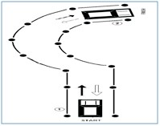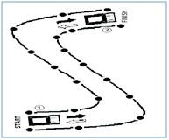

iii) After “L” shape and parallel parking, the applicant shall be

asked to go through the “?” shape test. Time limit for “?” shape will be 03 minutes.

**2**

**1**

iv) After “?” shape test, the applicant shall be asked to go through “S” shape test. Time limit for “S” shape will be 03 minutes.

**2**

**1**

1. Touching any cone, crossing line, exceeding time limit,

adjusting vehicle more than once shall be straight disqualification.

1. “L” shape test and parallel parking test will be for all M.CAR/JEEP/LTV/LTV-PSV applicants.
2. “?” shape test will be only for LTV/LTV-PSV applicants. viii)“S” shape test will be only for LTV-PSV applicants.
3. **USE OF UNFAIR MEANS:**
   1. Use of unfair means will result in straight disqualification. Legal and criminal proceedings will also be initiated against such person.
   2. Use of Influence, threats to use influence or offering bribe will result in disqualification. Legal and criminal proceedings will also be initiated against such person.

[www.nhmp.gov.pk](http://www.nhmp.gov.pk/)

05

**GUIDE FOR PRACTICAL DRIVING TEST PART - I & II**

1. Get start from the start point
2. Drive forward and move to the finish point at point no. 02
3. Drive back in reverse and stop at the start

point at point no. 01

1. Total time allowed is 03 min
2. Touching any cone or exceeding time limit will be straight disqualification
3. Get start from the start point
4. Drive forward and move to the finish point at point No. 02
5. Drive back in reverse and stop at the start point

at point No. 01

1. Total time allowed is 03 min
2. Touching any cone or exceeding time limit will be straight disqualification



|  |  |  |
| --- | --- | --- |
|  | | |
|  | **GUIDE FOR PRACTICAL DRIVING TEST PART - I & II** |  |
| **PROCEDURE FOR PRACTICAL DRIVING TEST PART-II**  The applicant having passed practical driving test part-I can appear for practical driving test-II on the same day or as directed by the examiner. The applicant should bring the following documents while appearing for practical driving test part-II:   * Valid Original CNIC * Learner permit original * Test Result Part-I * Prescribed Copy of Highway Code   The applicant can use his/her own vehicle for undergoing practical driving tests.  Practical driving test-II shall consist of following steps;   1. **COCKPIT DRILL:**   After sitting in the vehicle, the applicant should follow the cockpit drill procedure before starting the vehicle. The following steps are required from the applicant during the cockpit drill;   * 1. The applicant must make sure that all the doors are closed properly. If any of the door is open or half closed, the applicant should close it properly.   2. The applicant should adjust the seat as per his/her convenience.   3. After seat adjustment, the applicant should adjust steering according to his/her seat.   4. The applicant should adjust side mirrors as well as back view mirror of the vehicle according to his/her seat position.   5. The applicant should wear seat belt after seat and mirrors adjustment.   6. Before starting of vehicle, the applicant should make sure that the hand brake is working/applied properly.  1. **VEHICLE CONTROL:**    1. Prior to starting, the applicant should make sure that the gear is in neutral position.    2. Clutch should be pressed and checked properly before switching on the ignition switch.   06 [www.nhmp.gov.pk](http://www.nhmp.gov.pk/) | | |



|  |  |  |
| --- | --- | --- |
|  | | |
|  | **GUIDE FOR PRACTICAL DRIVING TEST PART - I & II** |  |
| 1. Use of accelerator should be appropriate. 2. After starting, the applicant should press the clutch, apply first gear, push down hand brake and release clutch gently to move the vehicle. 3. The applicant's both hands should be on the steering either in 10 and 2 or 9 and 3 position.     **9 and 3 10 and 2**   1. The applicant should not look down to the clutch or the gear while shifting/changing gear. 2. **MOVING:**    1. The applicant should move the vehicle in a safe manner and without creating any hazard for others.    2. Moving of vehicle should be smooth and without any jerks or switching off the engine. 3. **LANE DISCIPLINE:**    1. The applicant should use appropriate lane of the road. For instance, if he/she intends to turn left, the vehicle should be in left lane of the road and vice versa.    2. Speed should be according to usage of lane. For instance, while moving in the middle lane speed should not be too slow to obstruct traffic.    3. Driving with tyres in two lanes must be avoided except in case when the driver is changing lane after giving indicator.    4. The change of lane should not be abrupt and should be done after giving indicator and ensuring, through use of side/back mirrors, that it is safe to change the lane. 4. **OVERTAKING:**    1. Before overtaking, the applicant should observe traffic by using   [www.nhmp.gov.pk](http://www.nhmp.gov.pk/) 07 | | |



|  |  |  |
| --- | --- | --- |
|  | | |
|  | **GUIDE FOR PRACTICAL DRIVING TEST PART - I & II** |  |
| side mirrors as well as back view mirror.   1. The driver should ensure, by using side/back mirrors, that right hand lane is clear and there is no fast approaching vehicle from rear. The applicant should use right side indicator before changing lane. 2. After lane is changed, the indicator should be switched off. 3. Speed should be adequate to cross/overtake the vehicles on left side. 4. Over speeding is not allowed while overtaking. 5. After completely crossing the vehicle, the applicant should observe blind spot on left side by turning shoulders a bit to the left side. 6. If clear, left side indicator should be switched on and lane should be changed back in a safe and smooth manner. No abrupt or sharp cutting is allowed. 7. After lane change, the indicator must be switched off. 8. Overtaking from the wrong side or dangerous overtaking will result in straight disqualification. 9. **USE OF INDICATORS:**    1. The applicant should use indicators as per road/traffic situation. For lane change, road joining, entering/exiting roundabout, taking U-turn, or during turning etc, relevant indicators must be used.    2. Indicators must be used properly and timed in a manner so that the approaching traffic can judge intentions of the applicant.    3. The non-use of indicators where required would result in straight disqualification. 10. **RIGHT OF WAY:**   The applicant should strictly follow the rule for right of way. Following things about right of way should be kept in mind:   * 1. While joining roads, the vehicles already on the main road have the right of way.   2. At junctions, either the first approaching vehicle or vehicle on the right side has the right of way.   3. At round-about, the vehicles already in the round about or   08 [www.nhmp.gov.pk](http://www.nhmp.gov.pk/) | | |



|  |  |  |
| --- | --- | --- |
|  | | |
|  | **GUIDE FOR PRACTICAL DRIVING TEST PART - I & II** |  |
| vehicles on the right hand have the right of way.   1. At pedestrian/zebra crossing, the applicant must reduce speed and carefully observe the pedestrians. In case of approaching pedestrians, the vehicle must be stopped and wait until the pedestrians have crossed the road completely. 2. Violating the right of way will be straight away disqualification. 3. **ANALYZING DANGER:**   The applicant should be vigilant to analyze danger while driving;   * 1. In case of any hazard/accident etc. or poor road conditions the applicant should observe/analyze and reduce speed accordingly.   2. In case of any blockage or diversion on road, the applicant should be capable to analyze well in time and drive in a safe manner according to the situation.   3. Parked vehicles must be watched while taking turn, changing lane or joining roads.   4. At sharp turns, the applicant must reduce speed and should be more careful.   5. While driving the applicant should watch speed breakers/rumbles carefully and reduce speed accordingly.  1. **OBSERVING TRAFFIC SIGNS:**    1. The applicant should observe and obey all traffic signs e.g. speed limit, school, hospital etc.    2. The applicant should follow all traffic signals as breaking/violating any traffic signal will be straight disqualification.    3. The applicant should observe and obey all the traffic controllers. Violating any traffic controller will be straight disqualification.    4. The applicant should follow road markings accordingly. For example, if road markings indicate left turn for left lane traffic and straight for middle lane traffic, the applicant should follow accordingly.    5. The applicant should respect and show courtesy towards other road users. The applicant should take care of the rights of other road users.   [www.nhmp.gov.pk](http://www.nhmp.gov.pk/) 09 | | |



|  |  |  |
| --- | --- | --- |
|  | | |
|  | **GUIDE FOR PRACTICAL DRIVING TEST PART - I & II** |  |
| 1. **JUNCTIONS:**    1. The applicant must reduce speed before approaching a junction.    2. Traffic should be observed. Relevant lane of road should be used on approaching a junction.    3. The applicant must be vigilant while taking turn right/left and should observe traffic carefully.    4. The applicant should use indicators and use proper lane before taking turn.    5. Violating traffic rules or taking wrong/dangerous turn will be straight disqualification. 2. **EMERGENCY STOP:**    1. The applicant should be alert in case of emergency stop.    2. The applicant must have full control over vehicle in case of emergency stop.    3. In case of emergency stop the applicant should apply brakes wisely and according to the situation, keeping control over the vehicle.    4. Losing control over vehicle will be straight disqualification. 3. **ATTITUDE TOWARDS OTHER ROAD USERS:**    1. The applicant shall be courteous towards other road users.    2. The applicant should ignore mistakes of other road users and take care of their rights. 4. **SAFE DISTANCE FROM OTHER VEHICLES:**    1. The applicant should keep safe distance from other vehicles.    2. In normal weather conditions minimum safe distance will be a 03 seconds time gap while in adverse conditions minimum safe distance time gap will be 05 seconds. 5. **USE OF UNFAIR MEANS:**   Use of unfair means, influences, threatens to use influence or offering bribe will result in straight-away disqualification. Legal and criminal proceedings will also be initiated against such person.  10 [www.nhmp.gov.pk](http://www.nhmp.gov.pk/) | | |

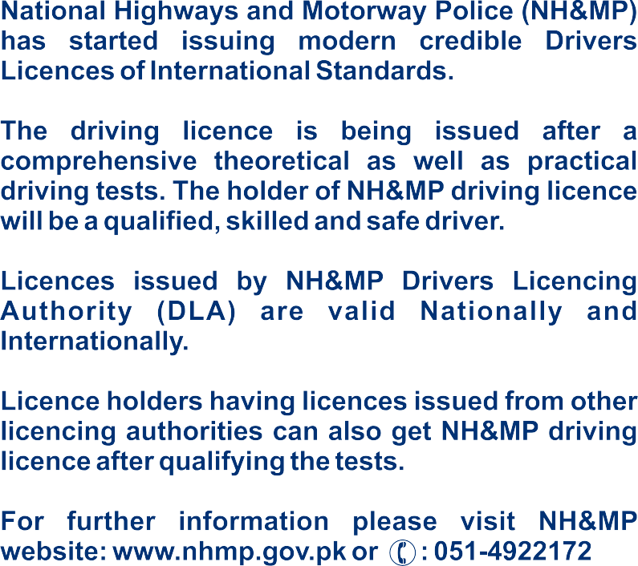

**Saudi Arabia Traffic Rules**

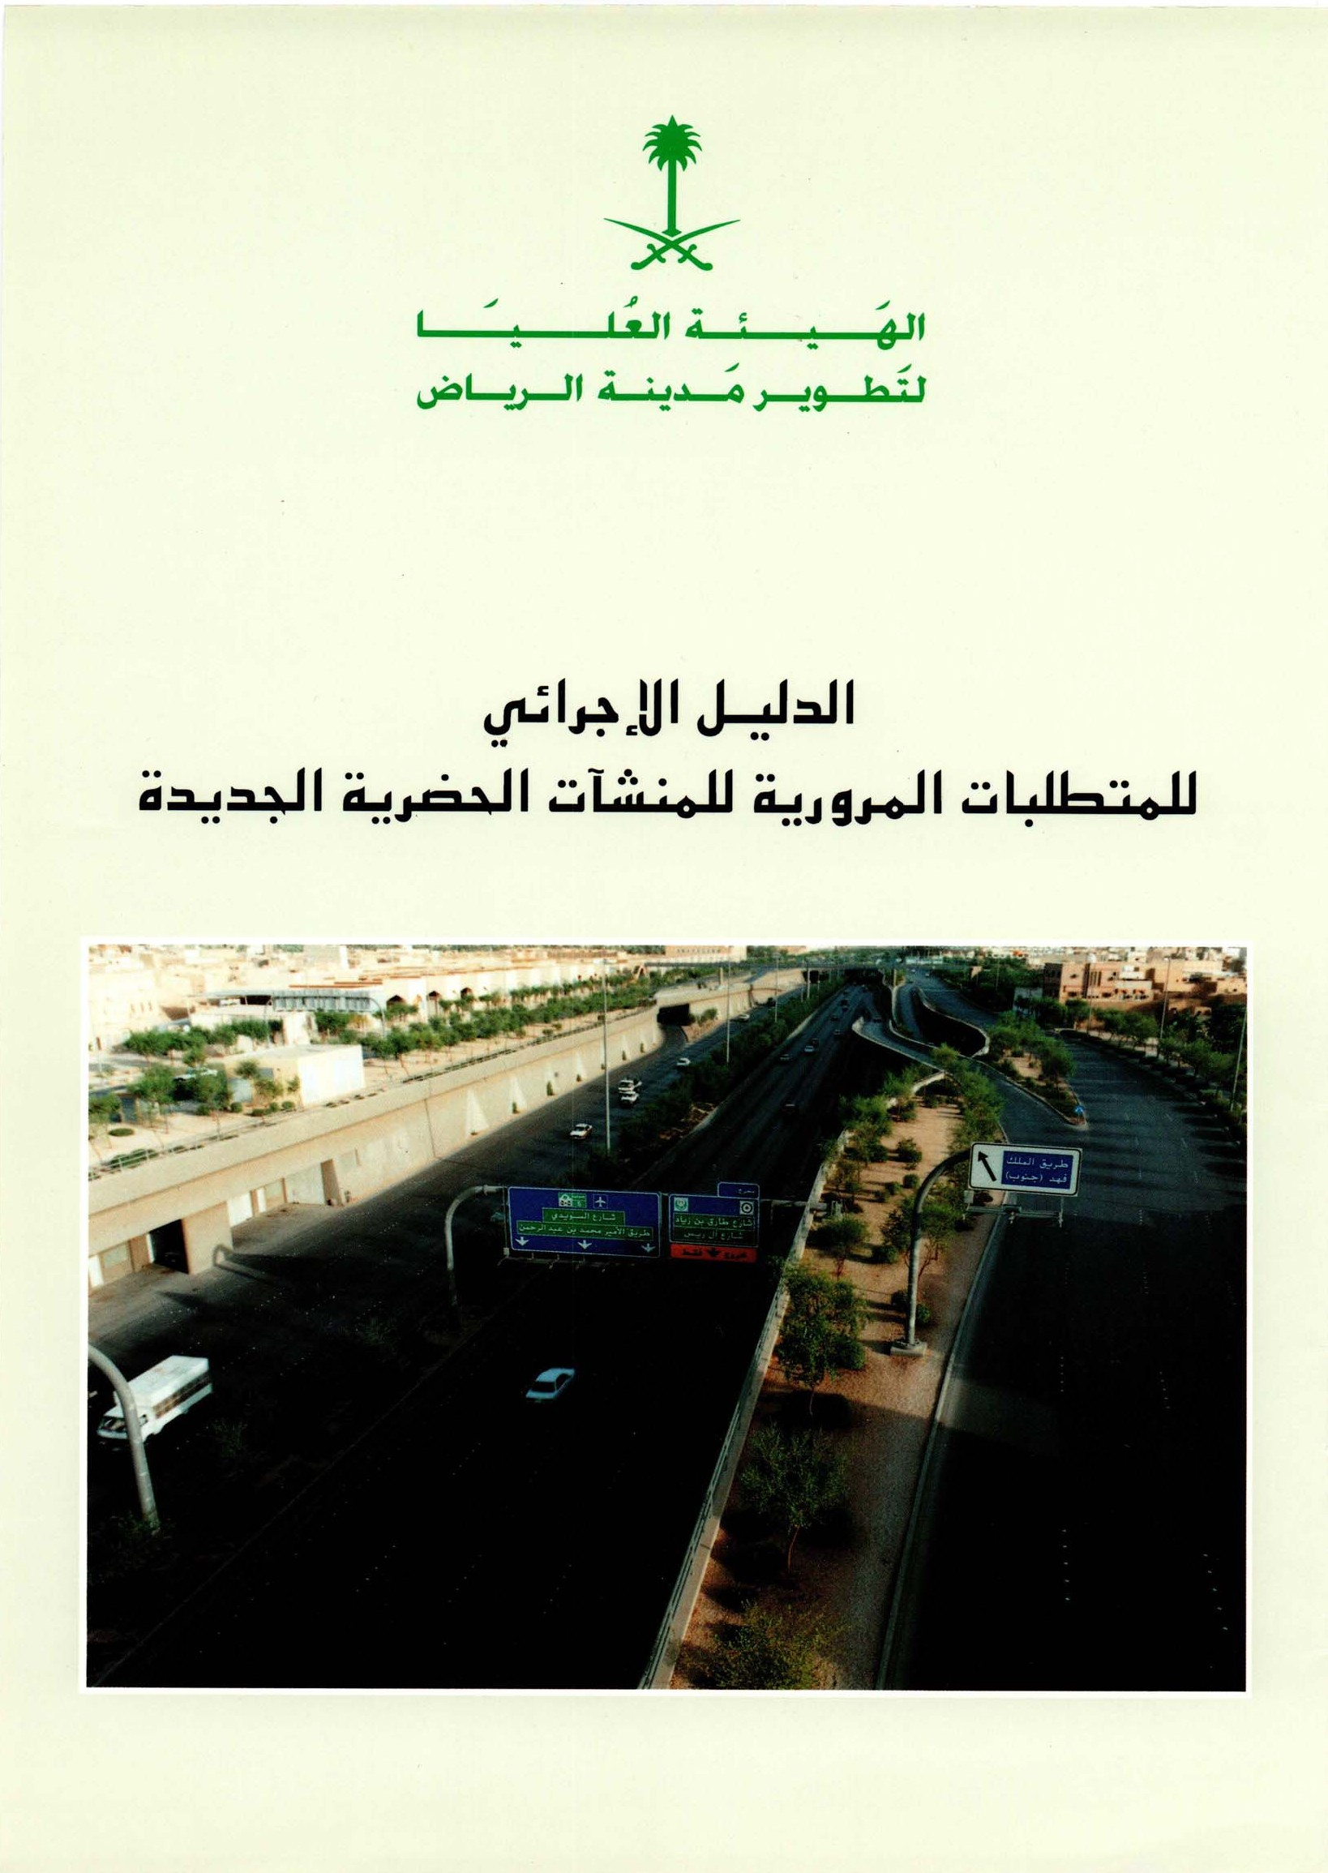

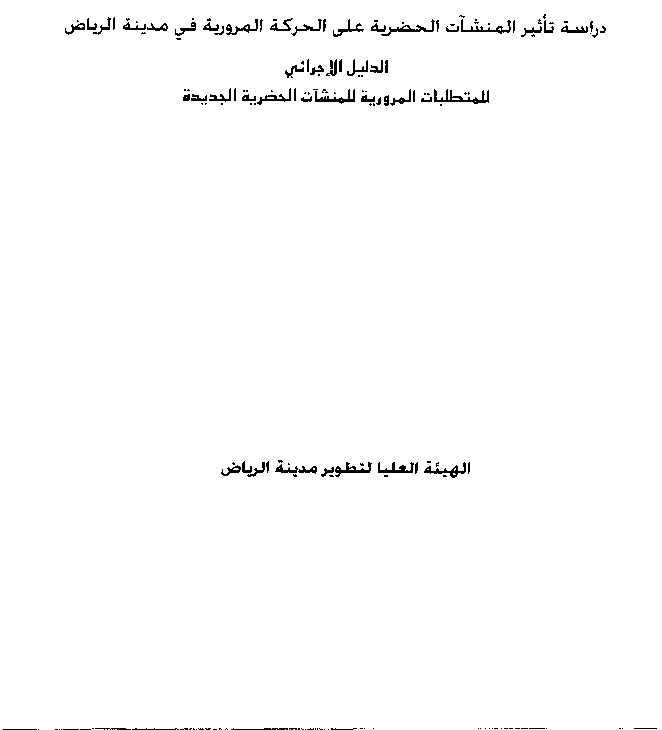

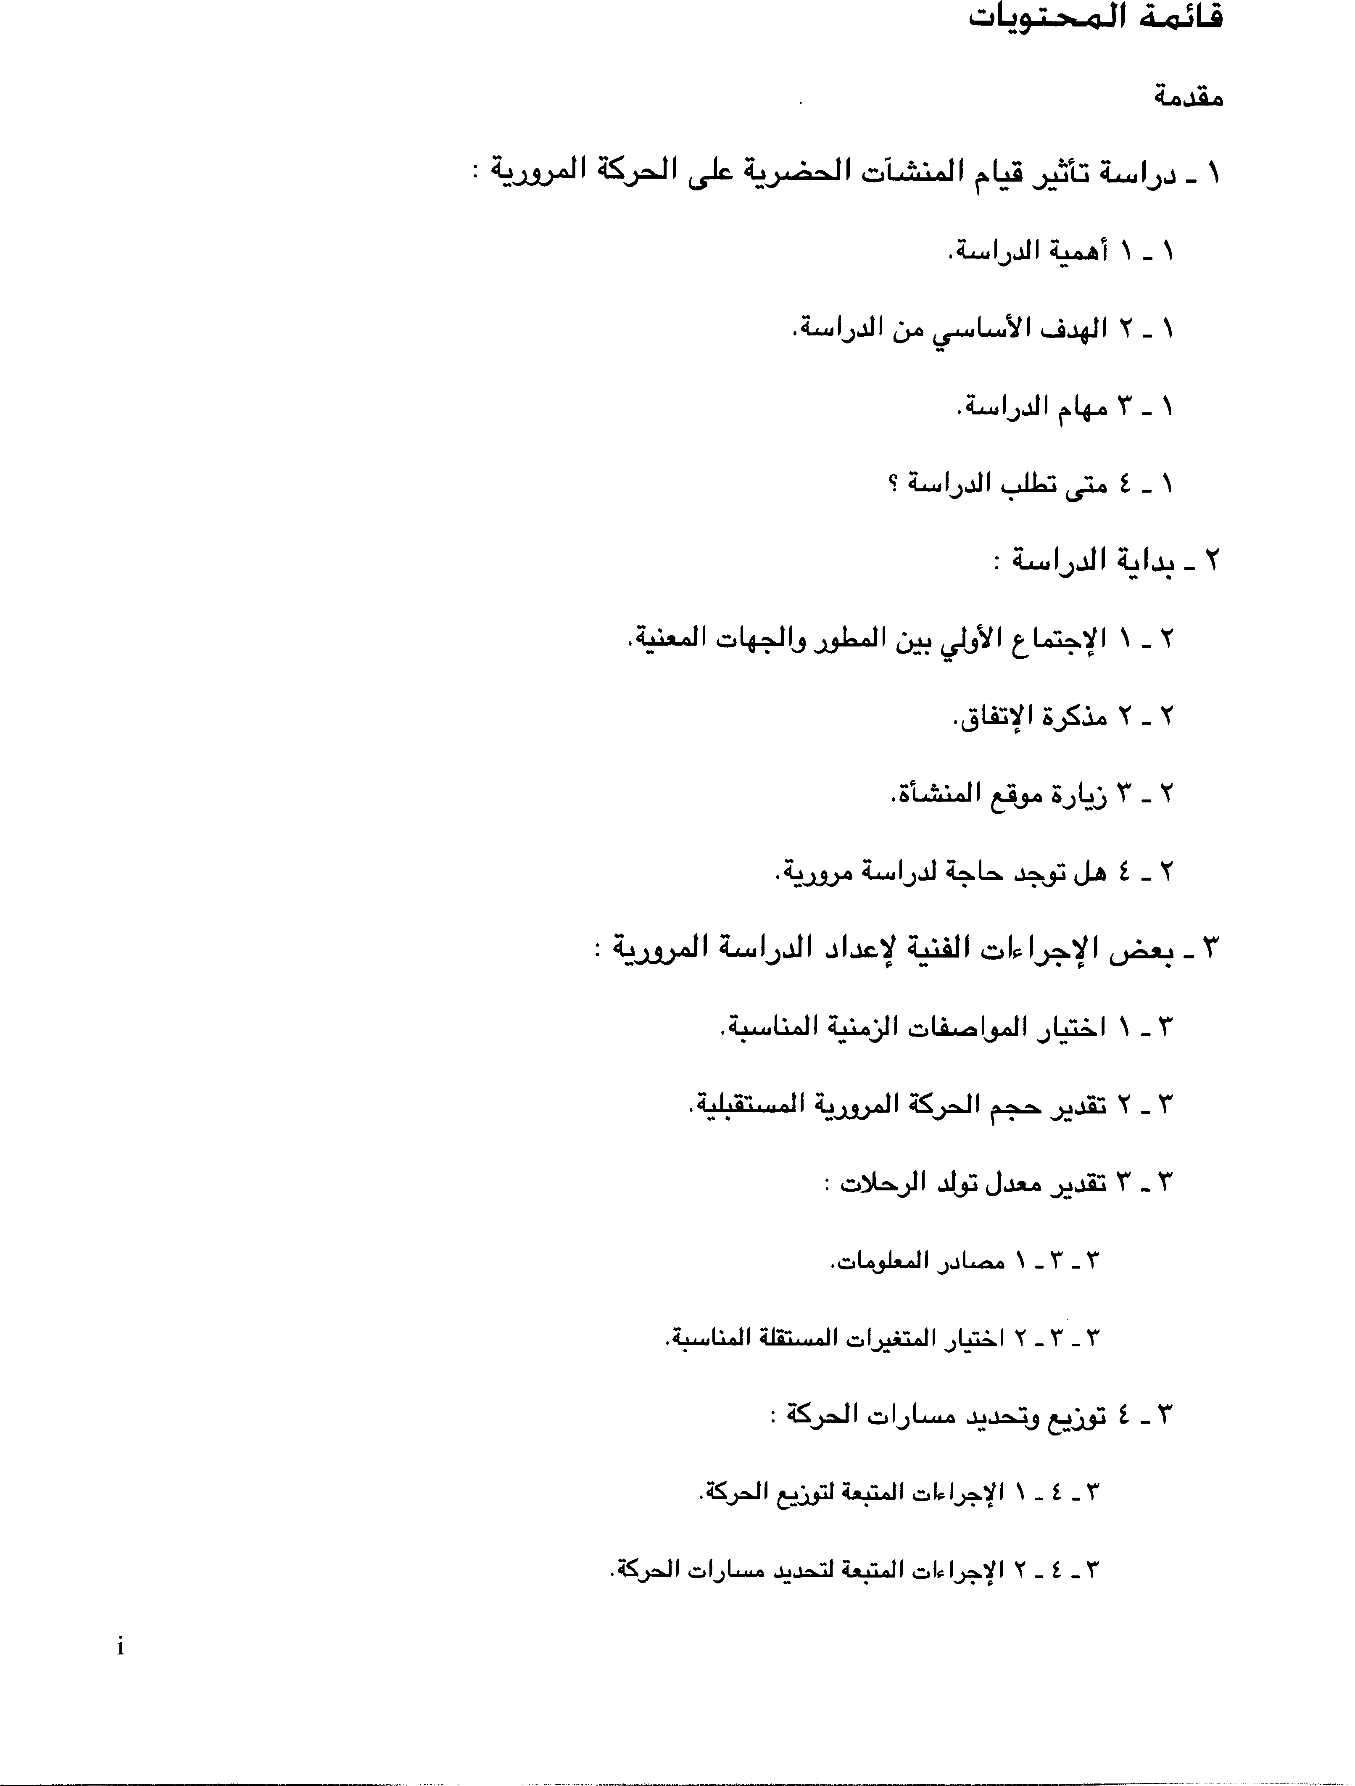

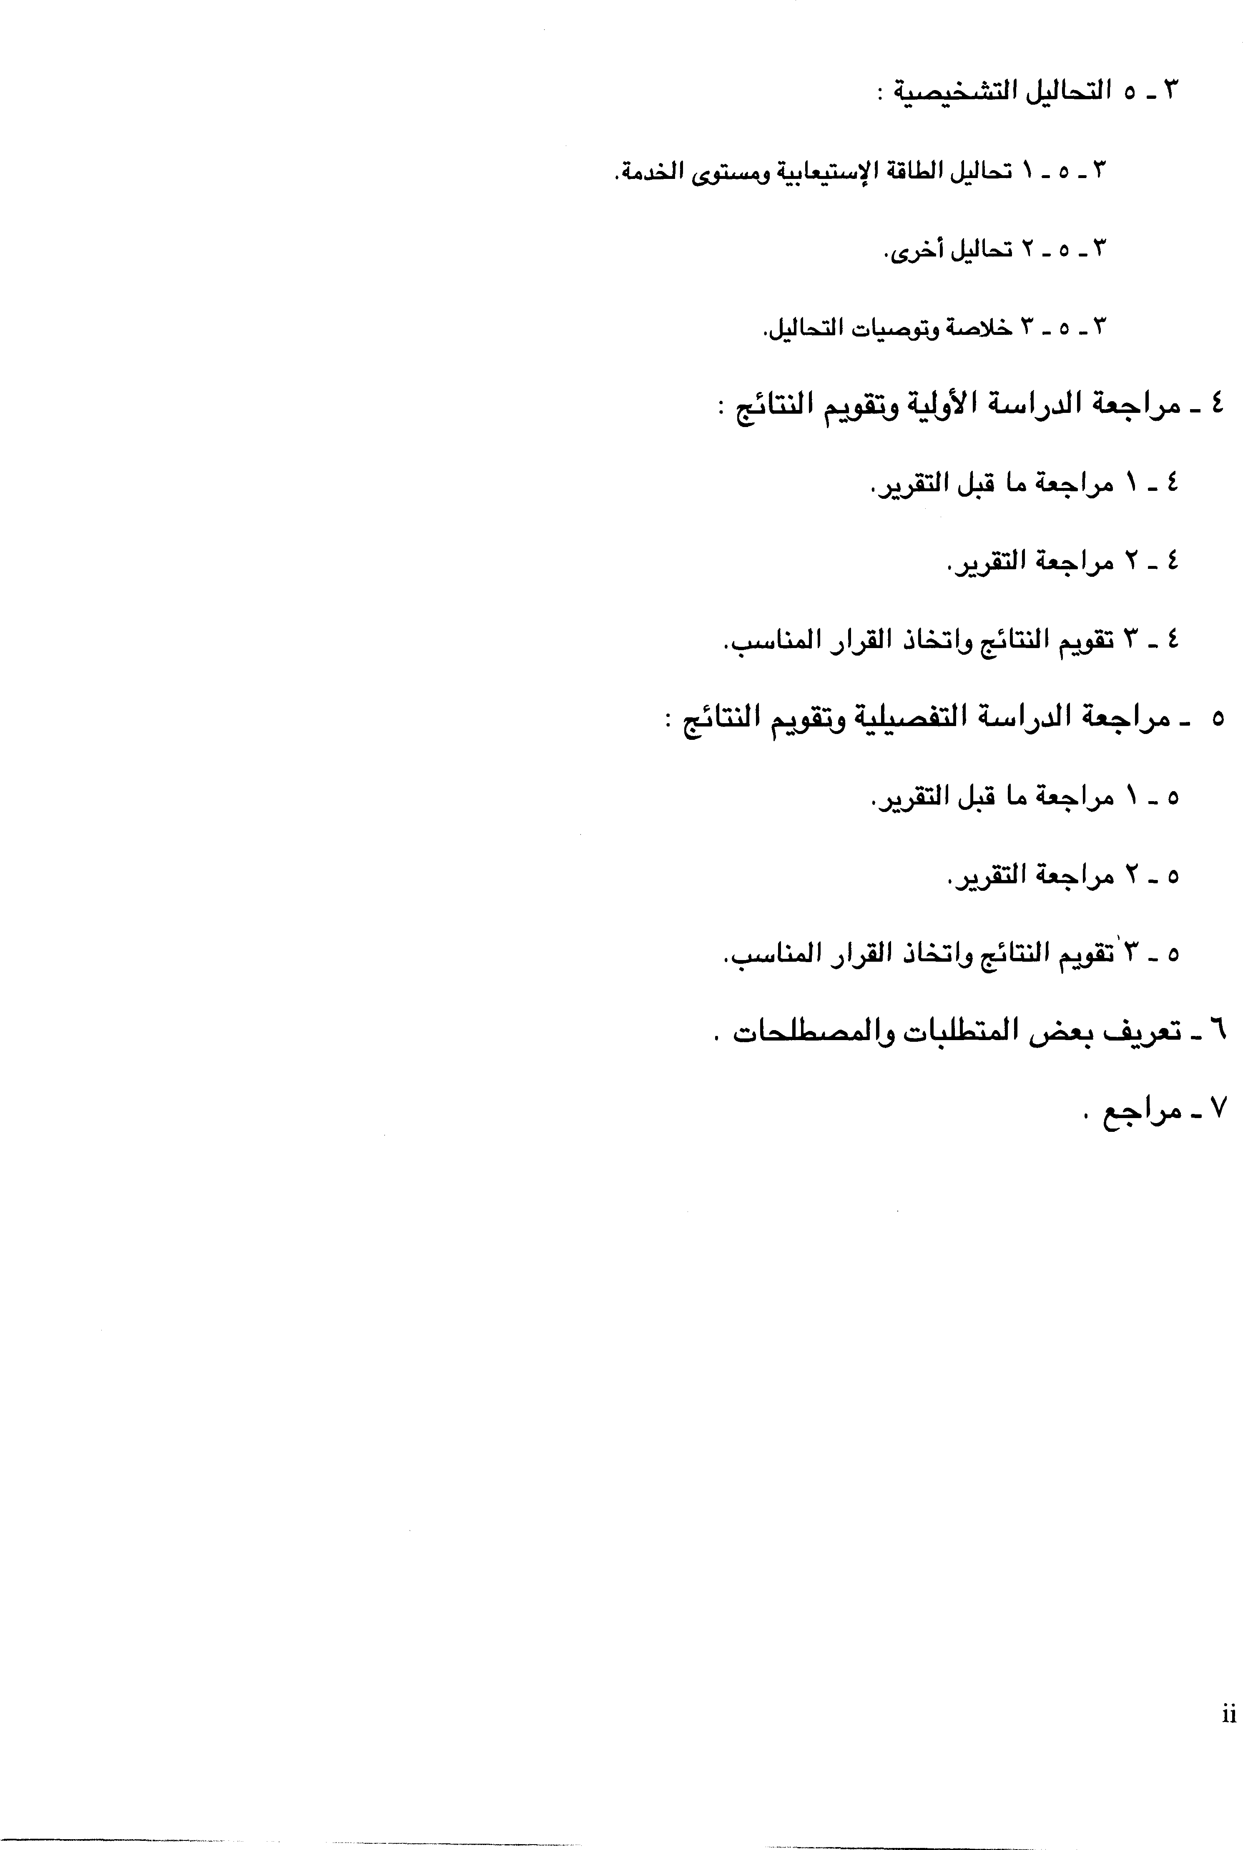

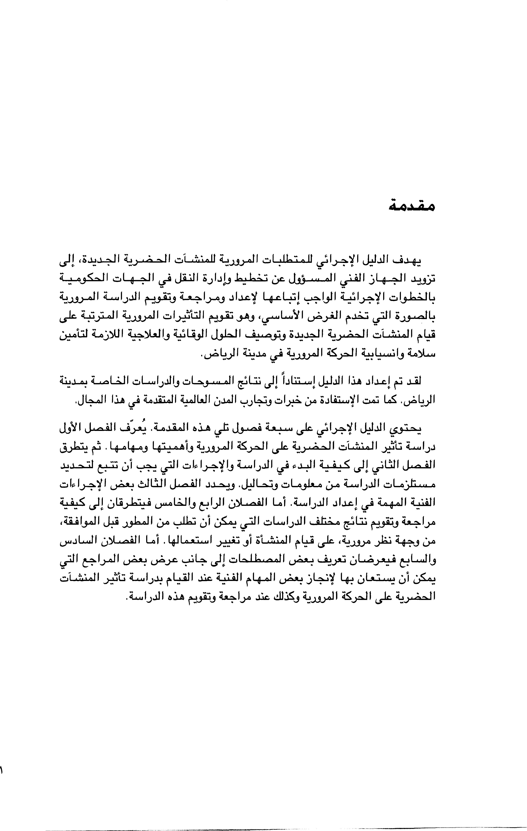

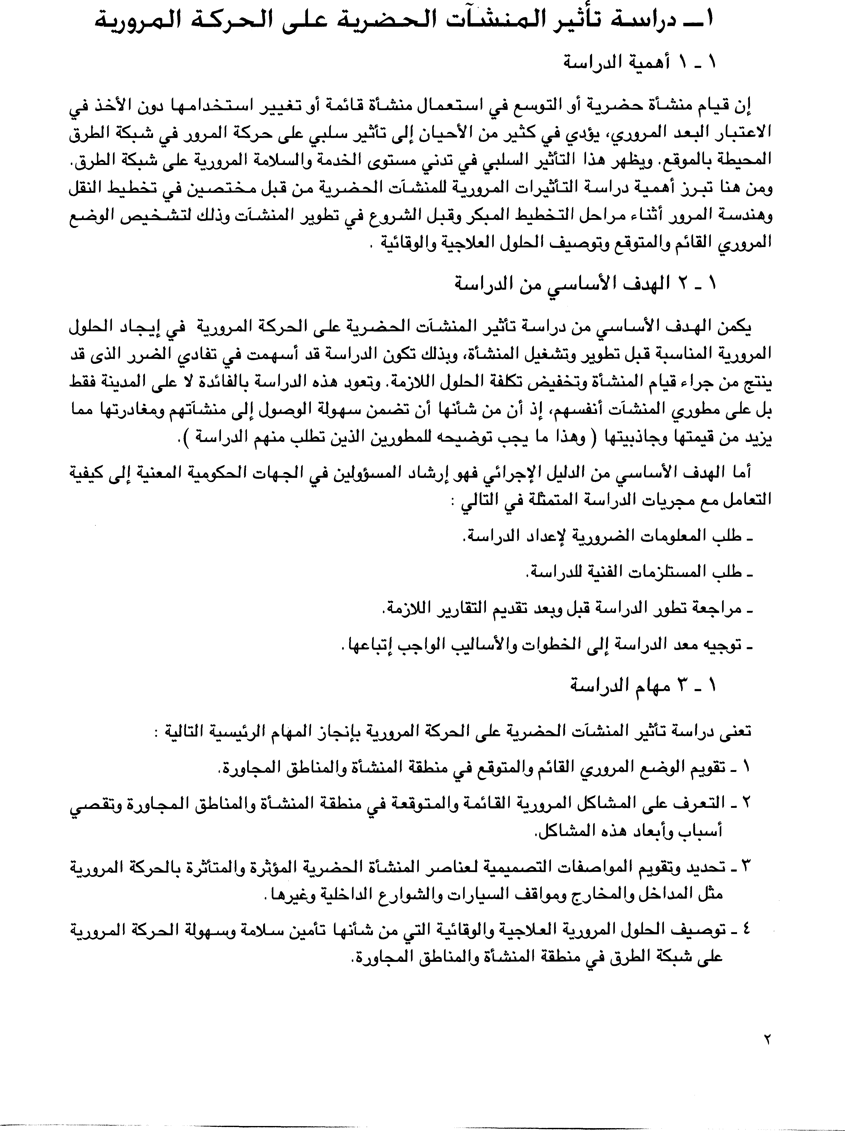

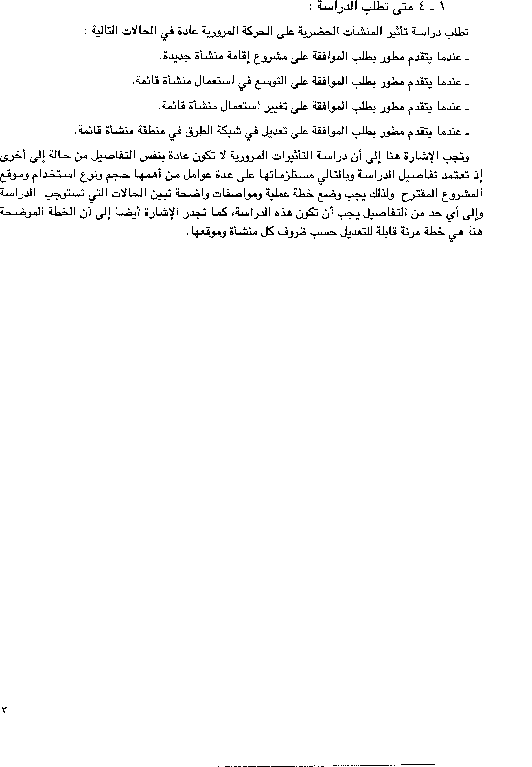

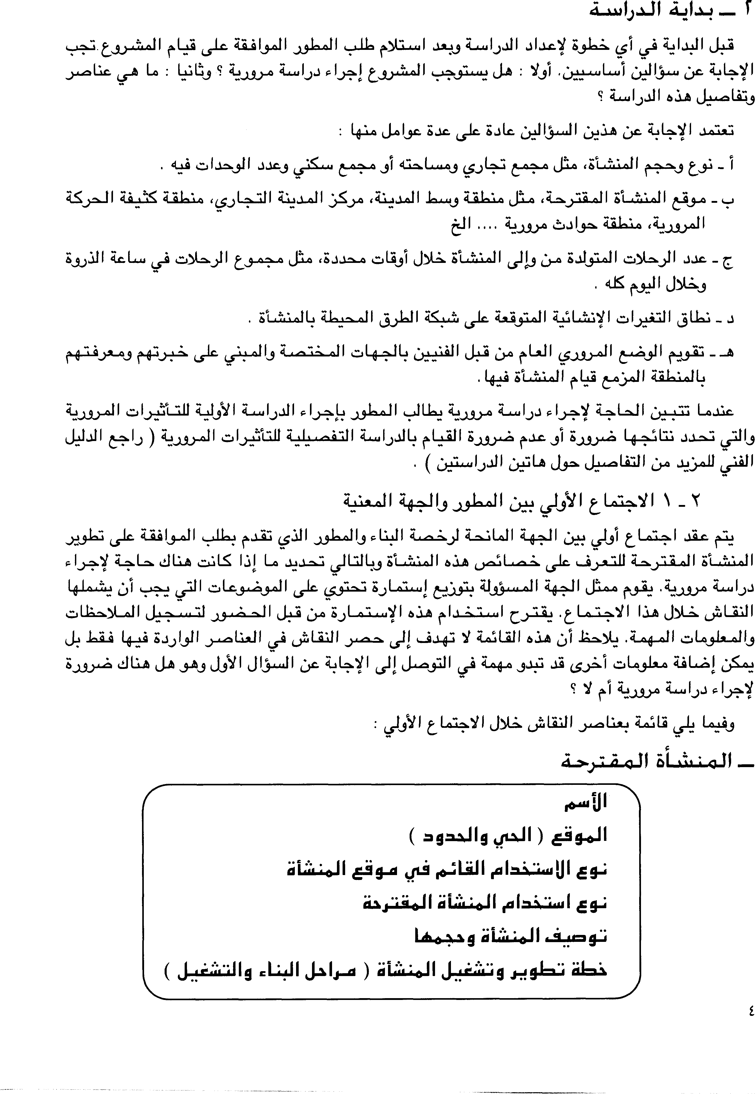

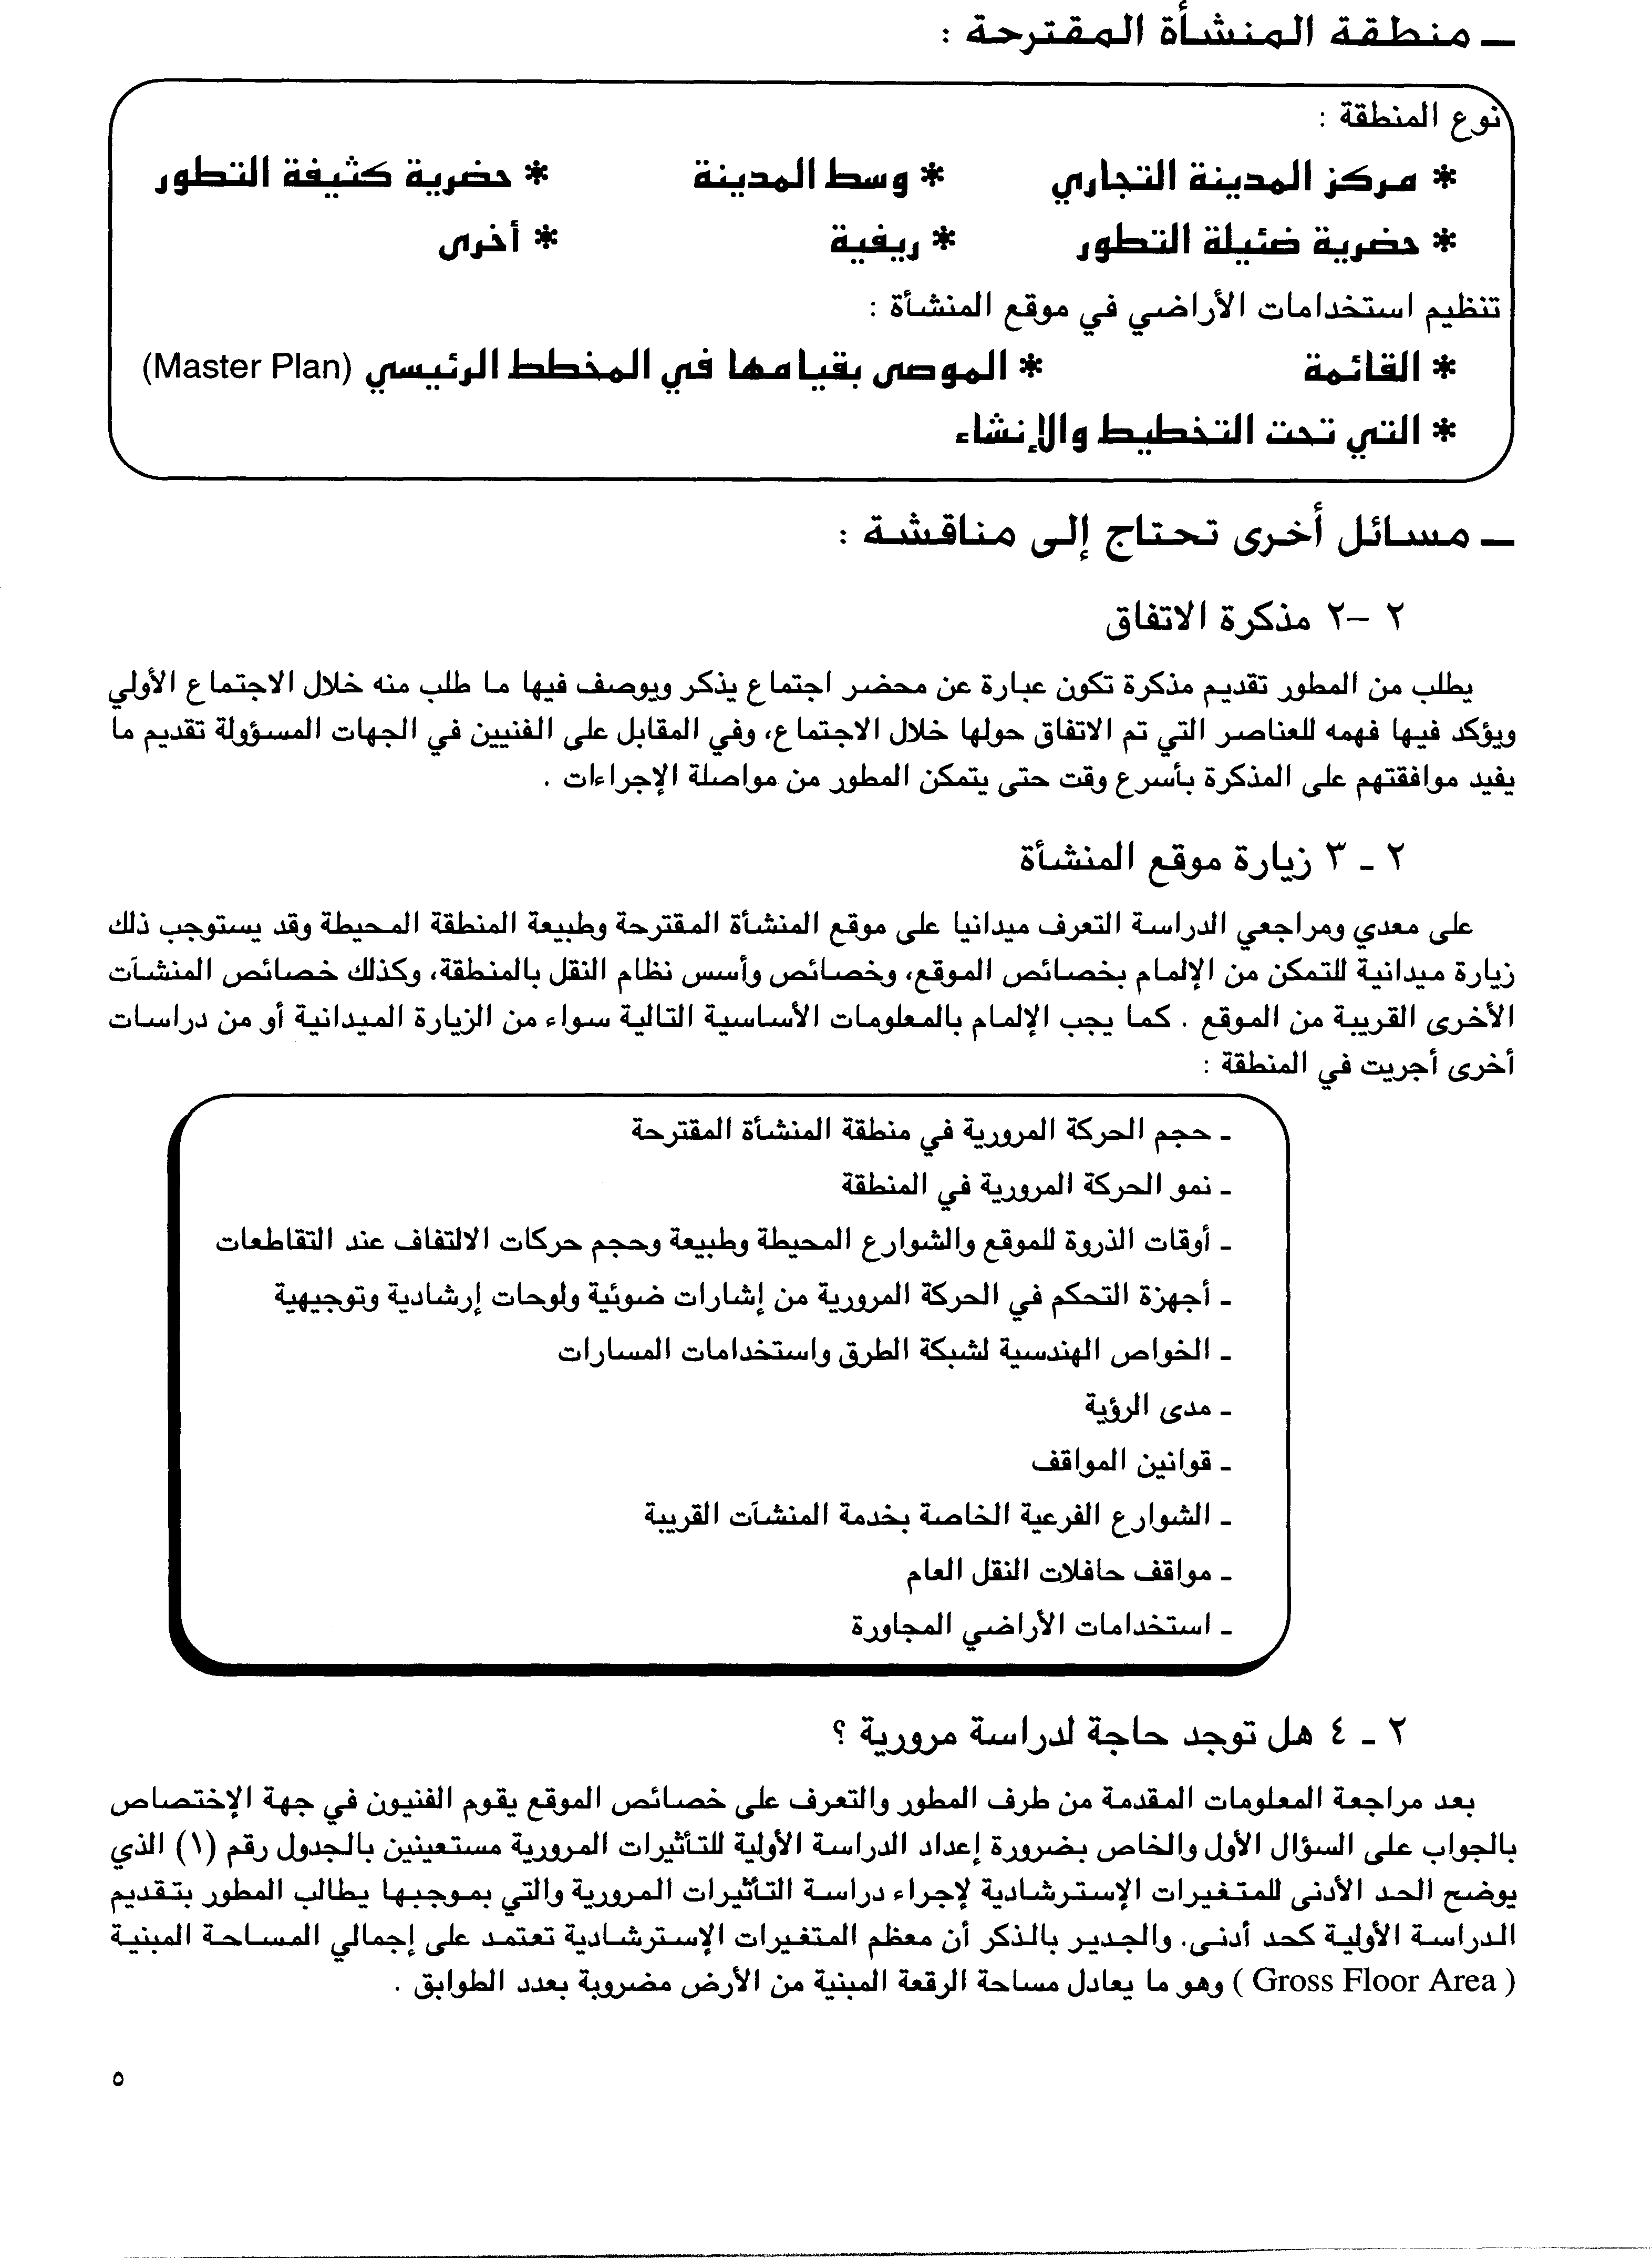

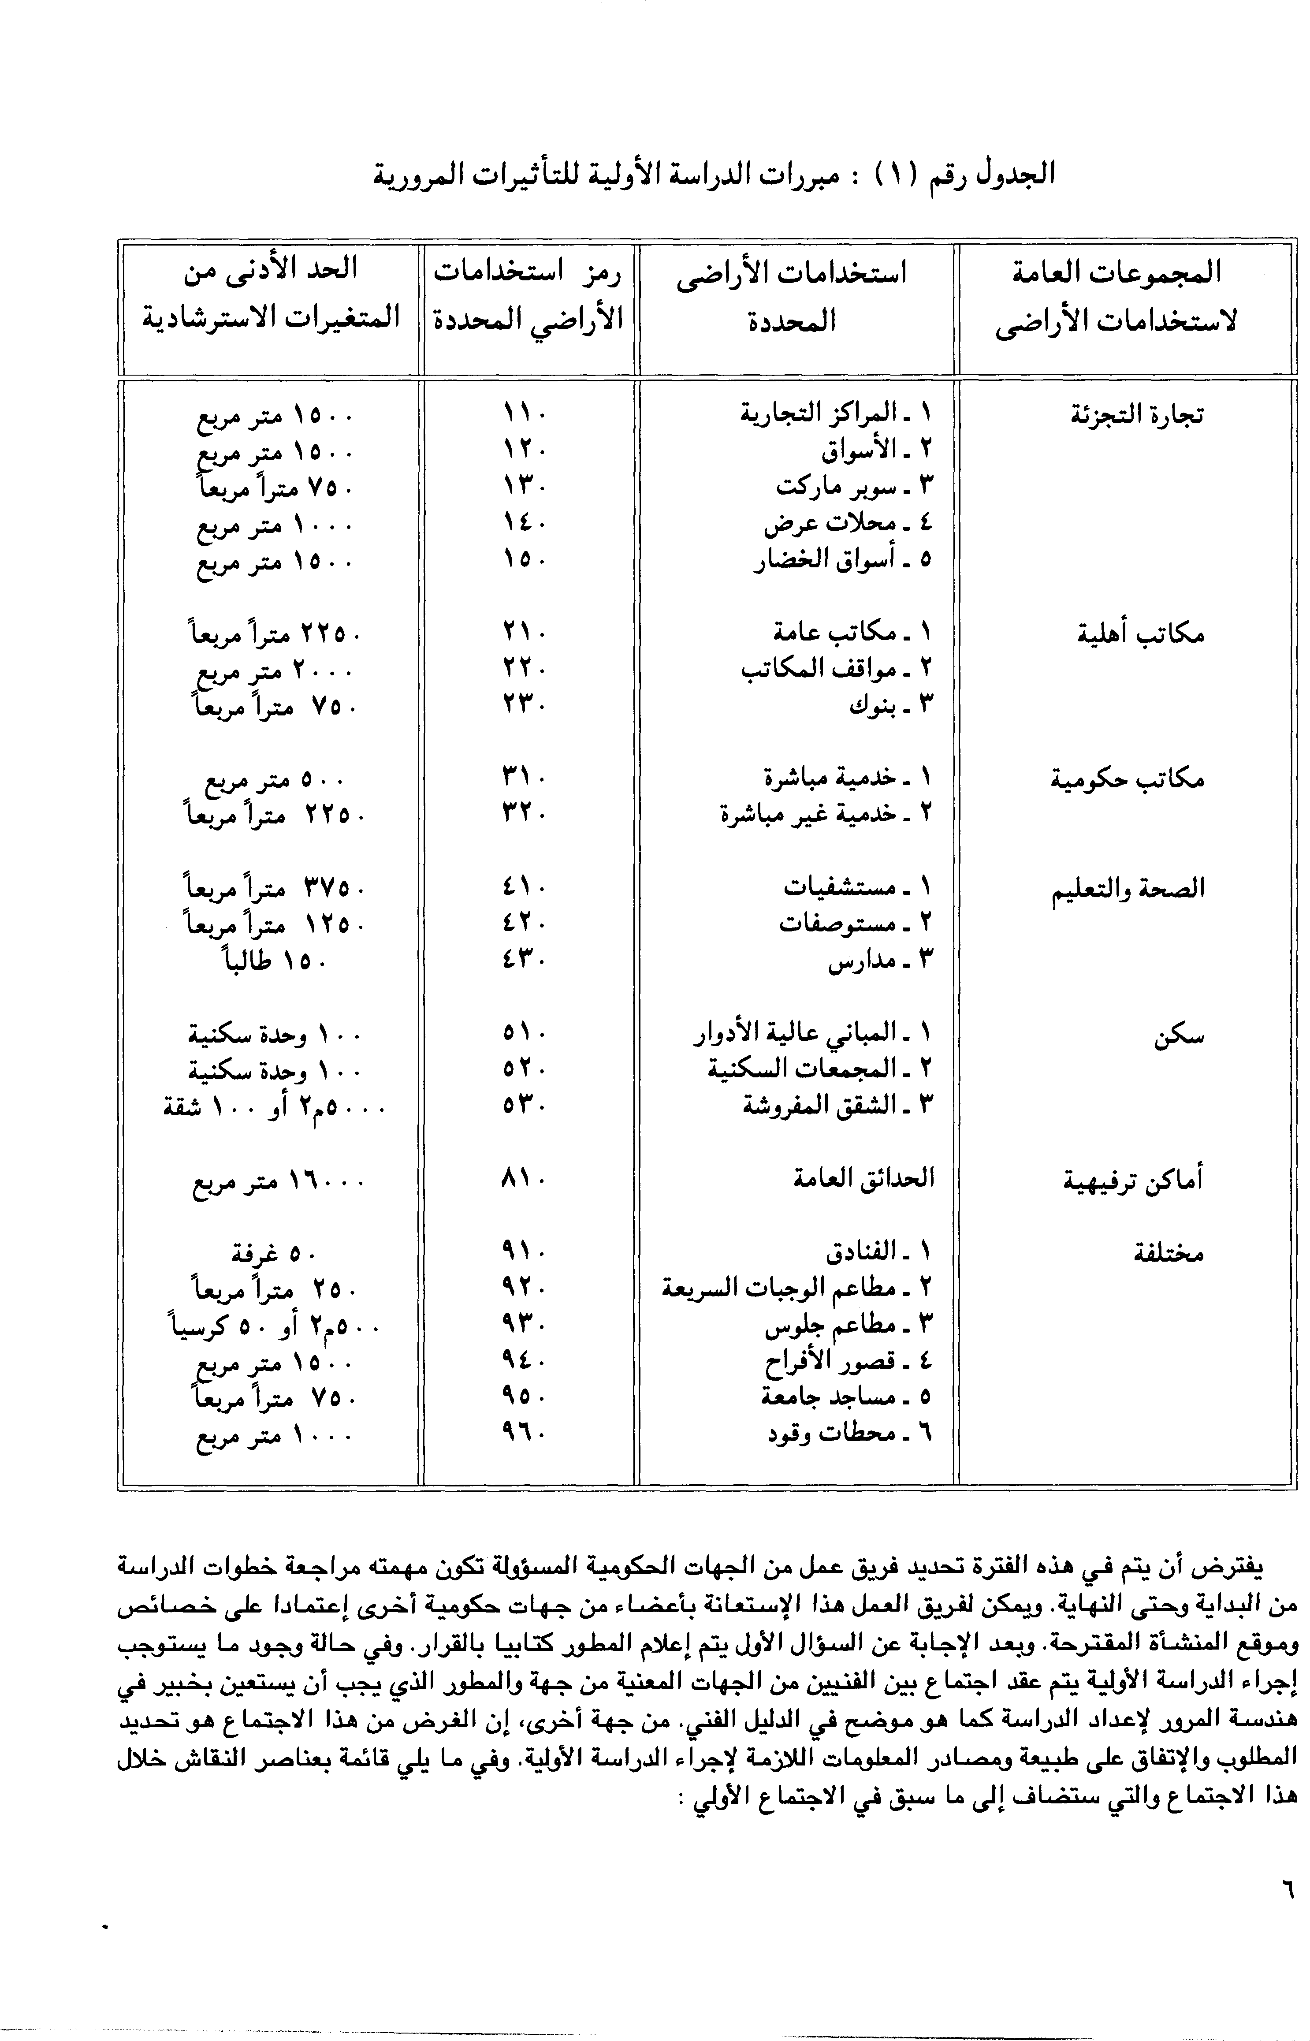

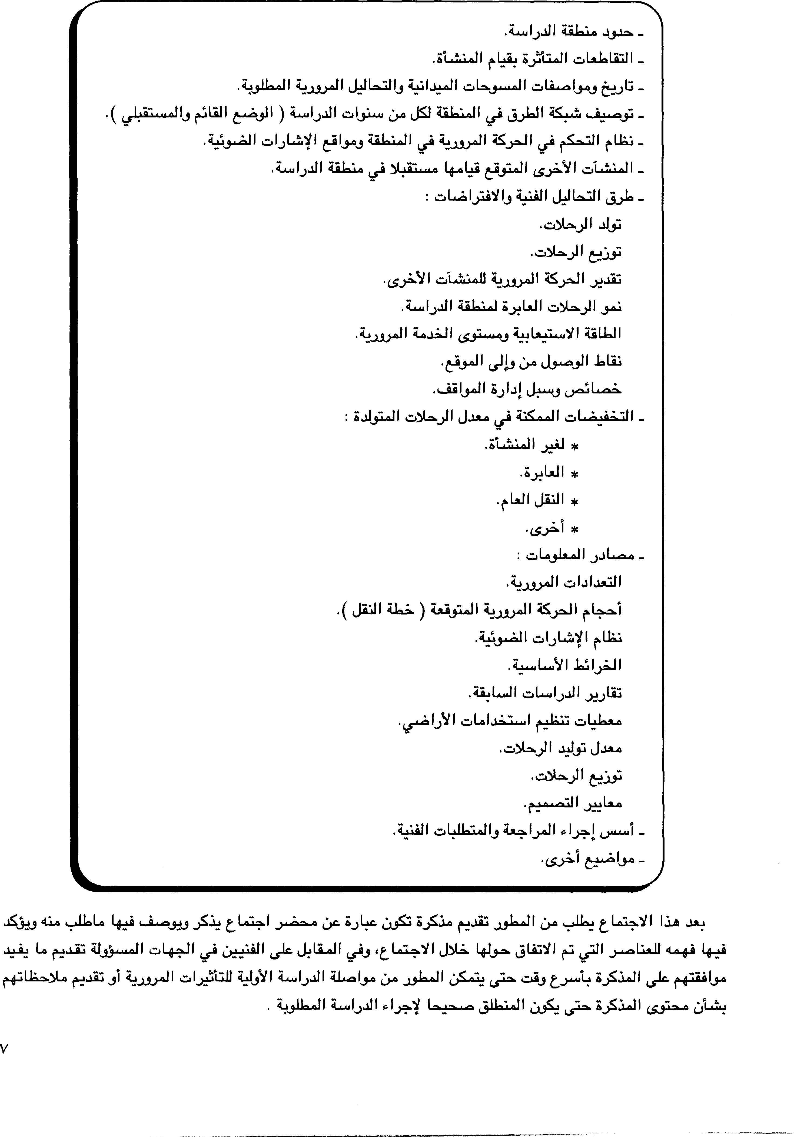

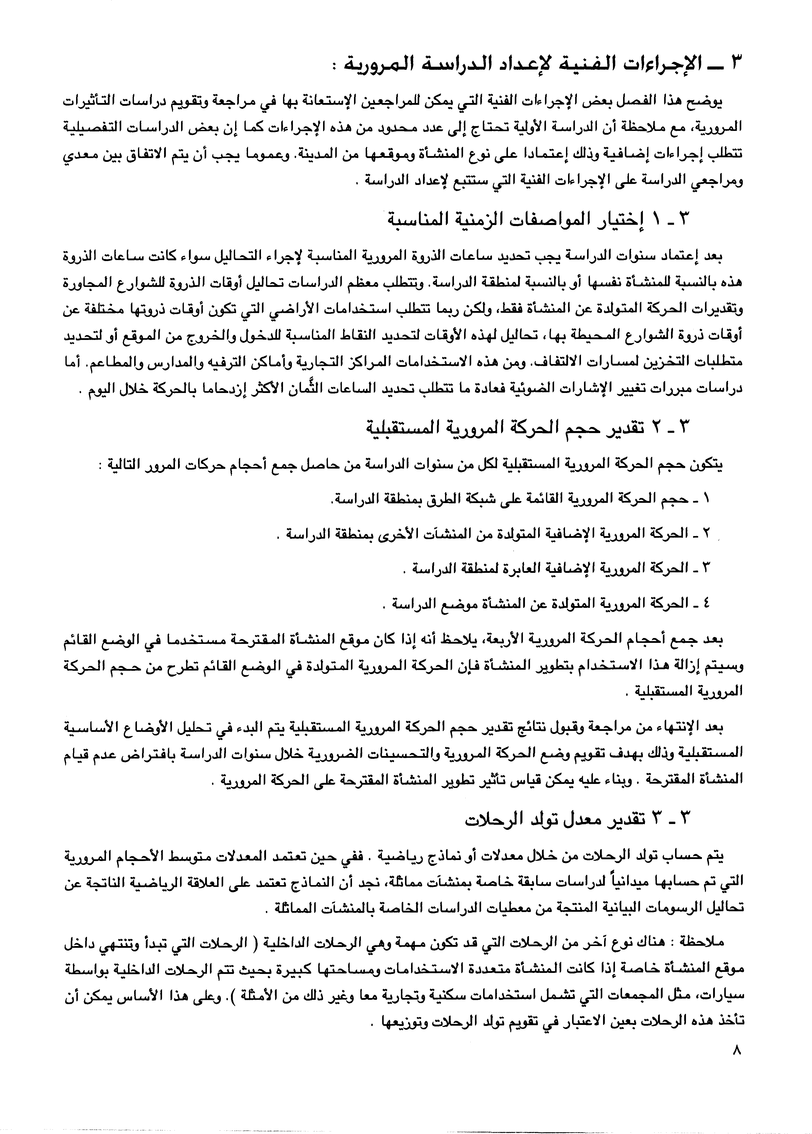

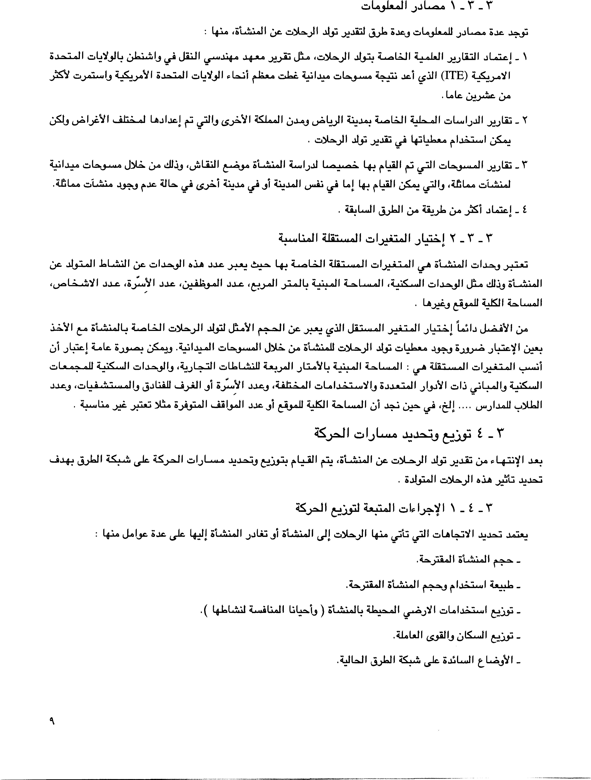

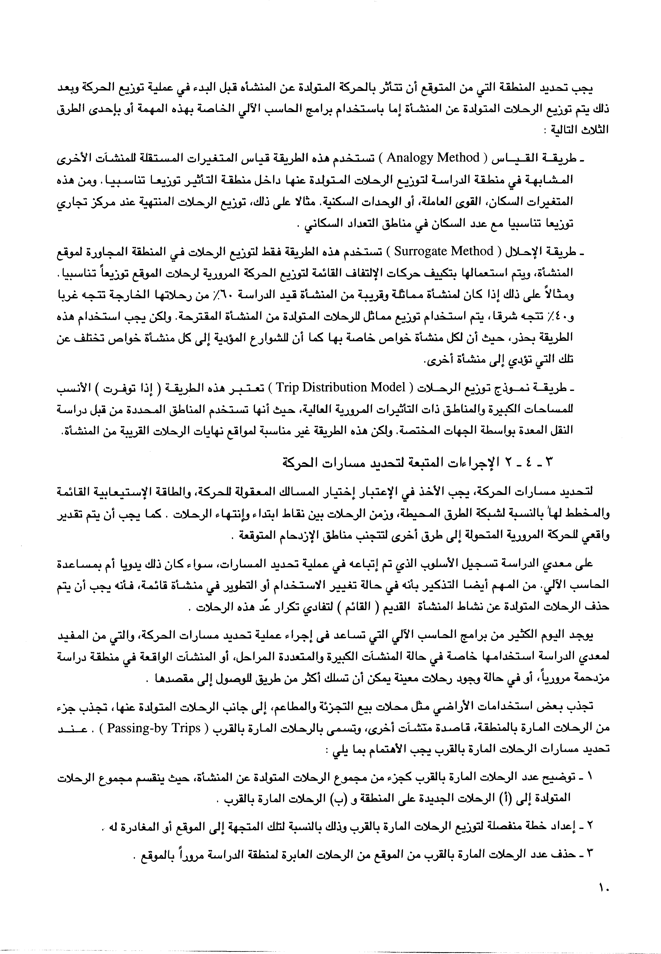

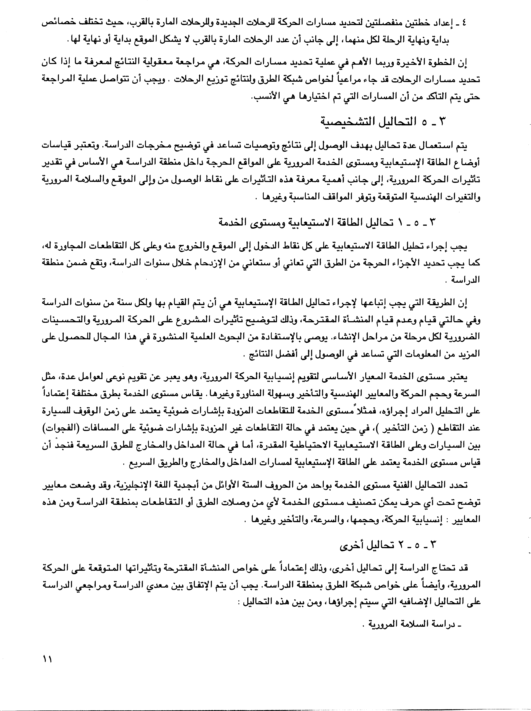

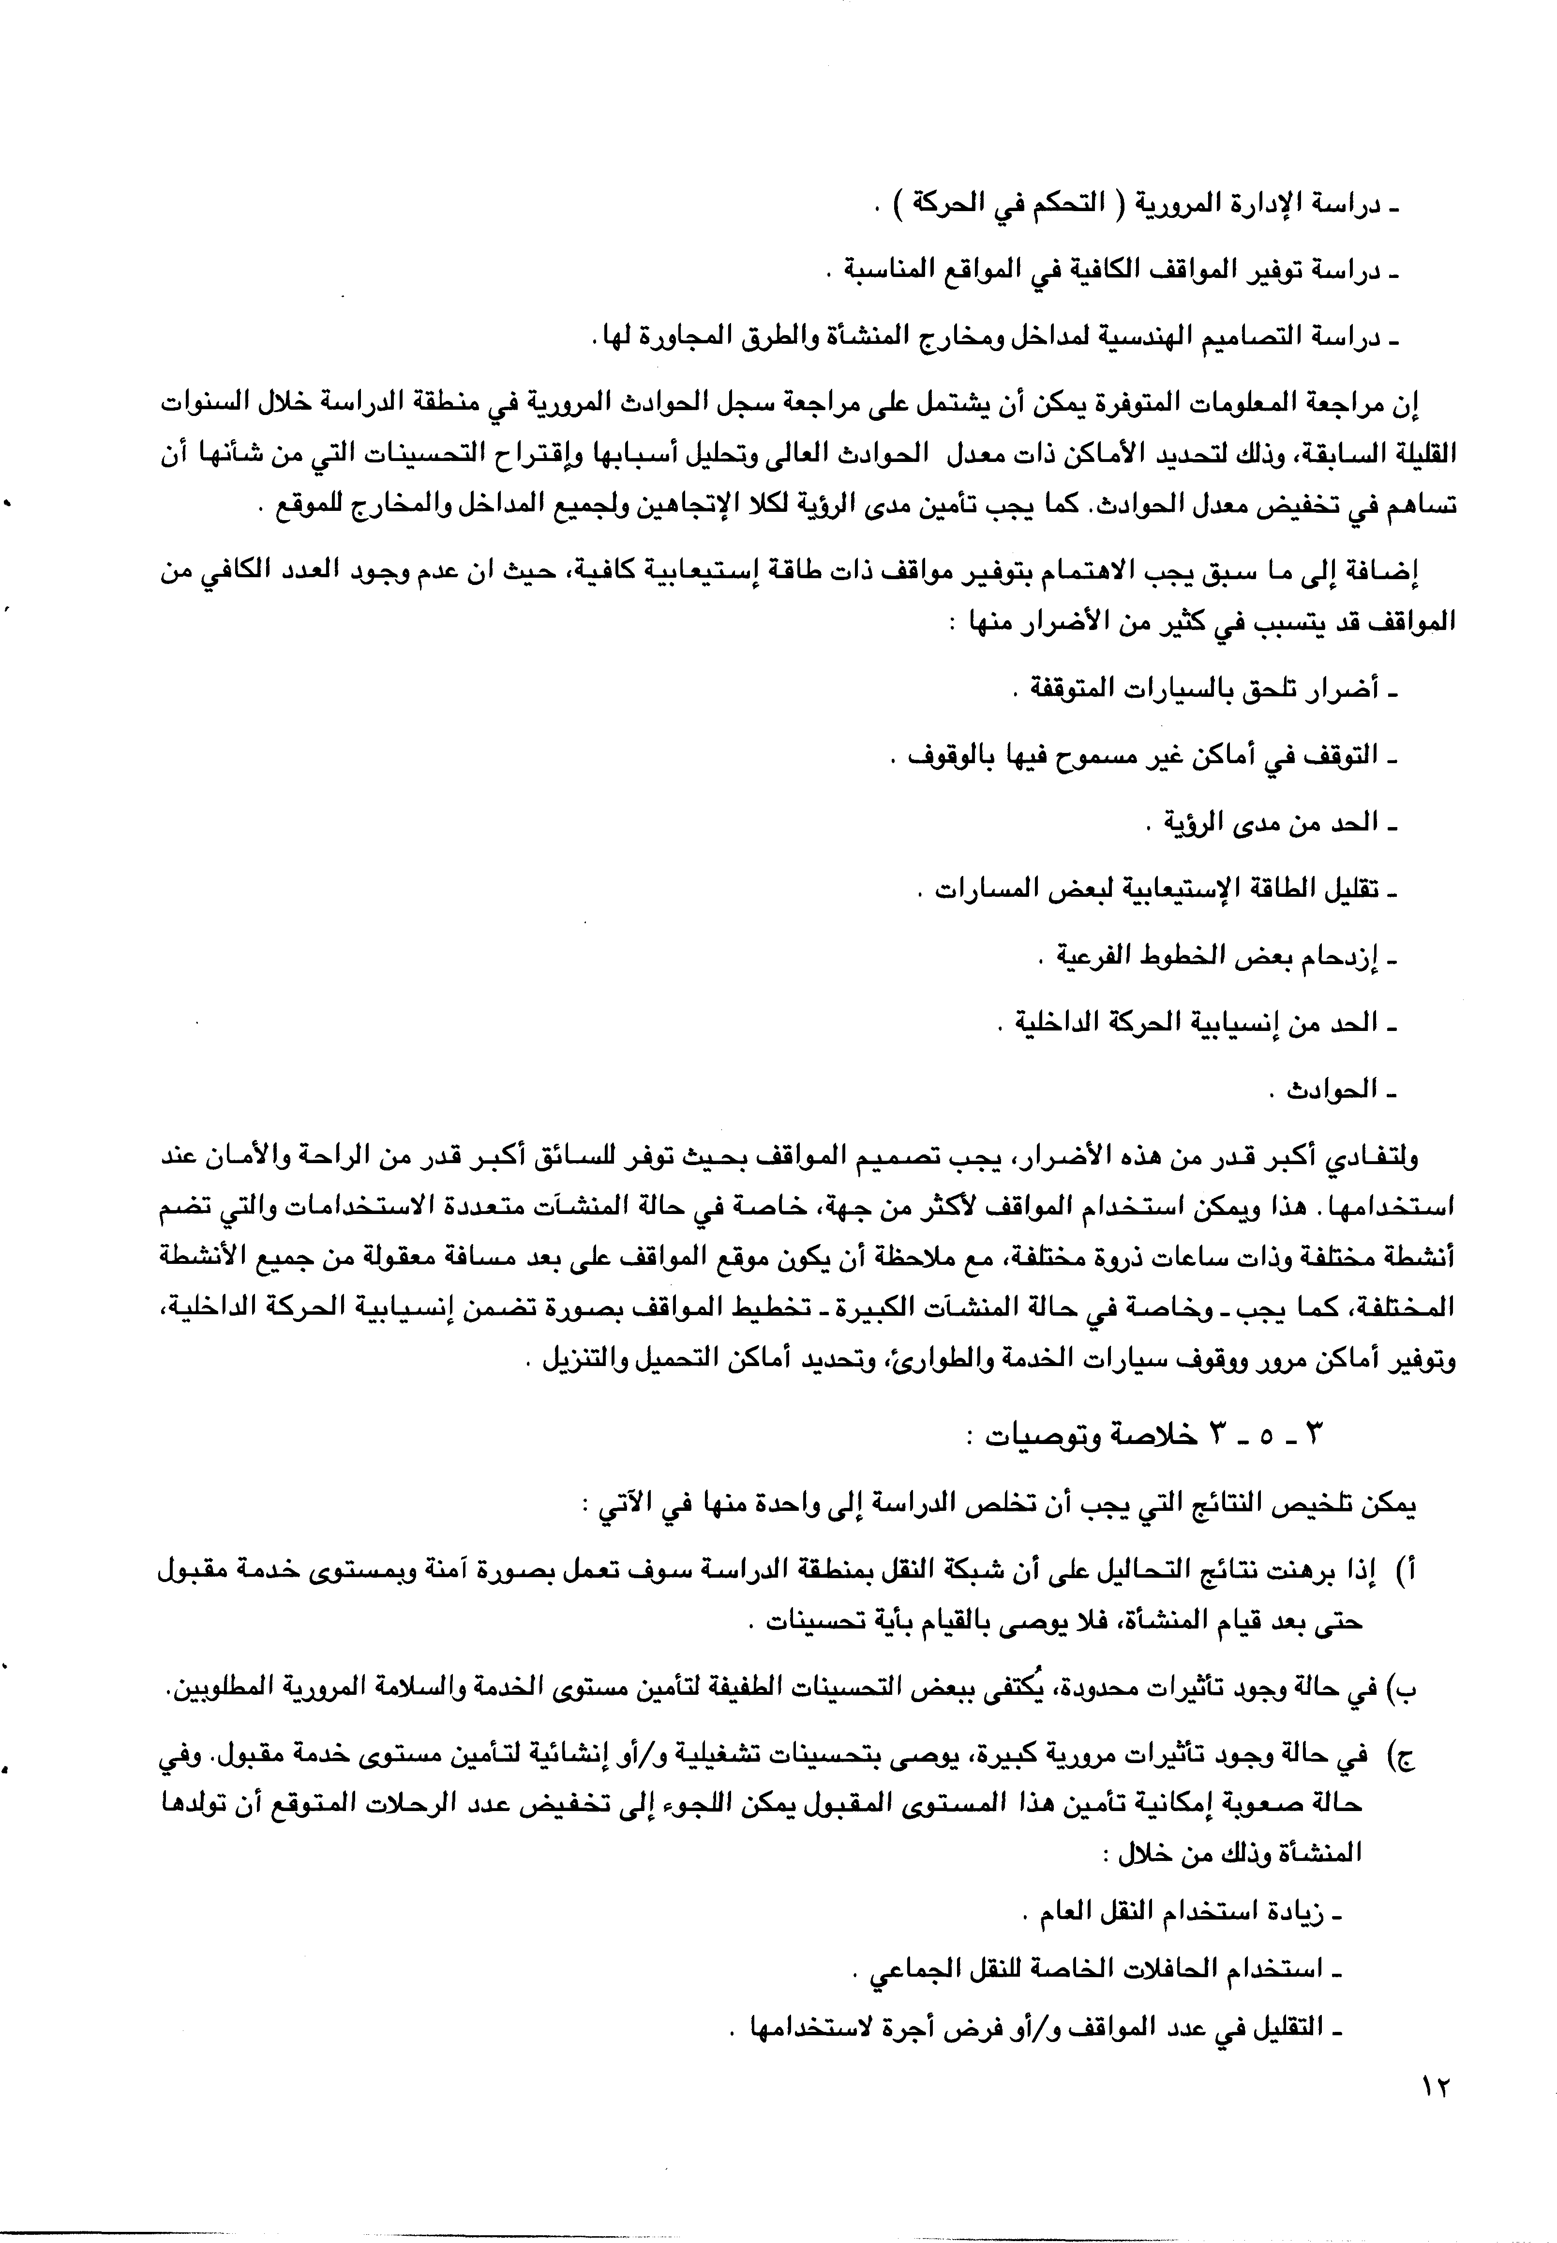

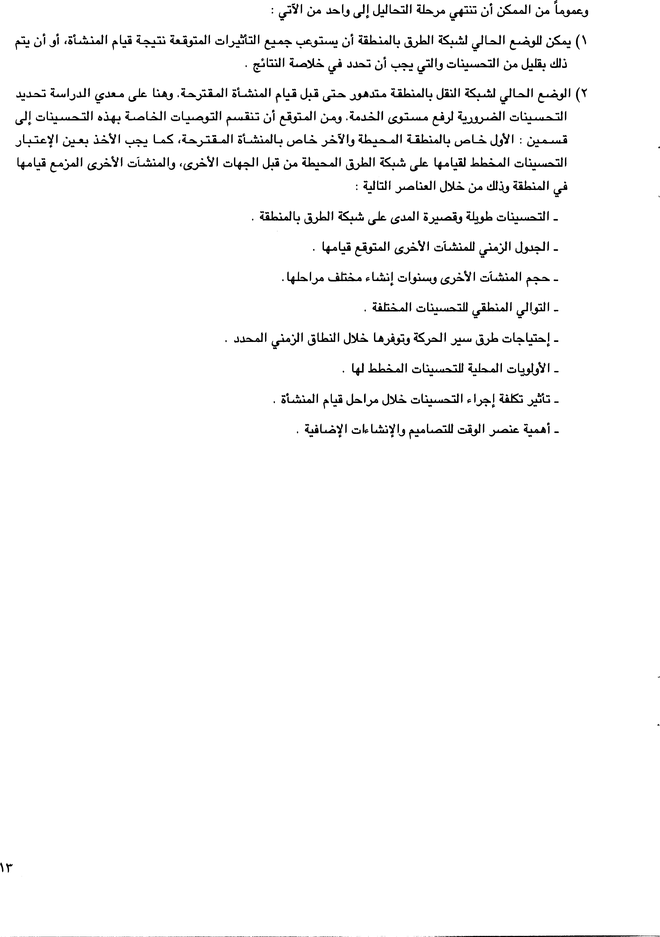

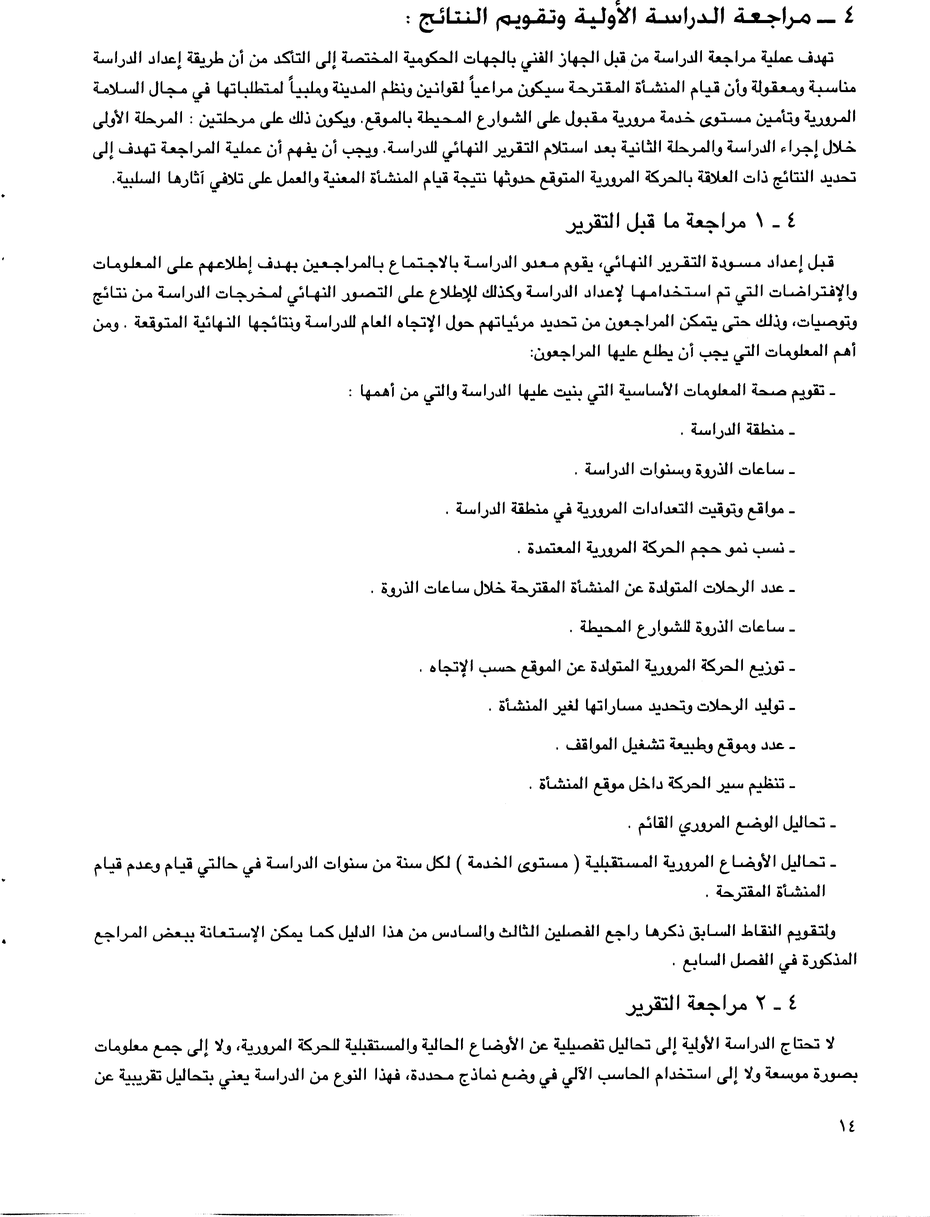

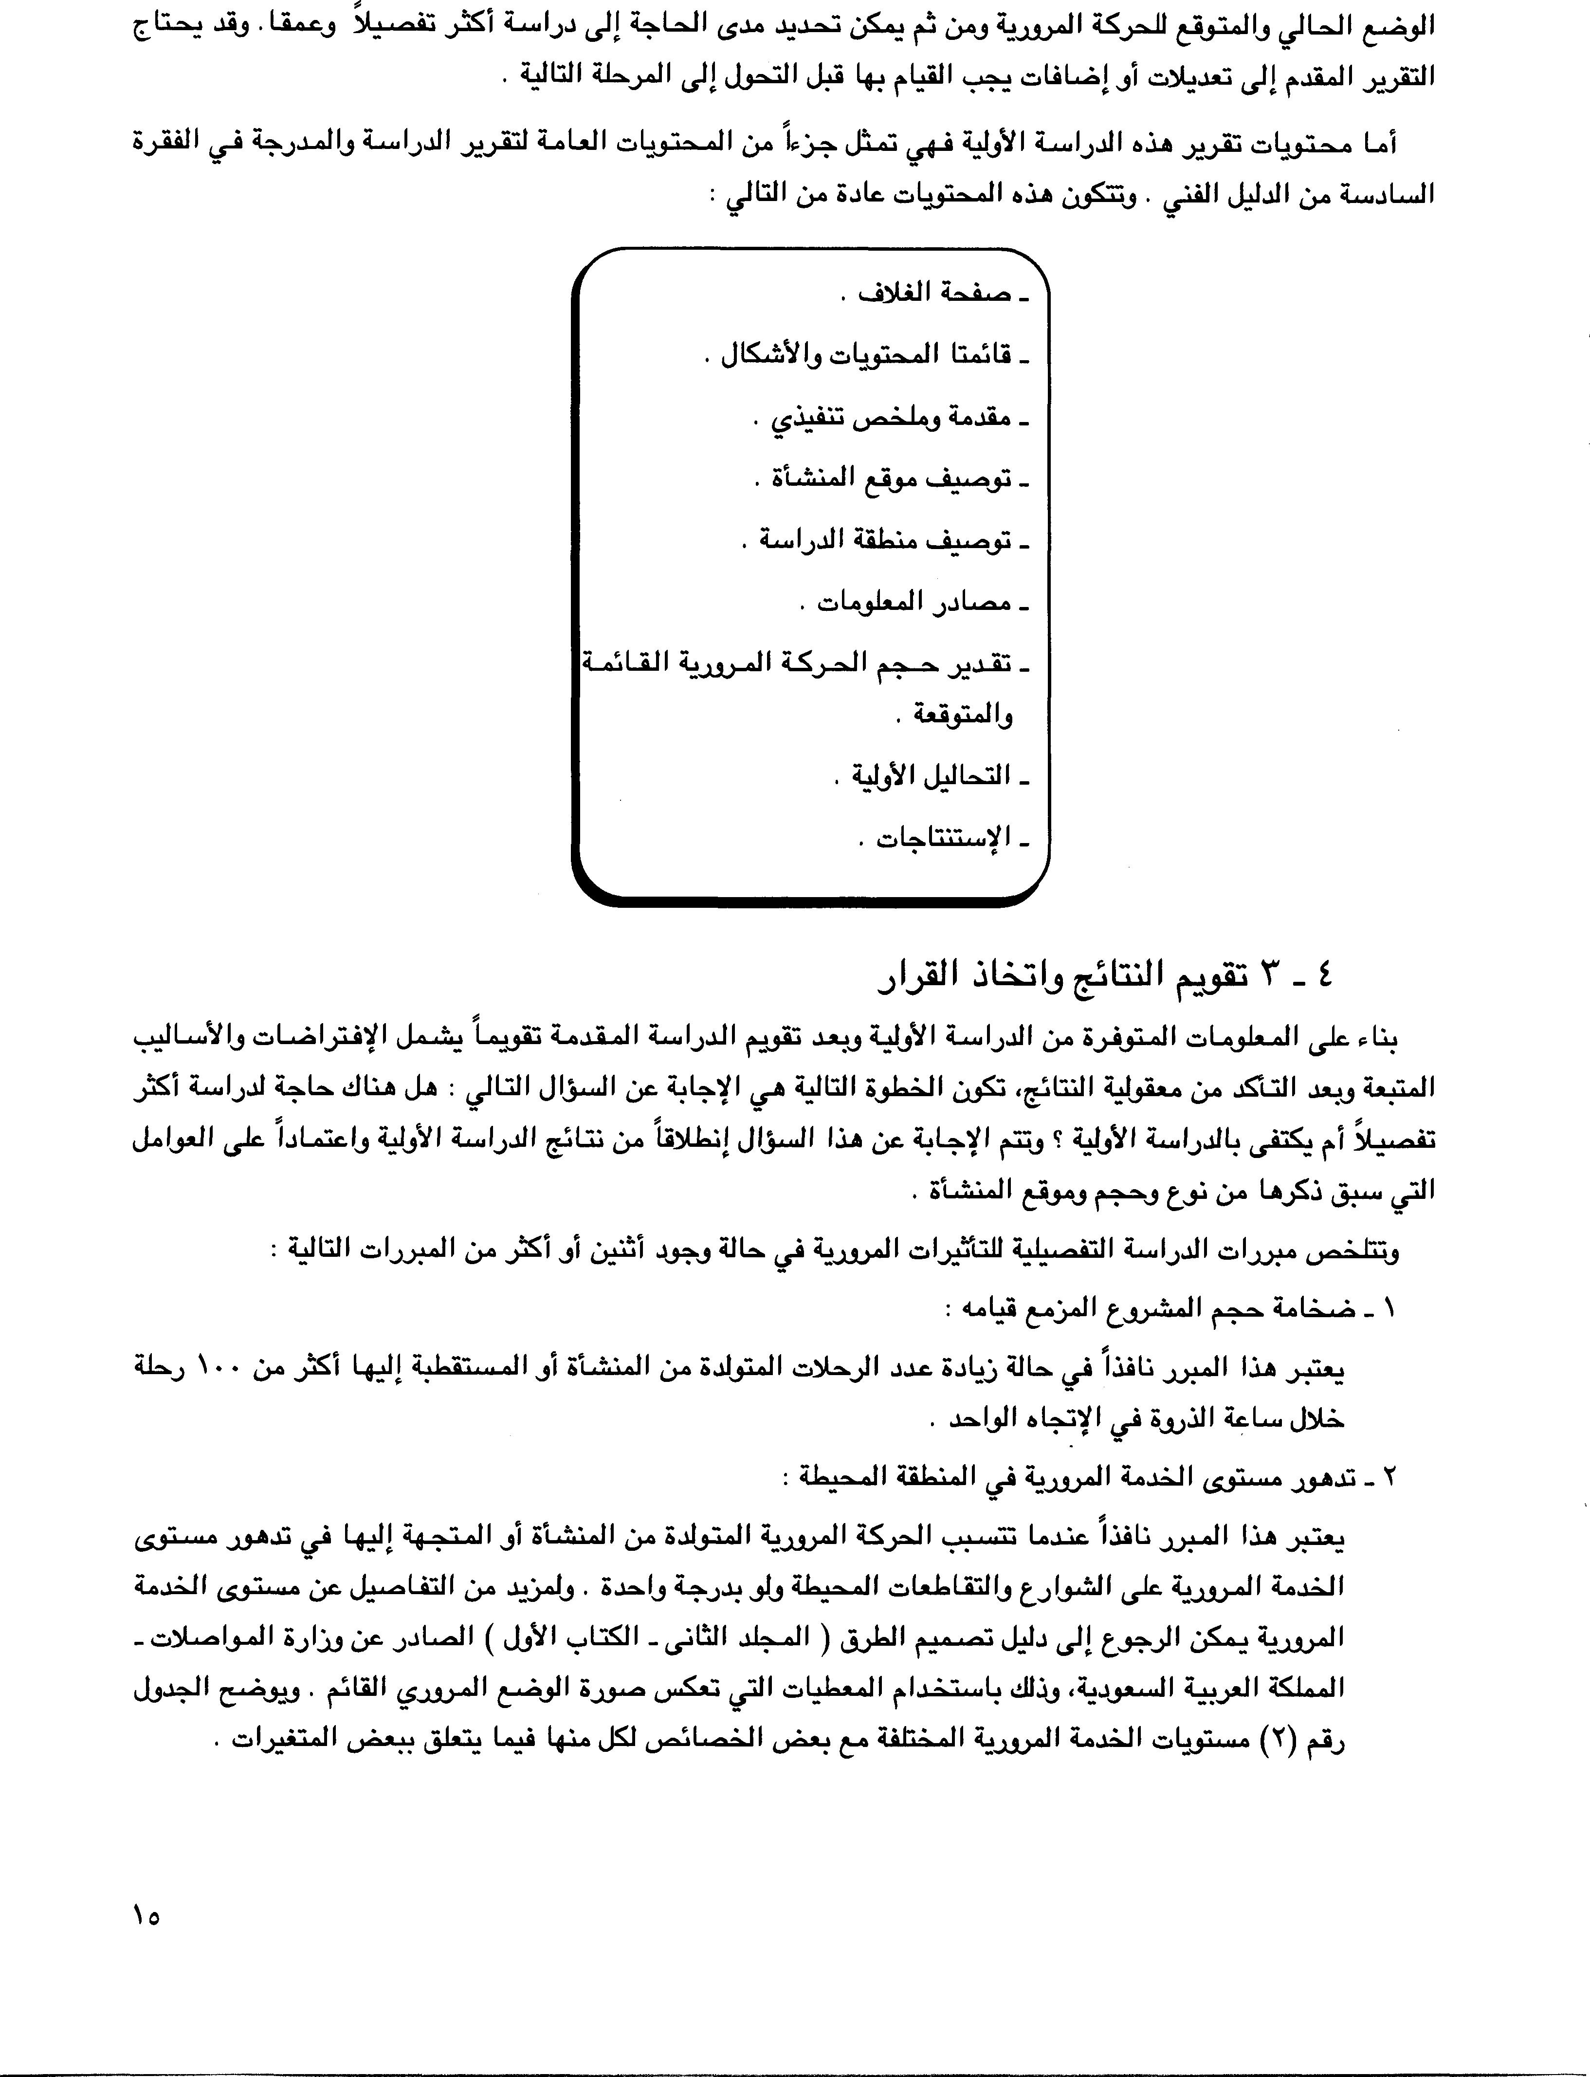

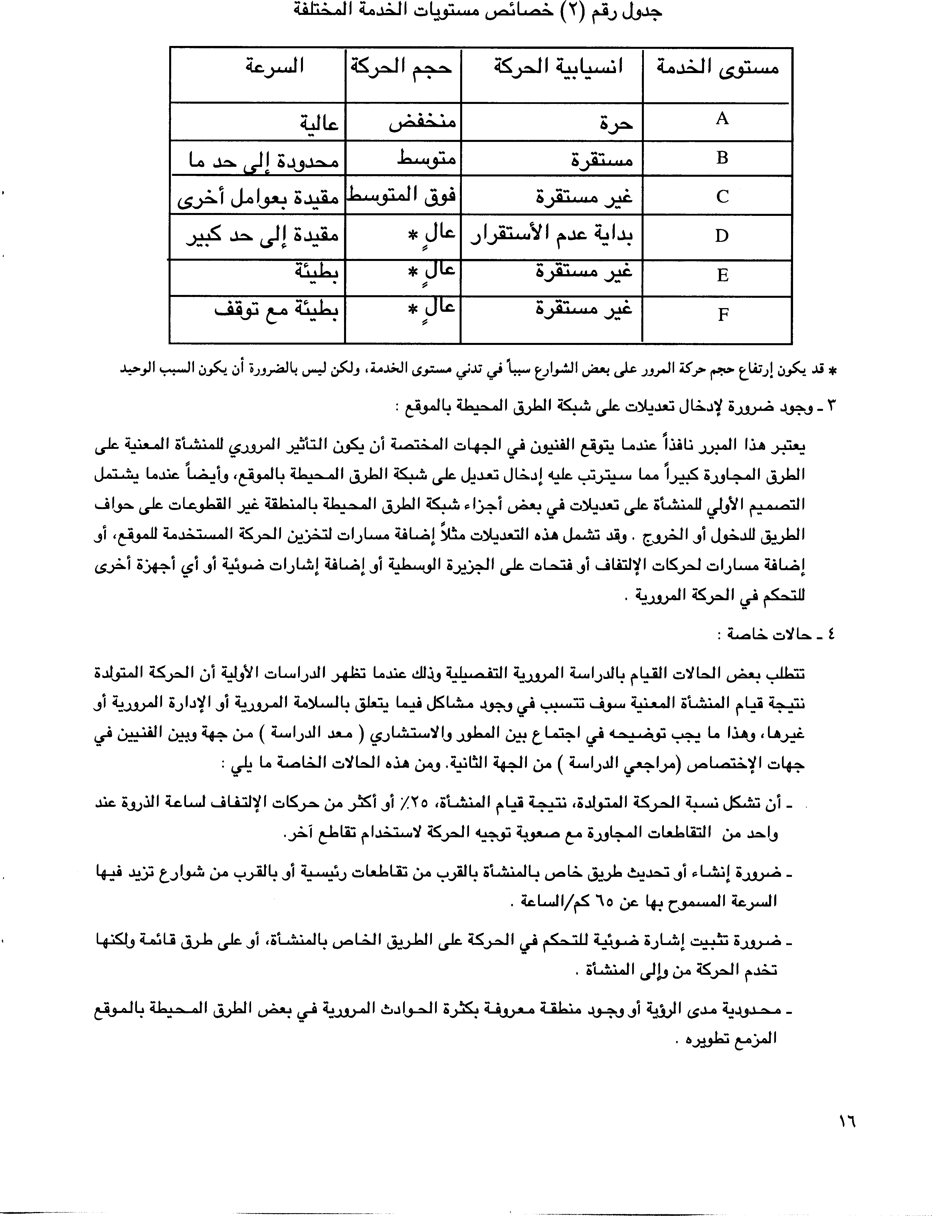



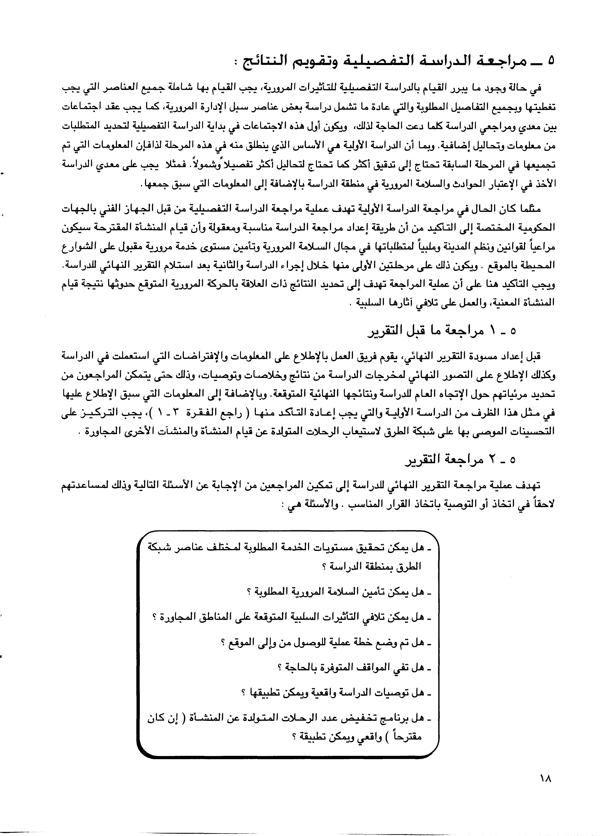

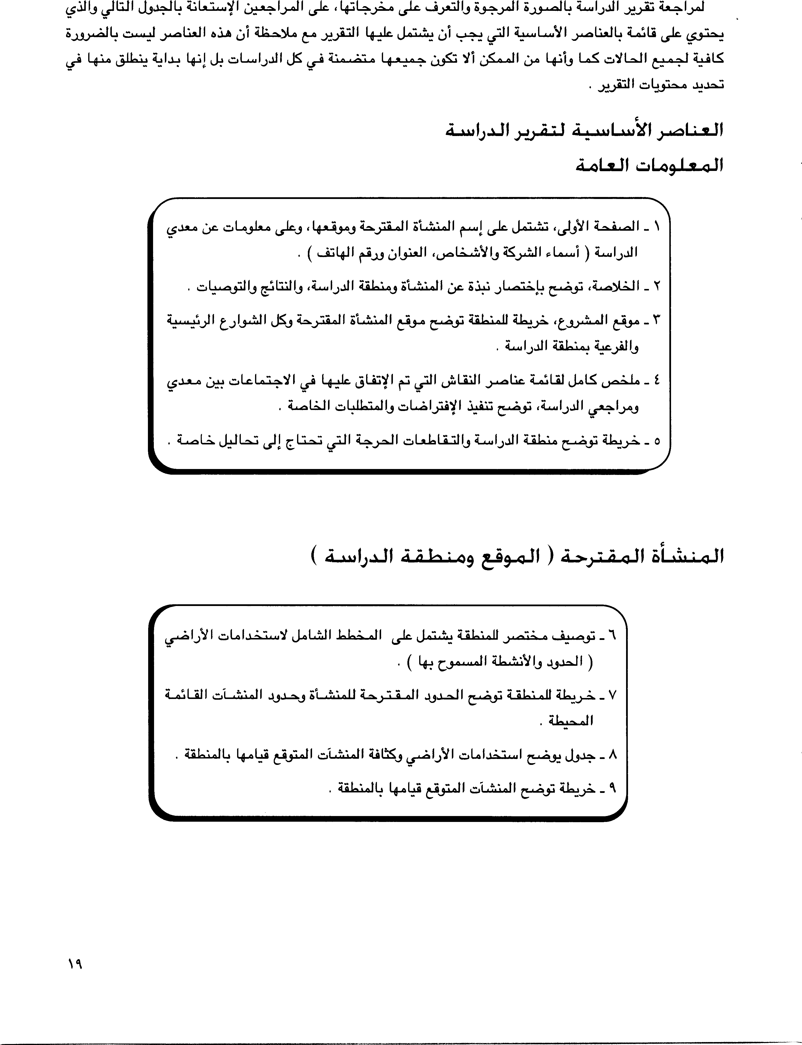

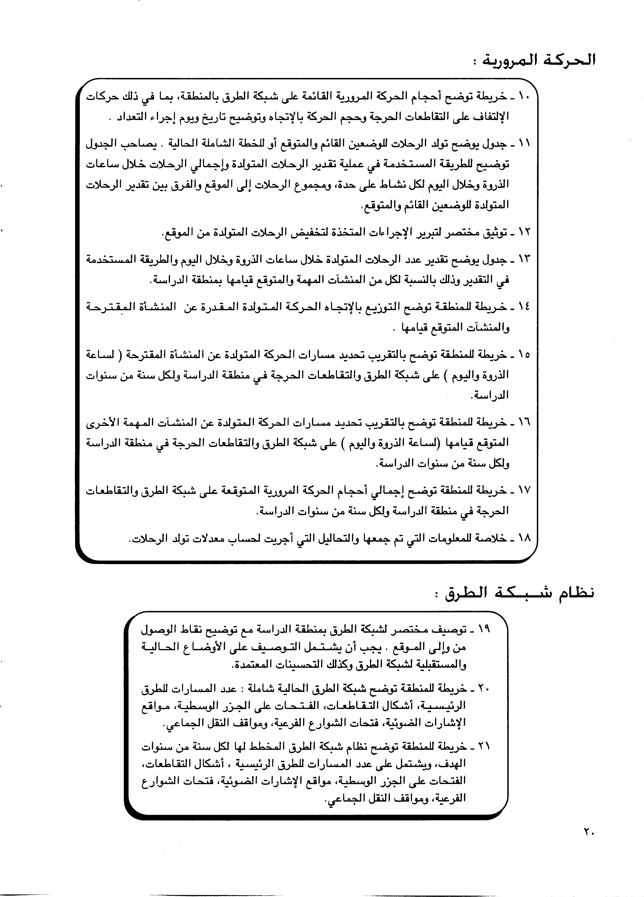

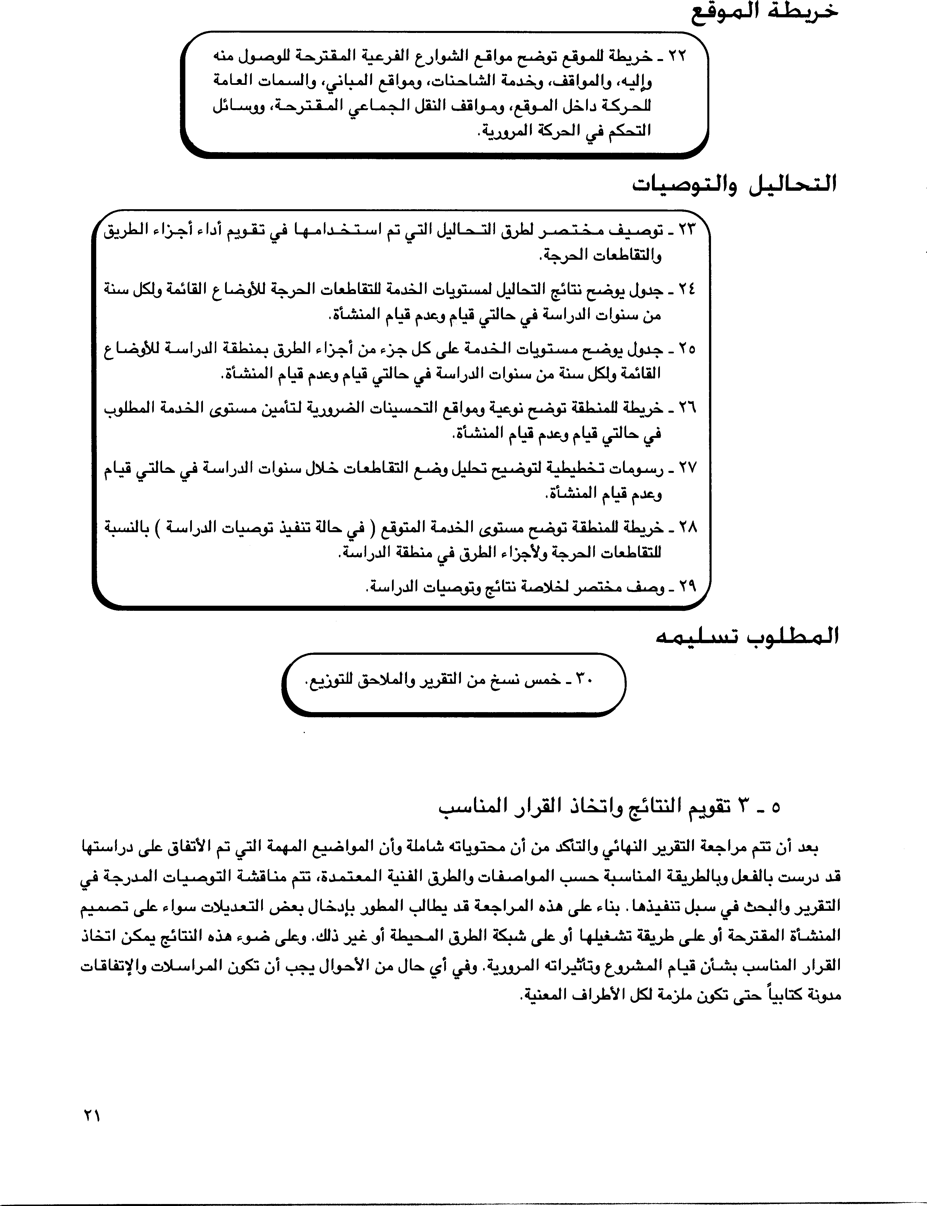

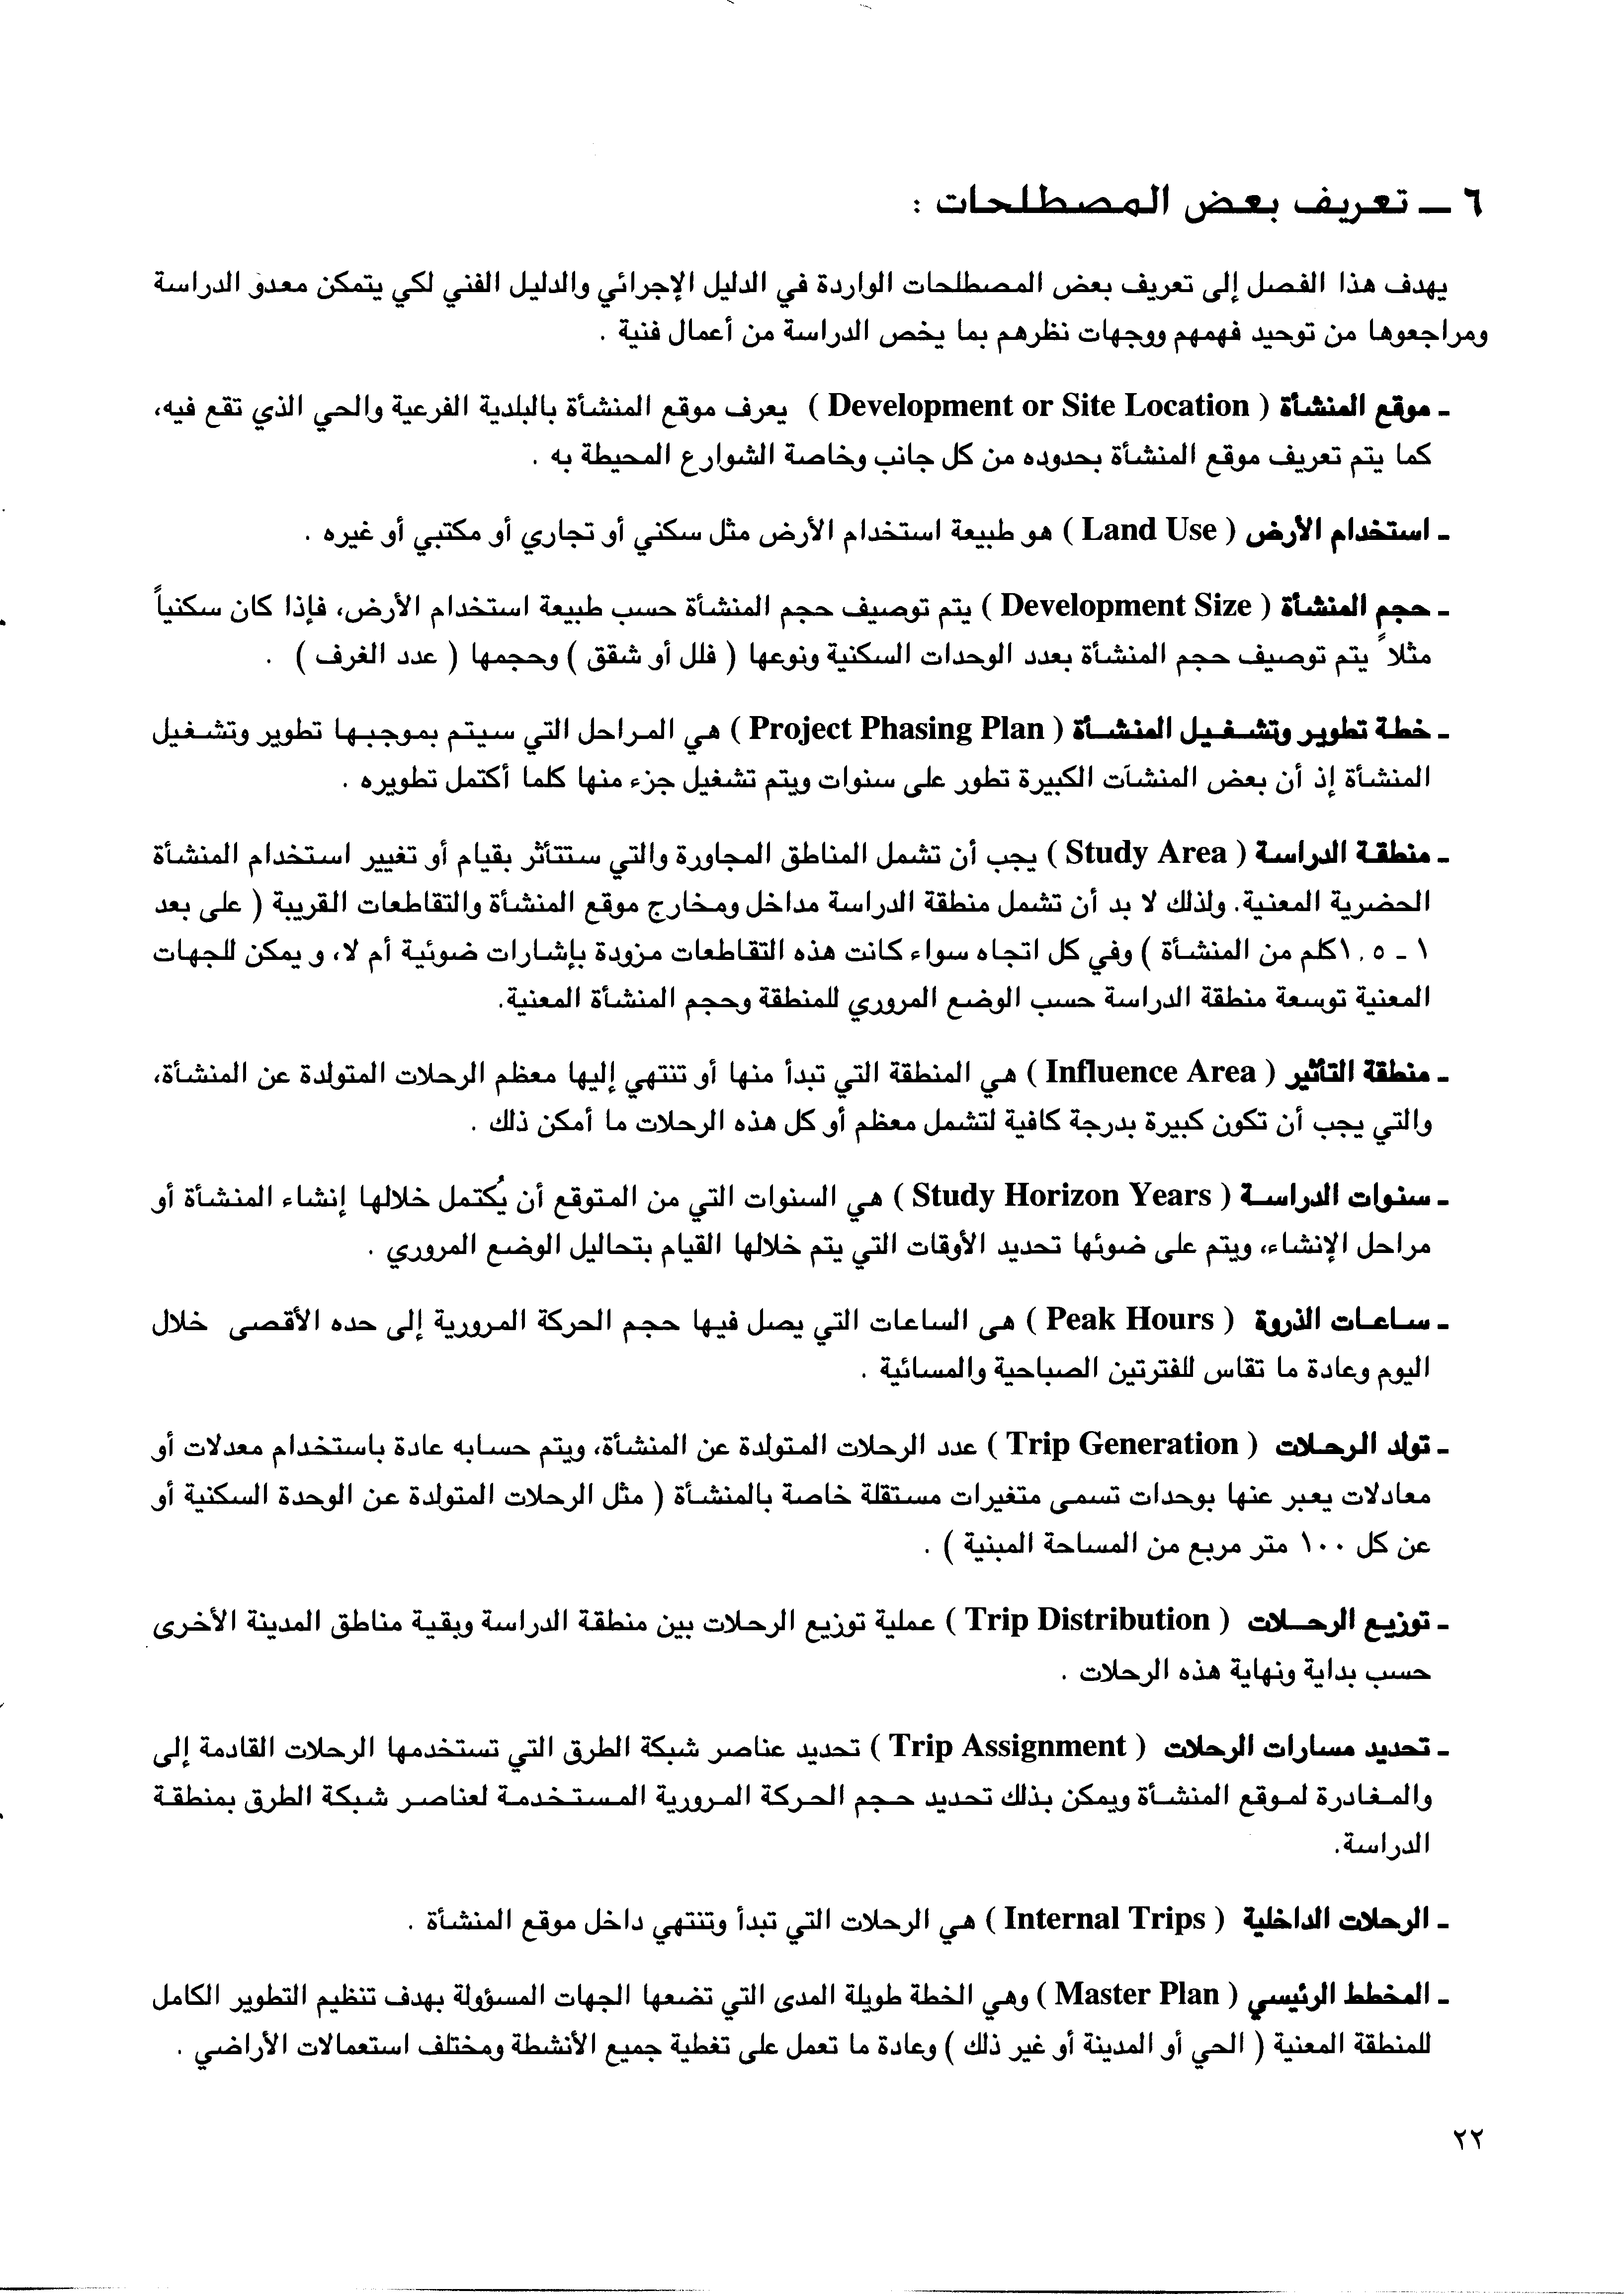

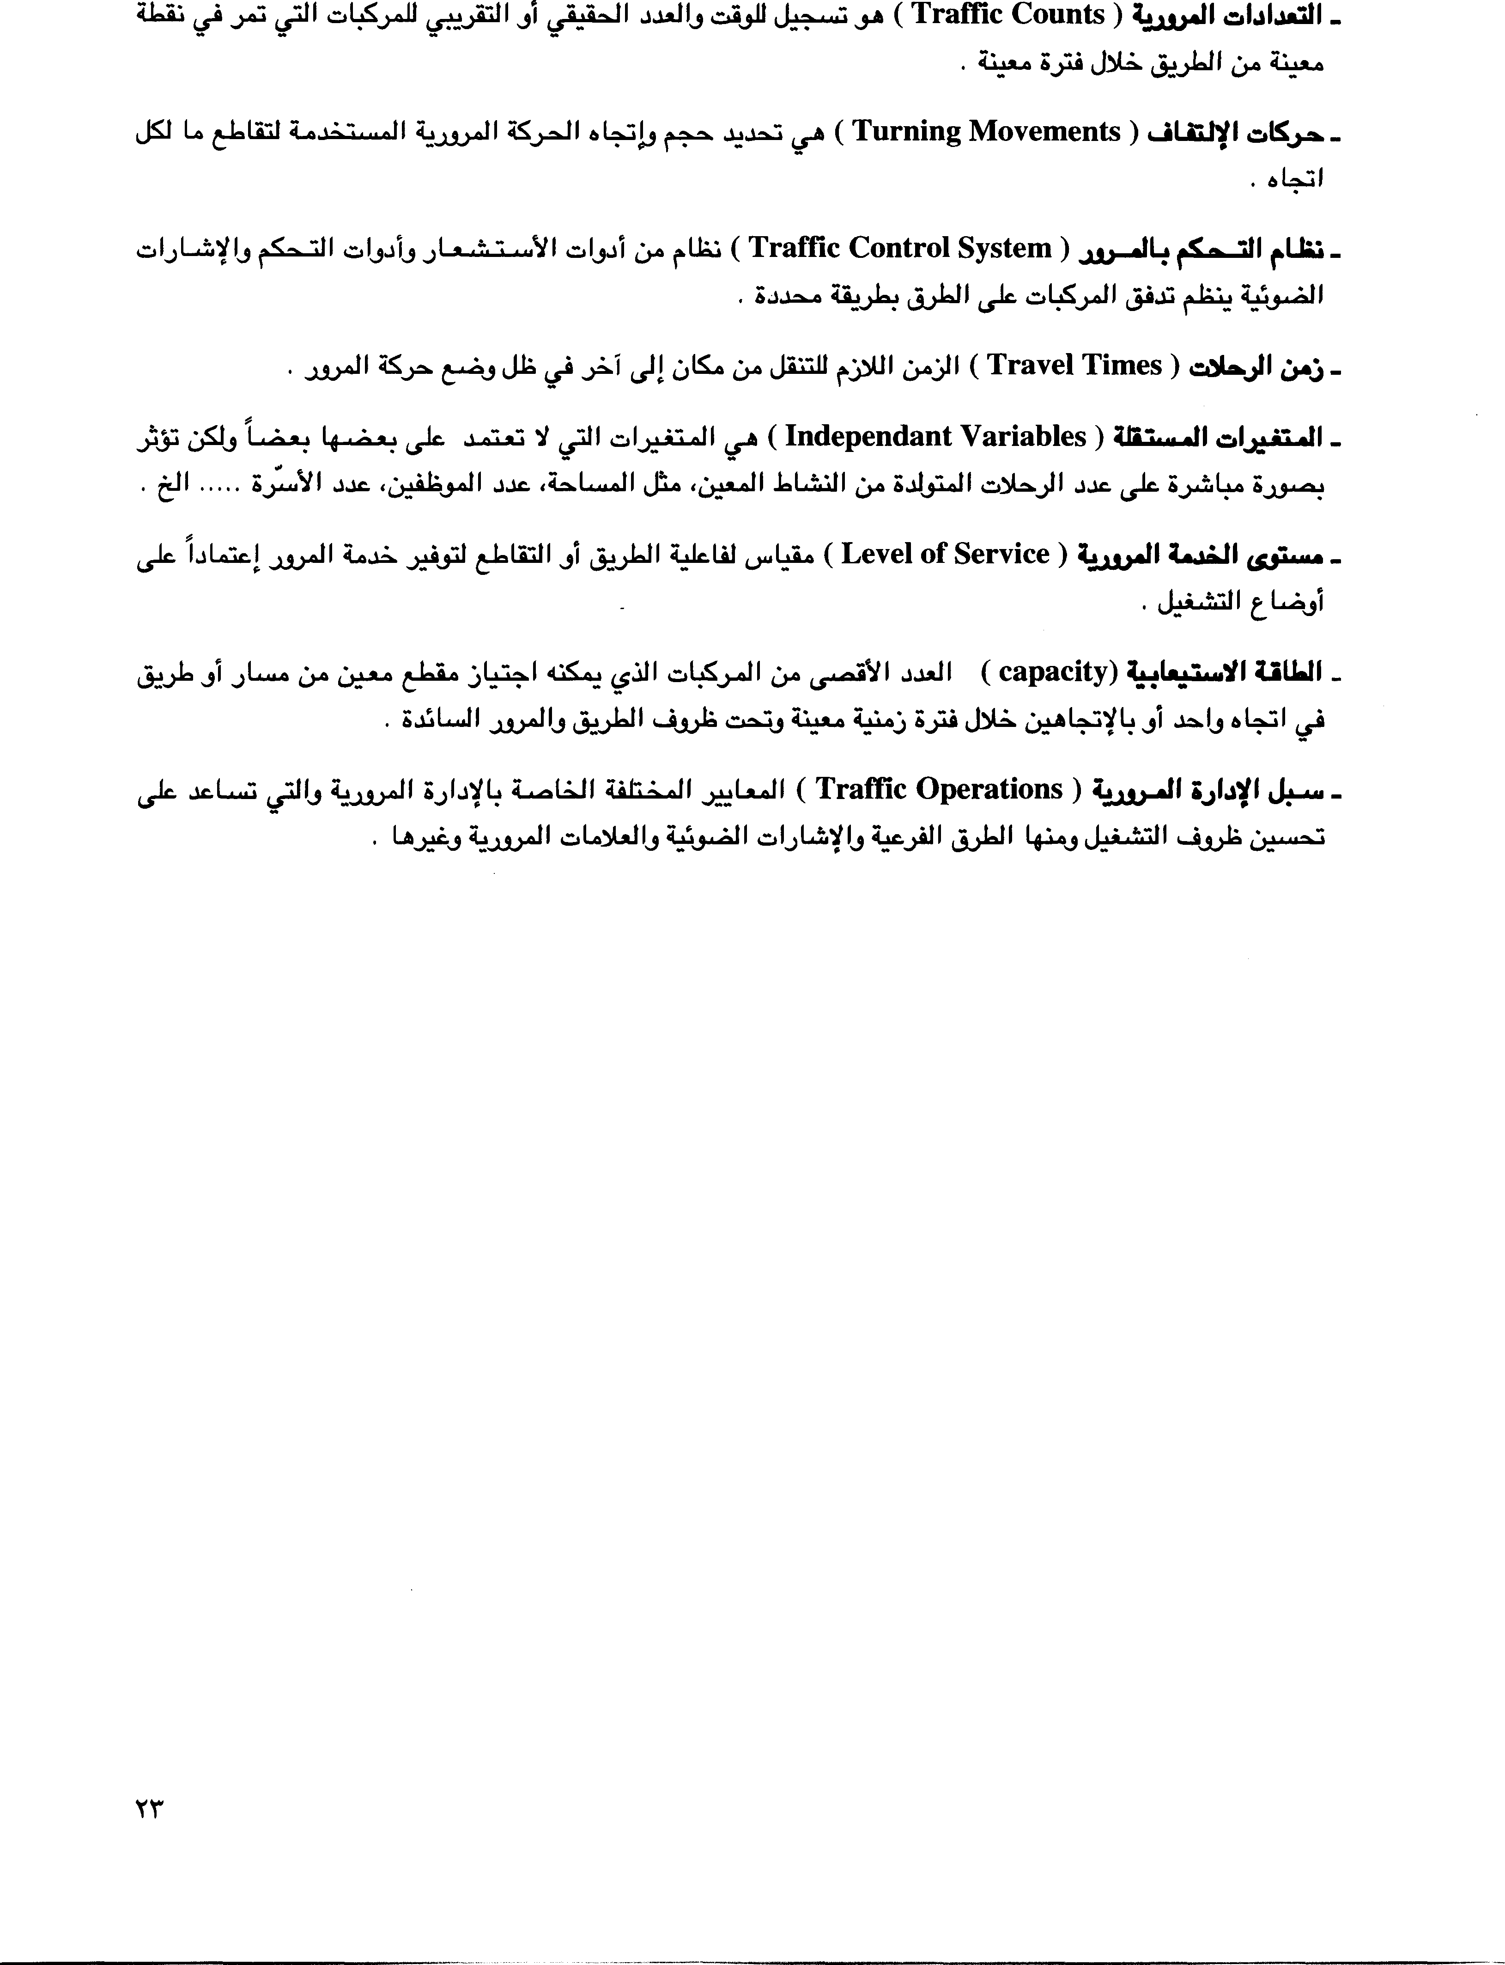

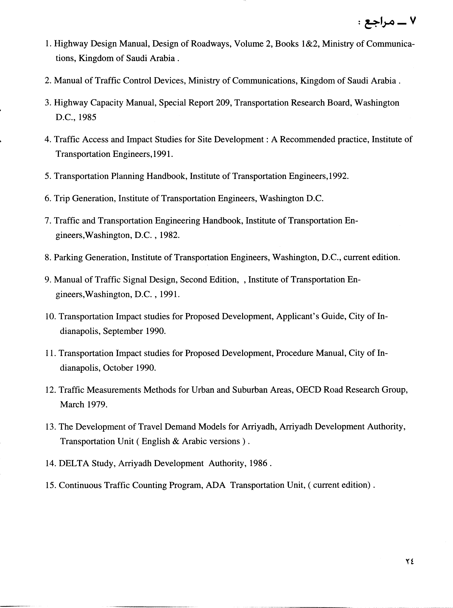



**Driving Rules in Qatar**

Qatar driving can be intimidating, frustrating and even dangerous. Experienced drivers, however have adapted and found - knowing what to expect can be half the battle. You won't be able to change the system or the drivers – so it is better to accept reality and save yourself the anguish.

***Accept and adapt to the local driving conditions***

## DO NOT:

* 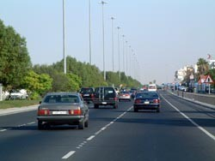lose your temper
* use bad language
* use hand gestures
* demonstrate aggressive behavior
* be put off by the flashing of headlights or the honking of horns
* listen to driver gossip (get out on the road and try it first)

## DO BE PATIENT!

***There is an order to driving on the roads in Qatar, be patient observe the system and you will come to understand it.***

### Defensive / Aggressive Driving

A contradiction in terms, but the safest way to arrive at your destination.

Be aware of your surroundings at all times, expect the unexpected and be prepared for it. Assume that any vehicle around you will make an incorrect action (just because the vehicle in the front is indicating right, this doesn't mean that he's going to turn right!) Anticipate the worst of actions by the vehicles around you.

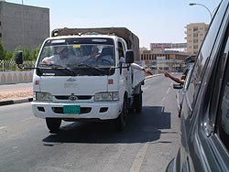When choosing a vehicle some people prefer the security of a large size - and others the agility of a smaller vehicle. Choose what you are most comfortable driving.

Maintain an awareness of vehicles to your rear and those passing (on the left or right) by keeping a close eye on all of your mirrors. This is referred to as situational awareness.

### The Flashing of Headlights

If you are driving in the left lane (well any lane) and the vehicle behind you is approaching quickly with flashing headlights - the driver is in a hurry and wishes you out of his path. If it is safe to do so – signal and move over. Do not touch your brake pedal flashing your brake lights - telling the driver "back off buddy you're too close." The driver behind will interpret this as very aggressive behavior.

Flashing headlights are a gesture to give way in some countries. Beware – not usually the case in Qatar. Locally this translates to – "you’d better wait – I’m coming through".

### Honking the Horn

The honking of car horns usually means I'm here, but as you will find there can be an enthusiastic volley when the lights turn to green, or if the vehicle behind thinks there was a space for you to join the traffic on the roundabout or that you were taking too long to move. Don’t be intimidated by the honking. Take your time and join the traffic when you’re ready.

### Lane Protocol

People tend to drive in the left lane, as vehicles approaching from the right tend not to stop when joining the main road, so:

* On a three lane road most people will drive in the middle or left lane, leaving the right lane to the water trucks, pickups, and entering vehicles.
* On a two lane road most people will drive in the left lane
* On a single lane road: **BE CAREFUL!!**

### Roundabout Protocol

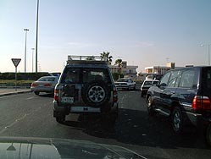Usually when approaching a roundabout from a two lane carriageway the right lane is meant for turning right and the left lane for continuing straight ahead, turning left or turning back - unless otherwise stated.

On a three lane carriageway the right lane is for turning right, the middle lane is for going straight ahead and the left lane is for turning left or turning back unless otherwise stated.

Many roundabouts are now being fitted with a separate slip road for turning right.

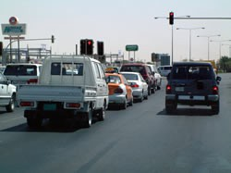***EXAMPLE:***

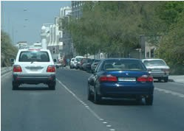Ideally if you approach the roundabout from the middle lane and intend to go straight ahead you should drive into the roundabout position yourself in the centre - as if there is another vehicle on your left and right sides. Follow the round shape of the roundabout. As you approach your exit you should indicate and turn off, almost as if you’re making a right turn.

Some people follow this lane discipline, but I have to say that they may be the minority. So just because someone is in the middle lane do not assume they are going straight ahead, they may be turning left or believe it or not they may even wish to turn right,.

Approaching the roundabout, it seems many people position themselves in the shortest – or fastest moving queue regardless of which way they might be turning in the roundabout

***I once heard someone call a roundabout over here a straight-on-about, this is generally because some people don’t indicate or follow lane discipline***

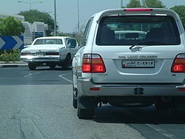Now going through the maneuver as in example above will probably be more like this: approach the roundabout from the middle lane intending to go straight ahead, when you see a gap in the traffic, pull away as quick as possible to get ahead of the traffic on your left, then cut straight through the roundabout (making it a straight-on-about) as soon as you see your exit aim straight for it checking your right mirror, because remember the vehicle on your right should have turned right, but maybe he’s trying to turn left.

Vehicles in the roundabout have the right of way. Most drivers comply.

### Caution

If someone is driving erratic, pulling out in front of you, suddenly stopping, cutting you off, and obviously having no consideration for others, take one or two deep breaths, get out of the way, and let them go. Then smile to yourself, because it is not worth a duel or the trouble.

Be mindful of trucks carrying any load and in particular when they are going around a roundabout or overtaking you.

### Avoid driving behind:

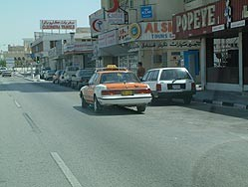**Taxi's**: they are likely to stop anywhere without indicating to pick up or drop a fair

### wtPolice Checks and Penalties

**Trucks** in general and especially **Water Trucks**: They are often very slow and unpredictable. You also have very limited forward vision when behind a truck.

The Traffic Police from time to time will carry out random checks on:

* Driving licenses
* Vehicle registration documents
* The wearing of seat belts

*For not wearing your belt the fine is QR100*

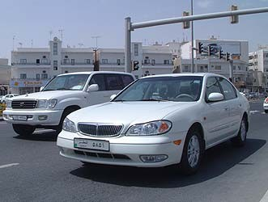There are now speed limits on all roads, and the police have mobile radar cameras and unmarked cars fitted with video cameras.

*Speeding fines vary from QR300 to QR500.*

Be aware that the police can and do impound your vehicle if your speed is excessive.

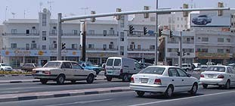Many traffic signals have a static camera, which will take a picture with flash of anyone jumping a red light. *The fine is QR1200*

You can be subjected to a traffic penalty without your knowledge. Frequently the first you will learn of the penalty will be upon annual vehicle re-registration, when in a car accident, or trying to leave the country.

Rules, regulations and procedures are subject to changes - sometimes frequent changes. The above advice is current at this time.

***Remember: don’t be put off by what you have read here or by what other people might say, because after you’ve been here for a short time you will see that there is an order to the way people drive***

## ACCIDENT GUIDELINES

Should you be involved in an accident, strict procedures will apply, however - if you handle yourself well and follow this advice - it need not be such a harrowing experience.

1. 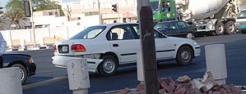DO NOT MOVE THE VEHICLES - no

matter where the accident occurs, whether on your property or on a main road causing major congestion. The police need to see the position of all vehicles to assess responsibility. They will likely allow you to move your vehicle once an assessment has been completed.

## DO NOT MOVE YOUR VEHICLE UNTIL THE POLICE TELL YOU TO

1. If you have a colleague or friend who speaks Arabic - try to get them to come to the accident scene. Whilst many of the police do speak English, some may not be fluent.
2. Contact police on 4890699, 4890670 or 999, provide them with the location of the accident including names of landmarks near to you i.e. large shops, buildings etc.
3. If there are injuries call 999 and ask for an ambulance or contact Hamad Hospital on 4392222. If you are injured and are able, it is advisable to arrange for someone else to come and stay with your vehicle.
4. At the accident scene you will be asked to provide your license, vehicle registration and insurance documents (it is advisable to have photocopies of these documents available in your vehicle). The police will listen to the explanations of all involved and complete their preliminary roadside report. They will advise all involved when to attend the Traffic Department (normally the following day, although it can be immediate) to receive the documentation required for repair-work and the insurance companies.

It is illegal for any garage in Qatar to carry out any accident or body work repairs on your vehicle without the authorized paperwork from Police and or insurance company.

1. Ensure you get contact details from the policeman making the road side report - his name, which police station he is from, details of his shift schedule over the next few days. Try your best to retrieve his personal GSM phone number, (THIS WILL SAVE YOU A LOT OF FRUSTRATION, WASTED TIME AND RUNNING AROUND)
2. It is advisable that your company PRO or well informed Arabic speaking colleague assist you at the police station.
3. 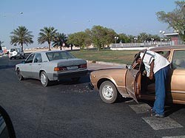DO NOT SIGN ANYTHING unless you fully understand what it is, DO NOT accept the blame if you think it is not your fault.
4. Do not lose your temper Do not use bad language
5. Do not use aggressive behavior Do be patient
6. DO SMILE AND BE RESPECT FULL TO THE POLICE (it works wonders)

***In all my dealings with the Police force here in Qatar I have only found them to be polite and very helpful***

## DRIVER LICENSE REQUIREMENTS:

1. International Driver’s license is Valid for up to 6 months with an official visit visa, starting from the Date of entry to Qatar when accompanied with most first world country’s valid driver’s license.
2. Most first world home countries’ driver’s licenses are good for the duration of a tourist visa.
3. Any Other Driver’s License and for all people with a permanent visa, the driver’s license is only valid for 7 Days, starting from the Date of entry to Qatar. A temporary driver’s license will need to be obtained before the end of 7 days.
4. A temporary Qatari license can be obtained after a vision exam and a fee of QR. 150.
5. If in doubt whether your driver’s license will be accepted, check with the Qatar Embassy.

## PLEASE NOTE THAT INSURANCE COMPANIES WILL NOT COVER ANY DAMAGE TO THE VEHICLE DUE TO DRIVING OFF ROAD.

With Compliments from BASELINE Trading

**Traffic Rules in Dubai**

**Source:** [**https://licensing.rta.ae/handbook/lmv/lmv_en.pdf**](https://licensing.rta.ae/handbook/lmv/lmv_en.pdf)

**Introduction**

1. A License To Drive
2. Steps to Obtain and Keep Your License
3. Expats Driving in Dubai
4. Licenses Recognised by the UAE
5. License Renewal
6. Learning to Drive
7. Learning to Drive in 5 Stages
8. Your Driving Instructor Will Help You to Learn
9. Theory Training Curriculum
10. Practical Training Curriculum
11. The Challenge of Driving Safely
12. Practice is the Best Way
13. Driving Defensively
14. You Will Continue to Learn for Years
15. Managing Risk
16. Speed
17. Seat Belts
18. Alcohol, Drugs and Medicines
19. Driving in Different Conditions
20. Driving in Fog
21. Driving Safely at Night
22. Driving When Tired
23. Driving When Angry
24. Floods in Dubai
25. Vehicle Maintenance
26. Driver Assistance Systems
27. Electric Vehicles
28. Reducing Your Risk of a Crash
29. Mobile Phones and Other Driver Distractions
30. Road User Safety
31. Dealing with Vulnerable Road Users
32. Sharing the Road With Other Vehicles
33. Giving Way To Emergency Vehicles
34. Dealing with Cyclists on the road
35. Bus & Taxi Lanes in Dubai
36. Dubai Tram and Dubai Metro
37. Signs and Markings Related to Dubai Tram
38. Rules and Responsibilities
39. Being a Responsible Driver
40. Disciplined Driving
41. What are Road Rules
42. Road Signs
43. Regulatory Signs
44. Warning Signs
45. Road Markings
46. Traffic Control at Intersections
47. Speed Limits
48. Giving Way to Pedestrians
49. Turning
50. Roundabouts
51. Changing Lanes and Overtaking
52. Driving on Freeways
53. Interchanges
54. Safe behavior in the event of a collision
55. Driving in Dubai
56. Salik in Dubai
57. Parking
58. Paid Parking in Dubai
59. Eco Friendly Driving Habits
60. Test Yourself Questions
61. Traffic Violations, Fines & Black Points
62. RTA Easy Licensing
63. Keep Learning and Enjoy Your Driving Experience

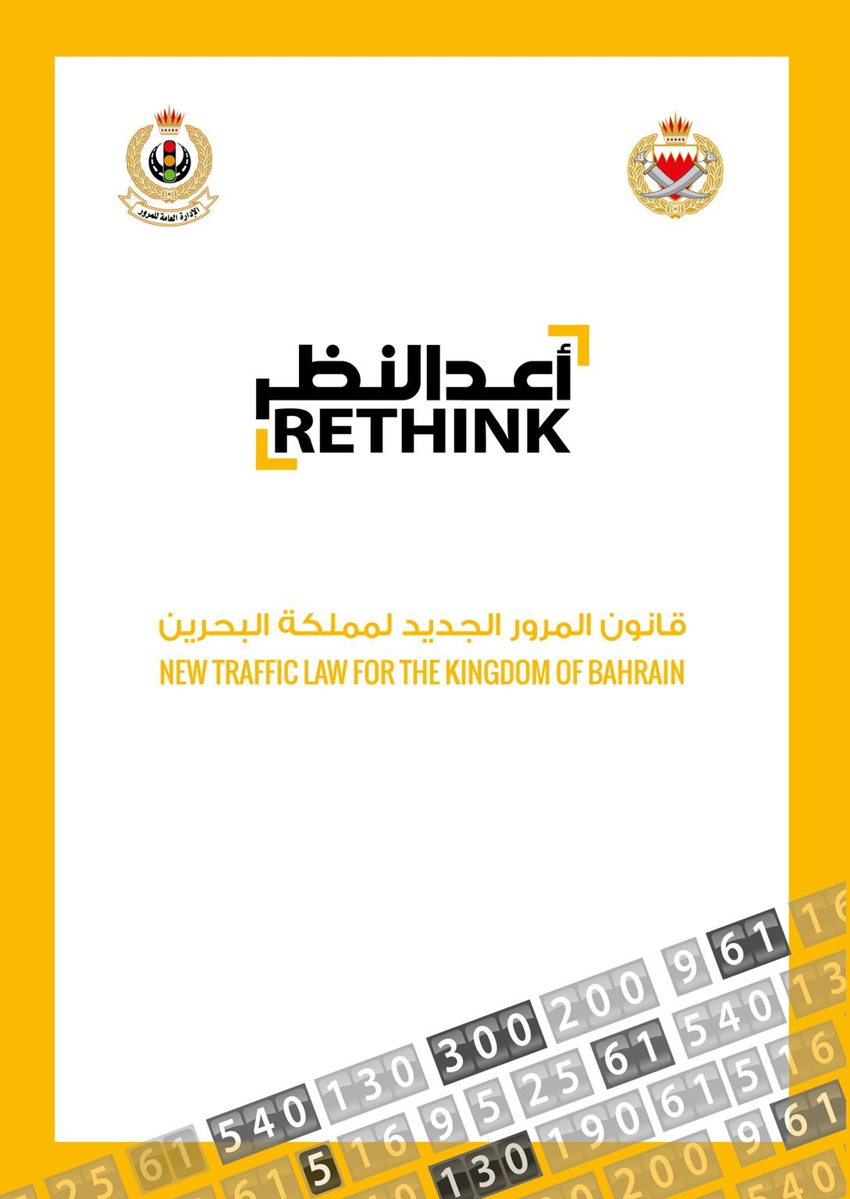

**Bahrain Traffic Rules:**

Source: <https://services.bahrain.bh/wps/PA_GDTDhBoardServices/faces/javax.faces.resource/en/GDTLaw.pdf?rel=v1>

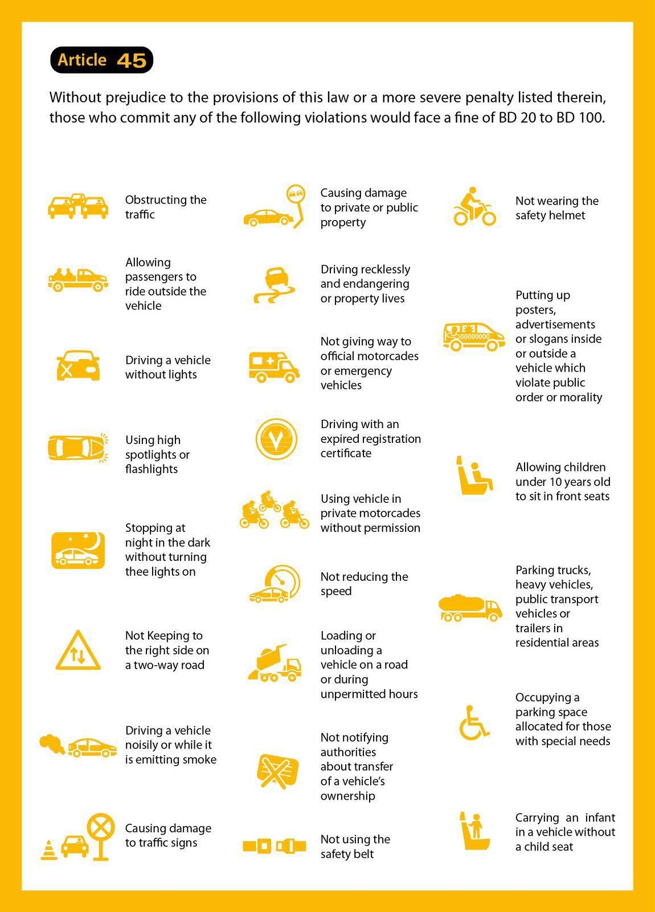

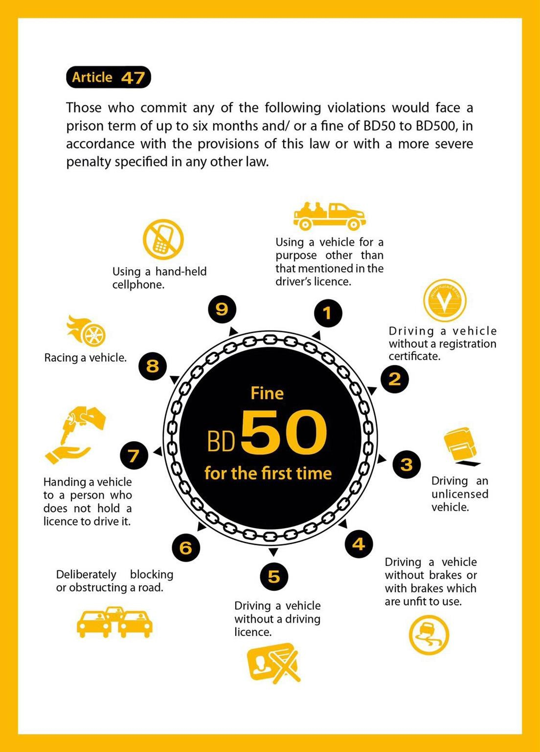

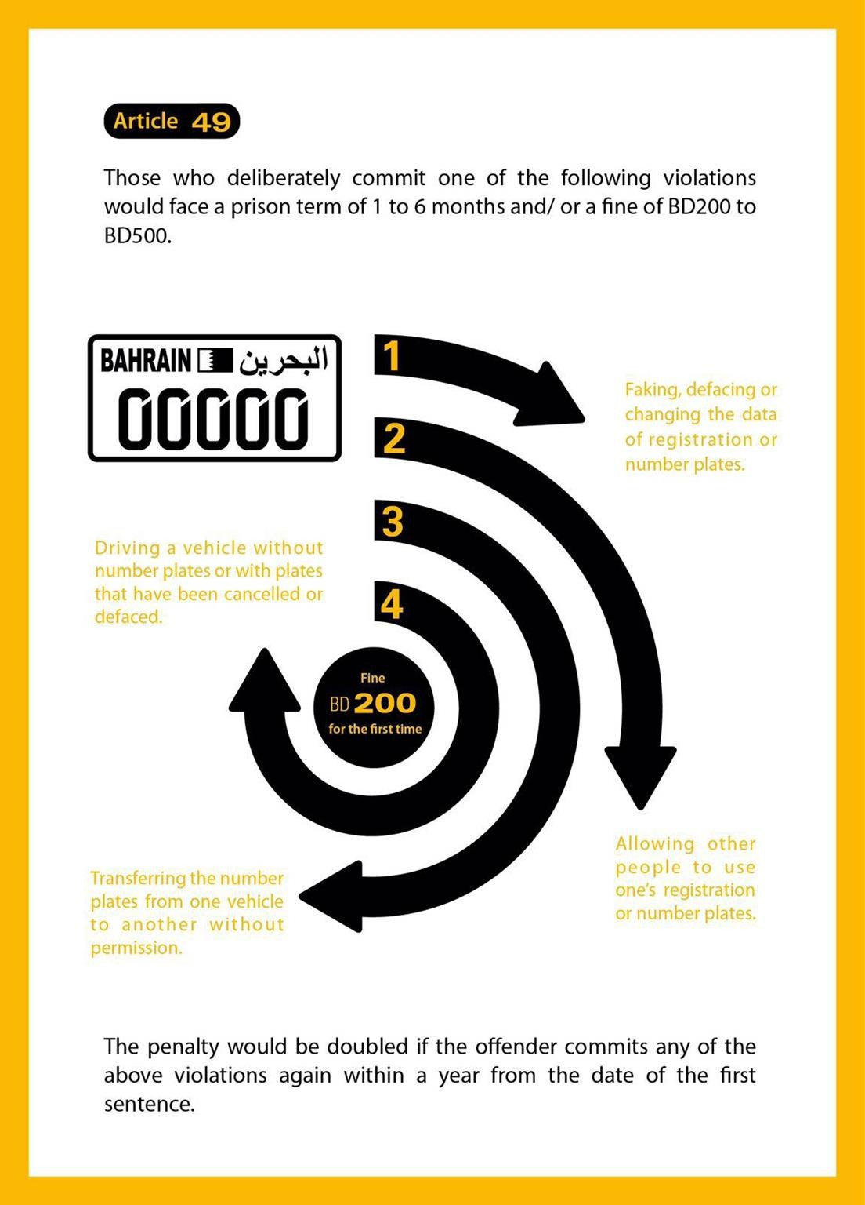

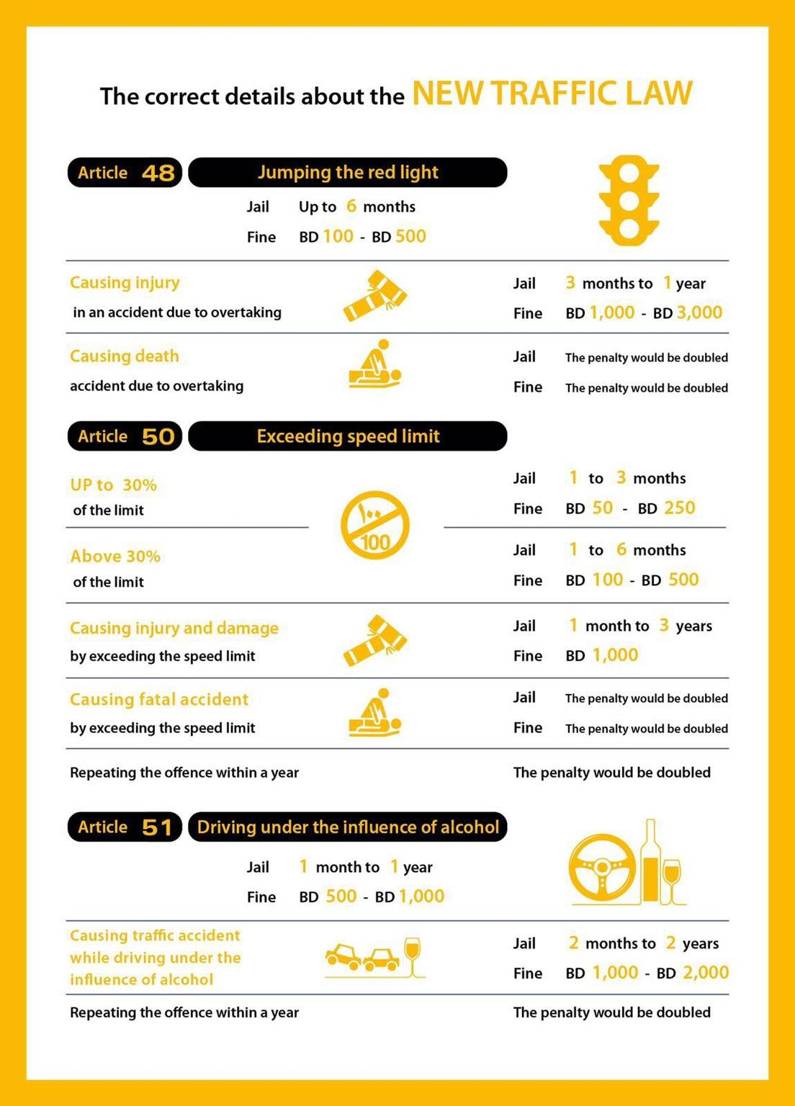



Canadian Manual of Standard Traffic Signs & Pavement Markings

**Canadian Traffic Rules:**

Source:

<https://www.atstraffic.ca/wp-content/uploads/2016/08/MoST_PM.pdf>



September 2000

**TABLE OF CONTENTS**

* 1. **General Provisions**
  2. Introduction
  3. Authority and Jurisdiction
  4. Requirements of Signing
  5. Functional groups of Signs
  6. **Standardization of Application**
  7. **Standardization of Design**
     1. Shape and Colour
     2. Dimensions
     3. Message
        1. Interdictory and mandatory/permissive symbols
     4. Retroreflectivity and Illumination
        1. Means of Reflectorization
        2. Means of Illumination
  8. **Standardization of Placement**
     1. Side of the Roadway

1.7.2. Longitudinal Positioning

* + 1. Lateral Positioning
    2. Height
    3. Angle
    4. Mounting and Grouping
  1. **Sign Posts and Bases**
  2. **Overhead Signs**
  3. **Maintenance**
  4. **Sign Supply**

**2.0 Regulatory Signs**

**3.0 Warning Signs**

* 1. **Guide Signs**
  2. Introduction
  3. Control City & Destination Selection Policy
  4. General Conventions for Guide Signs
     1. Colour and Retroreflectivity
     2. Lettering

4.3.3. Arrows and Borders

4.3.4 Abbreviations

* 1. Guide Sign Warrants and Application Policy
  2. Freeway Guide Signs
     1. Background
     2. Conventions for G-5 Signs
     3. Guide Sign Theory

Fig. 4.1 to 4.xx Sample Guide Sign Applications

**5.0 School and Pedestrian Signs**

**6.0 Information Signs**

* 1. **Pavement Markings**
  2. Introduction
     1. Materials
     2. Longitudinal Markings
        1. Colour
        2. Pattern
        3. Intersections
        4. Double Lines
        5. Single Solid Dividing Lines
        6. Lane Edge Lines
     3. Transverse Pavement Markings
        1. Color
        2. Shapes
        3. Stop Lines
        4. Crosswalks
        5. Lane Use Arrows
        6. Letters and Symbols

1. Chevron and Crosswalks Marking in Gore Areas
   1. Chevron Pavement Markings in Gore Areas
   2. Crosshatch Pavement Markings in Medians
   3. Advance Crossing Markings
2. Raised Pavement Markers (RPM’s)
   1. Guidelines for installations
   2. RPM – Reflective White Mon-direction
   3. RPM – Reflective Yellow Mon-directional
   4. RPM – Reflective Yellow Bi-directional
   5. RPM – Reflective Red an White Bi-directional
   6. Reflectors –CMB & CRB
3. Delineators
   1. Introductions
   2. Application
   3. Specifications
   4. Delineators on Conventional Highways
   5. Delineators on Freeway and Expressways
4. Reserved Lanes
5. Left Turn Pavement Markings
   1. Rural
   2. Urban
6. Two Way Left Turn Lanes
   1. General
   2. Application
   3. Median Lane Width
   4. Intersection Treatment
7. No Passing Zones
   1. Barrier Lines
   2. Field Measurement

Australian Road Rules

As at 19 March 2018

As approved by the Transport and Infrastructure Council Published by the Parliamentary Counsel’s Committee

**Australian Traffic Rules:**

Source:

<https://pcc.gov.au/uniform/Australian-Road-Rules-19March2018.pdf>

This is a consolidated version of the *Australian Road Rules*. These Rules are a national model law and are intended to provide the basis for nationally consistent road rules.

These Rules do not, by themselves, have any legal effect

Australian Road Rules

**Contents**

Part 1—Introductory 17

Division 1—General 17

1. Australian Road Rules 17
2. Commencement 17
3. Objects of the Australian Road Rules 17

Division 2—Some features of the Australian Road Rules 18

1. Definitions—the dictionary etc 18
2. Diagrams 18
3. Examples 18
4. Headings 18
5. Notes 18
6. Reader’s Guide 18
7. Offences 19

Part 2—Application of the Australian Road Rules 20

Division 1—Roads and road-related areas 20

1. Australian Road Rules apply to vehicles and road users on roads and road-related areas 20
2. What is a road 20
3. What is a road-related area 20

Division 2—Road users and vehicles 22

1. Road users 22
2. What is a vehicle 22
3. Who is a driver 22
4. Who is a rider 22
5. Who is a pedestrian 22
6. References to driver includes rider etc 23

Part 3—Speed-limits 24

1. Obeying the speed-limit 24
2. Speed-limit where a speed-limit sign applies 24
3. Speed-limit in a speed-limited area 25
4. Speed-limit in a school zone 26
5. Speed-limit in a shared zone 27
6. Speed-limit elsewhere 27

Part 4—Making turns 29

Division 1—Left turns 29

1. Application of Division to roundabouts, road-related areas and adjacent land 29
2. Starting a left turn from a road (except a multi-lane road) 29
3. Starting a left turn from a multi-lane road 30
4. Making a left turn as indicated by a turn line 32

Division 2—Right turns 34

1. Application of Division to certain right turns 34
2. Starting a right turn from a road (except a multi-lane road) 34
3. Starting a right turn from a multi-lane road 36
4. Making a right turn 37

Division 3—Hook turns at intersections 39

1. Making a hook turn at a hook turn only sign 39
2. Optional hook turn by a bicycle rider 39
3. Bicycle rider making a hook turn contrary to no hook turn by bicycles sign 41

Division 4—U-turns 42

1. Beginning a U-turn 42
2. Giving way when making a U-turn 42
3. Making a U-turn contrary to a no U-turn sign 42
4. Making a U-turn at an intersection with traffic lights 43
5. Making a U-turn at an intersection without traffic lights 43
6. Starting a U-turn at an intersection 43
7. Repealed 44

Part 5—Change of direction and stop signals 45

Division 1—Change of direction signals 45

1. Division does not apply to entering or leaving a roundabout or lane filtering 45
2. What is changing direction 45
3. Giving a left change of direction signal 46
4. How to give a left change of direction signal 46
5. Giving a right change of direction signal 47
6. How to give a right change of direction signal 47
7. How to give a right change of direction signal by giving a hand signal 47
8. When use of direction indicator lights permitted 48

Division 2—Stop signals 49

1. Division does not apply to bicycle riders or certain tram drivers 49
2. Giving a stop signal 49
3. How to give a stop signal 49
4. How to give a stop signal by giving a hand signal 49

Part 6—Traffic lights, traffic arrows and twin red lights 51

Division 1—Obeying traffic lights and traffic arrows 51

1. Stopping for a red traffic light or arrow 51
2. Stopping for a yellow traffic light or arrow 53
3. Exceptions to stopping for a red or yellow traffic light 54
4. Proceeding through a red traffic light 54
5. Proceeding through a red traffic arrow 55

60A Proceeding through a bicycle storage area before a red traffic light or arrow 55

1. Proceeding when traffic lights or arrows at an intersection change to yellow or red 55

Division 2—Giving way at traffic lights and traffic arrows 57

1. Giving way when turning at an intersection with traffic lights 57
2. Giving way at an intersection with traffic lights not operating or only partly operating 58
3. Giving way at a flashing yellow traffic arrow at an intersection 59
4. Giving way at a marked foot crossing (except at an intersection) with a flashing yellow traffic

light 60

Division 3—Twin red lights (except at level crossings) 61

1. Stopping for twin red lights (except at level crossings) 61

Part 7—Giving way 62

Division 1—Giving way at a stop sign, stop line, give way sign or give way line

applying to the driver 63

1. Stopping and giving way at a stop sign or stop line at an intersection without traffic lights 63
2. Stopping and giving way at a stop sign or stop line at other places 64
3. Giving way at a give way sign or give way line at an intersection (except a roundabout) 65
4. Giving way at a give way sign at a bridge or length of narrow road 67
5. Giving way at a give way sign or give way line at other places 68

Division 2—Giving way at an intersection without traffic lights or a stop sign, stop

line, give way sign or give way line applying to the driver 69

1. Giving way at an intersection (except a T–intersection or roundabout) 69
2. Giving way at a T–intersection 72

Division 3—Entering or leaving road-related areas and adjacent land 75

1. Giving way when entering a road from a road-related area or adjacent land 75
2. Giving way when entering a road-related area or adjacent land from a road 76

Division 4—Keeping clear of and giving way to particular vehicles 78

1. Keeping clear of trams travelling in tram lanes etc 78
2. Giving way to buses 78
3. Keeping clear of police and emergency vehicles 79
4. Giving way to police and emergency vehicles 79

Division 5—Crossings and shared zones 81

1. Stopping at a children’s crossing 81
2. Giving way at a pedestrian crossing 82
3. Overtaking or passing a vehicle at a children’s crossing or pedestrian crossing 84
4. Giving way to pedestrians in a shared zone 84

Division 6—Other give way rules 85

1. Giving way when driving through a break in a dividing strip 85
2. Giving way on a painted island 86
3. Giving way in median turning bays 86
4. Giving way when moving from a side of a road or a median strip parking area 87

Part 8—Traffic signs and road markings 89

Division 1—Traffic signs and road markings at intersections and other places 90

1. Left turn signs 90
2. Right turn signs 90
3. No turns signs 91
4. No left turn and no right turn signs 91
5. Traffic lane arrows 92

Division 2—Traffic signs and road markings generally 94

1. No overtaking or passing signs 94
2. No overtaking on bridge signs 94
3. Emergency stopping lane only signs 95
4. Keep clear markings 95
5. Road access signs 96
6. One-way signs 97
7. Keep left and keep right signs 98
8. No entry signs 98
9. Hand-held stop signs 99

101A Safety ramp and arrester bed signs 99

Division 3—Signs for trucks, buses and other large vehicles 100

1. Clearance and low clearance signs 100
2. Load limit signs 100
3. No trucks signs 101
4. Trucks must enter signs 102
5. No buses signs 102
6. Buses must enter signs 102
7. Trucks and buses low gear signs 103

Part 9—Roundabouts 104

1. What is a roundabout 104
2. Meaning of halfway around a roundabout 104
3. Entering a roundabout from a multi-lane road or a road with 2 or more lines of traffic

travelling in the same direction 104

1. Giving a left change of direction signal when entering a roundabout 108
2. Giving a right change of direction signal when entering a roundabout 109
3. Giving way when entering or driving in a roundabout 109
4. Driving in a roundabout 110
5. Obeying traffic lane arrows when driving in or leaving a roundabout 110
6. Giving a change of direction signal when changing marked lanes or lines of traffic in a

roundabout 110

1. Giving a left change of direction signal when leaving a roundabout 111
2. Giving way by the rider of a bicycle or animal to a vehicle leaving a roundabout 111

Part 10—Level crossings 112

1. What is a level crossing 112
2. Stopping and giving way at a stop sign at a level crossing 112
3. Giving way at a give way sign or give way line at a level crossing 113
4. Entering a level crossing when a train or tram is approaching etc 113
5. Leaving a level crossing 114

Part 11—Keeping left, overtaking and other driving rules 115

Division 1—General 115

1. Unreasonably obstructing drivers or pedestrians 115
2. Keeping a safe distance behind vehicles 115
3. Keeping a minimum distance between long vehicles 115
4. Entering blocked intersections 116

128A Entering blocked crossings 116

Division 2—Keeping to the left 117

1. Keeping to the far left side of a road 117
2. Keeping to the left on a multi-lane road 117
3. Keeping to the left of oncoming vehicles 118
4. Keeping to the left of the centre of a road or the dividing line 119
5. Exceptions to keeping to the left of the centre of a road 121
6. Exceptions to keeping to the left of a dividing line 122
7. Keeping to the left of a median strip 125
8. Driving on a one-way service road 126
9. Keeping off a dividing strip 126
10. Keeping off a painted island 127
11. Exceptions for avoiding obstructions on a road 128

Division 3—Overtaking 130

1. No overtaking unless safe to do so 130
2. No overtaking etc to the left of a vehicle 130
3. No overtaking to the right of a vehicle turning right etc 131
4. Passing or overtaking a vehicle displaying a do not overtake turning vehicle sign 131
5. Keeping a safe distance when overtaking 132
6. Driver being overtaken not to increase speed 132

Division 4—Driving in marked lanes or lines of traffic 133

1. Driving within a single marked lane or line of traffic 133
2. Moving from one marked lane to another marked lane across a continuous line separating the

lanes 134

1. Giving way when moving from one marked lane or line of traffic to another marked lane or

line of traffic 134

148A Giving way when moving within a single marked lane 135

1. Giving way when lines of traffic merge into a single line of traffic 136
2. Driving on or across a continuous white edge line 136
3. Riding a motor bike or bicycle alongside more than 1 other rider 137

151A Lane filtering between vehicles on a motor bike 138

Division 5—Obeying overhead lane control devices applying to marked lanes 140

1. Complying with overhead lane control devices 140

Division 6—Driving in marked lanes designated for special purposes 141

1. Bicycle lanes 141
2. Bus lanes 142
3. Tram lanes 142

155A Tramways 143

1. Transit lanes 145
2. Truck lanes 145
3. Exceptions to driving in special purpose lanes etc 146
4. Marked lanes required to be used by particular kinds of vehicles 147

Division 7—Passing trams and safety zones 149

1. Passing or overtaking a tram that is not at or near the left side of a road 149
2. Passing or overtaking a tram at or near the left side of a road 149
3. Driving past a safety zone 149
4. Driving past the rear of a stopped tram at a tram stop 150
5. Stopping beside a stopped tram at a tram stop 151

164A Staying stopped if a tram comes from behind a stopped driver and stops 151

Part 12—Restrictions on stopping and parking 153

Division 1—General 153

1. Stopping in an emergency etc or to comply with another rule 153
2. Application of Part to bicycles 153

Division 2—No stopping and no parking signs and road markings 154

1. No stopping signs 154
2. No parking signs 154
3. No stopping on a road with a yellow edge line 155

Division 3—Stopping at intersections and crossings 156

1. Stopping in or near an intersection 156
2. Stopping on or near a children’s crossing 157
3. Stopping on or near a pedestrian crossing (except at an intersection) 158
4. Stopping on or near a marked foot crossing (except at an intersection) 159
5. Stopping at or near bicycle crossing lights (except at an intersection) 159
6. Stopping on or near a level crossing 160

Division 4—Stopping on clearways and freeways and in emergency stopping lanes 162

1. Stopping on a clearway 162
2. Stopping on a freeway 162
3. Stopping in an emergency stopping lane 163

Division 5—Stopping in zones for particular vehicles 164

1. Stopping in a loading zone 164
2. Stopping in a truck zone 164
3. Stopping in a works zone 165
4. Stopping in a taxi zone 165
5. Stopping in a bus zone 166
6. Stopping in a minibus zone 166
7. Stopping in a permit zone 167
8. Stopping in a mail zone 167

Division 6—Other places where stopping is restricted 169

1. Stopping in a bicycle lane, bus lane, tram lane, tramway, transit lane, truck lane or on tram

tracks 169

1. Stopping in a shared zone 169
2. Double parking 170
3. Stopping in or near a safety zone 171
4. Stopping near an obstruction 172
5. Stopping on a bridge or in a tunnel etc 172
6. Stopping on a crest or curve outside a built-up area 173
7. Stopping near a fire hydrant etc 173
8. Stopping at or near a bus stop 174
9. Stopping at or near a tram stop 174
10. Stopping on a path, dividing strip, , nature strip, painted island or traffic island 175
11. Obstructing access to and from a footpath, driveway etc 175
12. Stopping near a postbox 176
13. Stopping on roads—heavy and long vehicles 177
14. Stopping on a road with bicycle parking sign 177
15. Stopping on a road with motor bike parking sign 178
16. Stopping in a parking area for people with disabilities 178

203A Stopping in a slip lane 179

Division 7—Permissive parking signs and parking fees 180

1. Meaning of certain information on or with permissive parking signs 180
2. Parking for longer than indicated 181

205A Parking outside times indicated 182

1. Time extension for people with disabilities 182
2. Parking where fees are payable 183

Division 8—Parallel parking 184

1. Parallel parking on a road (except in a median strip parking area) 184

208A Parallel parking in a road-related area (except in a median strip parking area) 185

1. Parallel parking in a median strip parking area 186

Division 9—Angle parking 187

1. Angle parking 187

Division 10—Other parking related rules 193

1. Parking in parking bays 193
2. Entering and leaving a median strip parking area 193
3. Making a motor vehicle secure 194

Part 13—Lights and warning devices 196

Division 1—Lights on vehicles (except bicycles, animals and animal-drawn vehicles) 196

1. Division does not apply to riders of bicycles, animals or animal-drawn vehicles 196
2. Using lights when driving at night or in hazardous weather conditions 196
3. Towing a vehicle at night or in hazardous weather conditions 196
4. Using fog lights 197
5. Using headlights on high-beam 197
6. Lights not to be used to dazzle other road users 198
7. Using lights on vehicles that are stopped 198
8. Using hazard warning lights 199
9. Using warning lights on buses carrying children 199

Division 2—Lights on animal-drawn vehicles 201

1. Using lights when riding an animal-drawn vehicle at night or in hazardous weather

conditions 201

Division 3—Horns and radar detectors 202

1. Using horns and similar warning devices 202
2. Using radar detectors and similar devices 202

Division 4—Portable warning triangles for heavy vehicles 203

1. Heavy vehicles to be equipped with portable warning triangles 203
2. Using portable warning triangles 203

Part 14—Rules for pedestrians 205

Division 1—General 205

1. No pedestrians signs 205
2. Pedestrians on a road with a road access sign 205
3. Crossing a road—general 206
4. Crossing a road at pedestrian lights 206
5. Crossing a road at traffic lights 207
6. Crossing a road to or from a tram 208
7. Crossing a road on or near a crossing for pedestrians 209
8. Crossing a level crossing 209

235A Crossing a pedestrian level crossing that has a red pedestrian light 210

1. Pedestrians not to cause a traffic hazard or obstruction 211
2. Getting on or into a moving vehicle 212
3. Pedestrians travelling along a road (except in or on a wheeled recreational device or toy) 212
4. Pedestrians on a bicycle path or separated footpath 212

Division 2—Rules for persons travelling in or on wheeled recreational devices and

wheeled toys 215

240A No wheeled recreational devices or toys sign 215

1. Wheeled recreational devices and toys not to be used on certain roads 215
2. Travelling in or on a wheeled recreational device or toy on a road 216
3. Travelling in or on a wheeled recreational device or toy on a footpath or shared path 216
4. Travelling on rollerblades etc on a bicycle path or separated footpath 217
5. Wheeled recreational devices or wheeled toys being towed etc 218

244A Meanings of scooter and motorised scooter 218

244B Wearing of helmets by users of motorised scooters 219

244C Motorised scooters not to be used 219

Part 15—Additional rules for bicycle riders 220

1. Riding a bicycle 220
2. Carrying people on a bicycle 220
3. Riding in a bicycle lane on a road 221

247A Entering a bicycle storage area 221

247B Giving way while entering or in a bicycle storage area 221

1. Riding across a crossing 222
2. Riding on a separated footpath 222
3. Riding on a footpath or shared path 222
4. Riding to the left of oncoming bicycle riders on a path 223
5. No bicycles signs and markings 223
6. Bicycle riders not to cause a traffic hazard 224
7. Bicycles being towed etc 224
8. Riding too close to the rear of a motor vehicle 225
9. Bicycle helmets 225
10. Riding with a person on a bicycle trailer 225
11. Equipment on a bicycle 226
12. Riding at night 226
13. Stopping for a red bicycle crossing light 226
14. Stopping for a yellow bicycle crossing light 227
15. Proceeding when bicycle crossing at an intersection or another place on a road 227

262A Repealed 228

Part 16—Rules for persons travelling in or on vehicles 229

1. Application of Part to persons in or on trams 229
2. Wearing of seatbelts by drivers 229
3. Wearing of seatbelts by passengers 16 years old or older 229
4. Wearing of seatbelts by passengers under 16 years old 230
5. Exemptions from wearing seatbelts 234
6. How persons must travel in or on a motor vehicle 235
7. Opening doors and getting out of a vehicle etc 237
8. Wearing motor bike helmets 237
9. Riding on motor bikes 238
10. Interfering with the driver’s control of the vehicle etc 239

Part 17—Additional rules for drivers of trams, tram recovery vehicles and public

buses 240

Division 1—Trams 240

1. Division also applies to tram recovery vehicles and public buses travelling along tram tracks 240
2. Stopping for a red T light 240
3. Stopping for a yellow T light 240
4. Exception to stopping for a red or yellow T light 241
5. Proceeding after stopping for a red or yellow T light 241
6. Proceeding when a red traffic light and a white T light or white traffic arrow is showing 241
7. Proceeding when a white T light or white traffic arrow is no longer showing 241

Division 2—Public buses 243

1. Application of Division 243
2. Stopping for a red B light 243
3. Stopping for a yellow B light 243
4. Exception to stopping for a red or yellow B light 243
5. Proceeding after stopping for a red or yellow B light 244
6. Proceeding when a red traffic light and a white B light or white traffic arrow is showing 244
7. Proceeding when a white B light or white traffic arrow is no longer showing 244

Part 18—Miscellaneous road rules 246

Division 1—Miscellaneous rules for drivers 246

1. Duties of a driver involved in a crash 246
2. Driving on a path 247
3. Driving on a nature strip 248
4. Driving on a traffic island 249
5. Making unnecessary noise or smoke 249
6. Insecure or overhanging load 249

292A Restricting movement of load 249

1. Removing fallen etc things from the road 250
2. Keeping control of a vehicle being towed 251
3. Motor vehicle towing another vehicle with a towline 251
4. Driving a vehicle in reverse 252
5. Driver to have proper control of a vehicle etc 252
6. Driving with a person in a trailer 252
7. Television receivers and visual display units in motor vehicles 253
8. Use of mobile phones 254

Division 2—Rules for people in charge of animals 256

1. Leading an animal while in or on a vehicle 256
2. Rider of an animal on a footpath or nature strip to give way to pedestrians 256
3. Riding an animal alongside more than 1 other rider 256

Division 3—Obeying directions 258

1. Direction by a police officer or authorised person 258

Part 19—Exemptions 259

1. Exemption for drivers of police vehicles 259
2. Exemption for drivers of emergency vehicles 259
3. Stopping and parking exemption for police and emergency vehicles and authorised persons 259
4. Exemption for police officers and emergency workers on foot 260
5. Exemption for drivers of trams etc 260
6. Exemption for road workers etc 260
7. Exemption for oversize vehicles 261
8. Exemption for tow truck drivers 262
9. Exemption for postal vehicles 263

313A Exemption for garbage truck drivers etc 263

313B Exemption for breakdown vehicles 264

Part 20—Traffic control devices and traffic-related items 265

Division 1—General 265

1. Diagrams of traffic control devices, traffic-related items and symbols 265
2. Legal effect of traffic control devices mentioned in the Australian Road Rules 265
3. When do traffic control devices comply substantially with the Australian Road Rules 265
4. Information on or with traffic control devices 267
5. Limited effect of certain traffic control devices 268
6. Legal effect of traffic-related items mentioned in the Australian Road Rules 269
7. When do traffic-related items comply substantially with the Australian Road Rules 269
8. Meaning of information on or with traffic control devices and traffic-related items 269
9. References to traffic control devices and traffic-related items on a road etc 269
10. References to lights that are traffic signals 271

323A Audible lines 271

Division 2—Application of traffic control devices to lengths of roads and areas 272

1. Purpose of Division 272
2. References to traffic control devices—application to lengths of road and areas 272
3. When do traffic control devices apply to a length of road or area—the basic rules 272
4. Length of road to which a traffic sign (except a parking control sign) applies 273
5. References to a traffic control device applying to a length of road 273
6. Traffic control devices applying to a marked lane 273
7. Traffic control devices applying to a slip lane 273
8. Traffic control devices applying to an intersection 274
9. Parking control signs applying to a length of road 274
10. Parking control signs applying to a length of road in an area to which another parking control

sign applies etc 275

1. How parking control signs apply to a length of road 275
2. Traffic control devices applying to an area 276
3. How separated footpath signs and separated footpath road markings apply 277

Division 3—Application of traffic control devices to persons 279

1. Purpose of Division 279
2. References to traffic control devices—application to persons 279
3. When do traffic control devices apply to a person—the basic rules 279
4. Traffic control devices (except road markings and parking control signs) 279
5. Road markings 280
6. Traffic signs (except parking control signs) applying to a length of road 280
7. Traffic signs (except parking control signs) applying to an area 280
8. Traffic control devices applying to a driver in a marked lane 281
9. Traffic control devices applying to a driver in a slip lane 281
10. Parking control signs 281

Part 21—General 282

1. Meaning of abbreviations and symbols 282
2. References to a driver doing something etc 282
3. References to certain kinds of roads 282
4. References to stopping or parking on a length of road etc 282
5. References to left and right 283
6. References to stopping as near as practicable to a place 283
7. References to pedestrians crossing a road 283

**United Kingdom**

**Traffic Signs Manual**

**United Kingdom Traffic Rules:**

Source:

<https://www.gov.uk/government/publications/traffic-signs-manual>

Chapter 1

**Introduction**

Department for Transport

Department for Infrastructure (Northern Ireland) Scottish Government

Welsh Government

**Content**

1. INTRODUCTION 5
   1. Overview 5
   2. Definitions 6
   3. Responsibility 6
   4. References 7
   5. Format 7
   6. Further information 8
2. THE GOLDEN RULES 9
   1. General 9
   2. Standardization of traffic signs 9
   3. Reducing sign clutter 10
   4. Duplication of regulatory signs 11
3. LEGAL ASPECTS AND RESPONSIBILITIES 12
   1. Responsibility 12
   2. Legal framework 12
   3. Location 12
   4. Removing unlawful traffic signs 13
4. CLASSIFICATION OF SIGNS 14
   1. General 14
   2. Warning signs 14
   3. Regulatory signs 15
   4. Informatory, directional and tourist signs 16
   5. Design of signs 18
5. POSITIONING OF SIGNS 20
   1. General 20
   2. Siting along the road 20
   3. Lateral placement 21
   4. Mounting heights 22
   5. Orientation 22
6. MOUNTING SIGNS 24
   1. Support structures 24
   2. Design of support structures 24
   3. Multiple signs on a support structure 25
7. SIGN BACKGROUNDS 27
   1. General 27
   2. Backing boards 27
8. MAINTENANCE OF SIGNS 29
   1. General 29
9. REMOVING SIGNS AND SUPPORTS 31
   1. General 31
10. SPECIFICATION FOR SIGNS 32
    1. General 32
11. ILLUMINATION OF SIGNS 33
    1. General 33
    2. Legislation 33
    3. Lighting and reflectorisation 35
    4. Road markings 35
12. SOURCES OF FURTHER ADVICE 36
    1. General 36
    2. Design Manual for Roads and Bridges (DMRB) 36
    3. Manual for Streets 36
    4. Institute of Highway Engineers guidance 36

APPENDIX A 37

Standard colours for traffic signs 37

Standard colours for road markings 37

APPENDIX B 38

British Standards for traffic signs 38

British Standards for road marking materials 38

Other relevant British Standards 38

LIST OF FIGURES 40

INDEX 41

DRIVING PRACTICES IN THE

UNITED STATES

**United States Traffic Rules:**

Source:

<https://2009-2017.state.gov/documents/organization/234570.pdf>

***The operation of a motor vehicle in the United States is a privilege, not a right, and is reserved for those of the requisite age, physical competence, and responsibility to properly perform the complex skills and duties associated with operation of an automobile.***

INTRODUCTION

MANDATORY INSURANCE

DRIVING UNDER THE INFLUENCE

MOVING VIOLATIONS

The Point System

NON-MOVING VIOLATIONS

Parking Zone Violations

Meter Violations

TOWABLE OFFENSES

Parking on Private Property

Snow Emergency Routes

Parking Signs

Handicapped Parking

Parking is Prohibited

Unregistered Vehicle or Expired Vehicle Registration

OBTAINING A U.S. DRIVER’S LICENSE

SAFE AND RESPONSIBLE DRIVING PRACTICES

Top Tips for Safety

In the Event of an Accident

DRIVING REGULATIONS IN THE UNITED STATES